Reviewing Certificates of Eligibility

Introduction
This guide provides instructions for using the Certificate of Eligibility (COE) Review pages in the Migrant Student Information Network (MSIN) system. The target audience is MSIN users with the Designated State Education Agency (SEA) Reviewer role. The ideal reader should meet the following criteria:
- The reader already knows all Migrant Education Program (MEP) eligibility concepts and the COE instructions in the California Identification and Recruitment Manual (I&R Manual).
- The reader has been trained and authorized by their local leadership to review COEs.
Accordingly, the instructions in this guide are designed to help Reviewers use the COE Review pages effectively as supplemental tools to facilitate their verification process.
This guide covers the following topics:
- Claiming a COE from the Workbench
- Reviewing Section I, Qualifying Moves & Work
  - Decision Block for items 1–2
  - Decision Block for items 3–5
  - Decision Block for item 6
- Reviewing Section II, Comments
  - Decision Block for Comments and Special Conditions
  - Subsequent Qualifying Move
  - Decision Block for Round-Trip Move
- Reviewing Section III, Family Data
- Reviewing Section IV, Child Data
- Reviewing Sections V–VI, Data for School, Birthplace, Ethnicity, and Race
- Reviewing Section VII, Interviewee Signature
- Reviewing Section VIII, Interviewee FERPA Signature
- Reviewing Section IX, Eligibility Data Certification
- Reviewing Section X, Local Comments
- System Comments
- Reviewer Action: Approving a COE
  - Forwarding a COE to a second Reviewer
  - Returning a COE for corrections or clarifications
  - Denying a COE
- Workbench and COE workflows
  - COE Review workflow
  - Second Reviewer workflow
  - Fix COE workflow
    - Fix COE email notifications
    - Fix COE edit page
    - Fix COE protected fields
  - My Data Entry + Review workflow
- Additional Resources

Claiming a COE from the Workbench
The first step in the COE review process is to navigate to the Workbench and open the Queued folder. From there, a Reviewer can claim the COE(s) they intend to review by clicking the plus icon, which adds the COE to the Reviewer’s My Tasks folder, as shown in the last row of figure 1.
Figure 1: Queued Folder
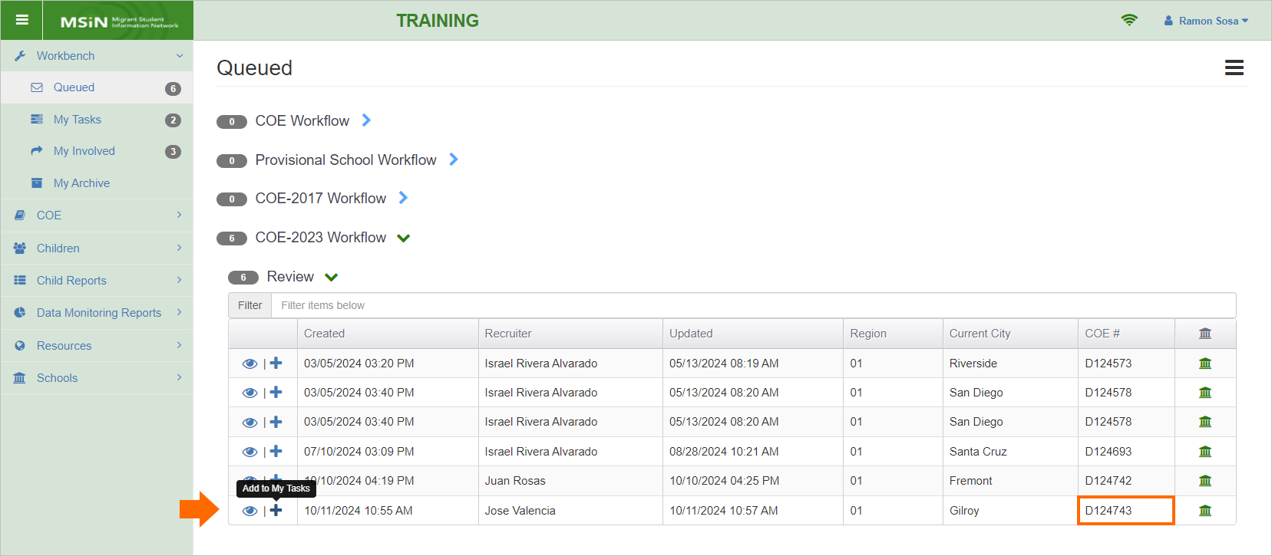
The Review table gives Reviewers the option to claim specific COEs because large subgrantees generally have multiple Reviewers. Subgrantee leadership teams may decide the best way to distribute their local reviewing workload. For example, some divide the work by assigning Reviewers to specified Recruiters, whereas others divide the work by assigning it based on the family’s current city (where they live). Notice that “Recruiter” and “Current City” are headings in the Review table above that Reviewers can click on to easily sort the list of COEs, as needed.
After a Reviewer claims the COEs they want to review, the COEs will transfer to their My Tasks folder. For instance, figure 2 shows that COE D124743, from the image above, is now in Ramon Sosa’s My Tasks folder.
Figure 2: My Tasks Folder
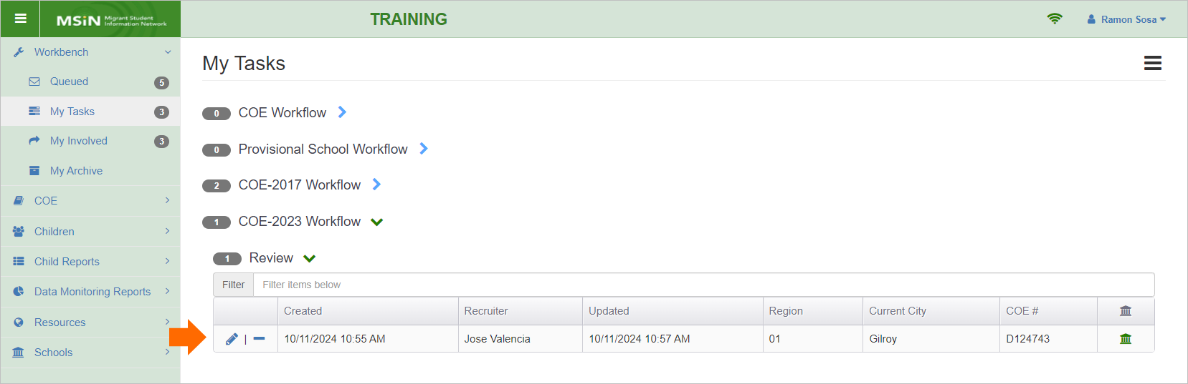
Notice that Ramon, the fictitious Reviewer used in this example, can now do two things with this COE. Ramon can either open the COE with the pencil icon or release the COE back to the Queued folder by clicking the minus icon. A Reviewer would release a COE if they claimed it by mistake or if they will not be able to review it because of a work absence, such as taking a vacation or a leave of absence.

Reviewing Section I, Qualifying Moves & Work
Although the COE form is already divided into sections, the COE Review page divides it further into decision blocks. These are outlined subsections where the Reviewer selects a radio button to show that they carefully evaluated the items within, and that the items have passed (or not) their quality assurance (QA) review. Section I of the COE form has three decision blocks.

Decision Block for items 1–2
By default, decision blocks are outlined in red and marked as DID NOT PASS, as shown in figure 3.
Figure 3: Decision Block for Items 1–2
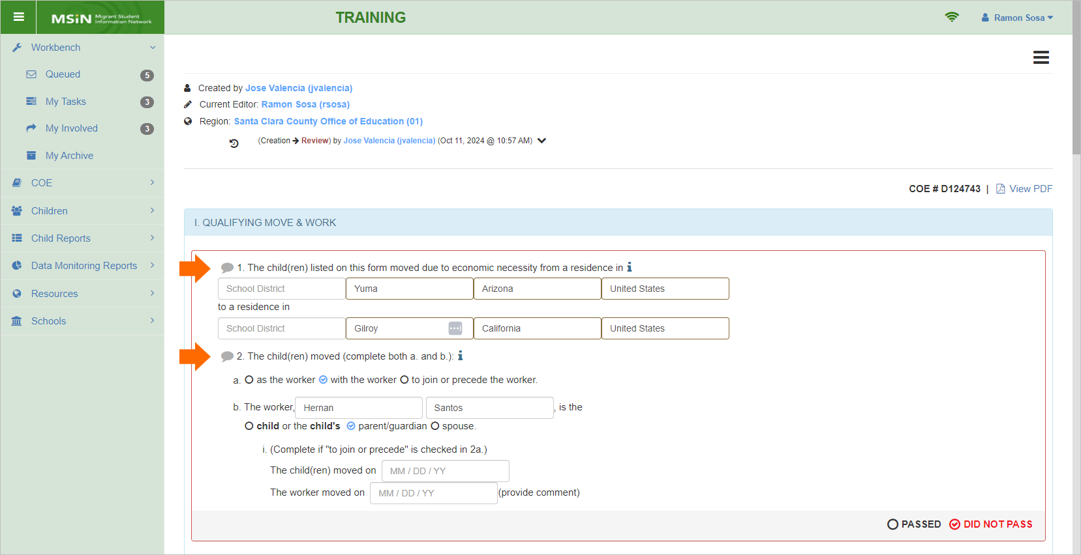
The Reviewer should complete their QA review of this decision block based on the knowledge they have acquired through state and local training. This includes applying their full understanding of the COE instructions in the I&R Manual and any additional quality checks required by their supervisor. Furthermore, Reviewers should understand the data quality checks and prompts embedded in the COE form when it was edited by the Recruiter, just prior to submission for review.
As stated earlier, this guide focuses on the mechanics of using the COE review features in MSIN (not eligibility criteria), and it presupposes that the Reviewer has been fully trained on MEP eligibility concepts and California-specific COE documentation requirements.
Returning to figure 3, notice the grey callout icons next to items 1 and 2 (arrows above). Throughout the Review page, callout icons appear next to each item or section. These icons open an input box for adding notes, as shown in figure 4.
Figure 4: Callout Comment Input Box
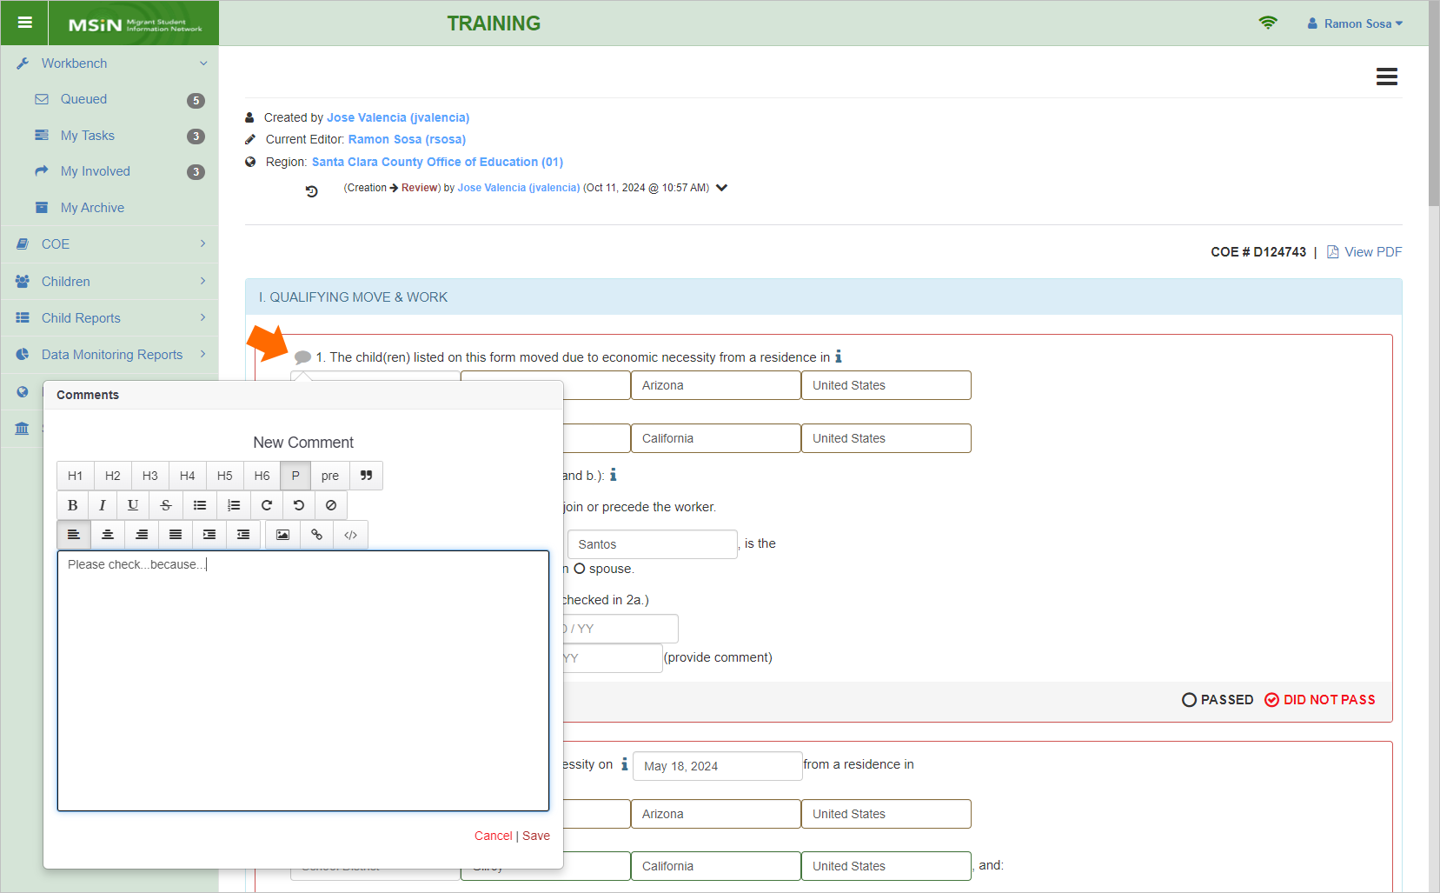
Referring to figure 4, suppose the Reviewer has found a major issue with item 1, causing them to select DID NOT PASS for the decision block. They should also enter a callout comment next to item 1 so the Recruiter can identify the location where the correction or clarification is needed. The Reviewer’s comment should briefly explain what they need from the Recruiter to feel confident enough to mark the decision block as PASSED.
Once the Reviewer has saved a callout comment, the corresponding icon will turn red and show the number of comments within. For example, after the Reviewer saves the comment above, the corresponding callout icon will be red and show the number 1 to indicate that it contains one comment, as shown in figure 5 below.
Figure 5: Callout Comment Numbering
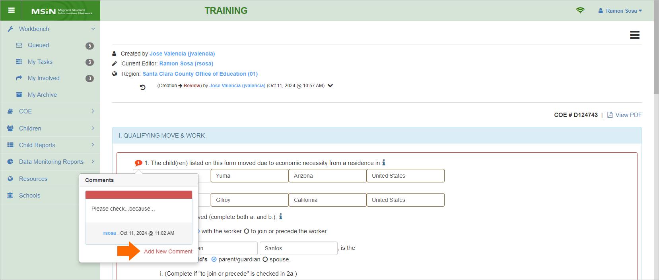
The Reviewer can click Add New Comment to add another entry if they forgot something in the first one. But a more common reason for having multiple comments within a callout icon is that a clarification was needed, and the Recruiter added a response. This scenario will be explained in more detail in the upcoming section on COE workflows.
Returning to the decision block above, the Reviewer should complete their careful QA review. Once they feel confident that the information will also pass the scrutiny of an independent reviewer, then the Reviewer can mark the decision block as PASSED, as shown in figure 6 below.
Figure 6: Decision Block in PASSED State
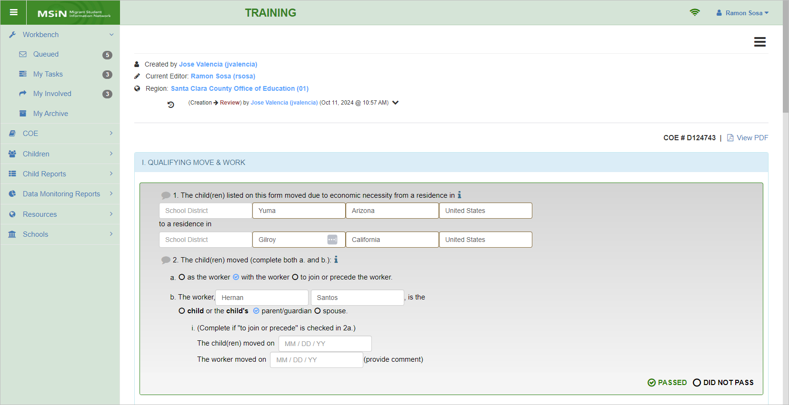
Notice that the decision block has become shaded and outlined in green. This helps the Reviewer quickly distinguish between the two decision block states, PASSED or DID NOT PASS.
Keep in mind that if any decision blocks are marked as DID NOT PASS, then this Review page will not allow the Reviewer to approve the COE. Instead, their only options will be to forward the COE to another Reviewer, return the COE for corrections or clarifications, or deny the COE. But if all decision blocks are marked as PASSED and all required fields are completed, then the Reviewer will have the option to approve the COE.
To recap, there are two decision block states, as follows, and they collectively trigger different Review page behaviors.
- PASSED: When all decision blocks have PASSED, the Review page automatically opens the Reviewer Action panel, where the Reviewer adds their signature, and the option to approve the COE, under the Next Step drop-down, becomes enabled.
- DID NOT PASS: If even one decision block DID NOT PASS, the Review page hides the Reviewer Action panel (where the Reviewer normally signs), and the option to approve the COE stays disabled in the Next Step drop-down. Instead, the Next Step drop-down will only allow the Reviewer to forward the COE to a second Reviewer, return the COE to the Recruiter for corrections or clarifications, or deny the COE (mark it as not approved).
When returning the COE to the Recruiter for corrections or clarifications, the Reviewer should always use the callout icons to add their comment(s) or question(s). As stated earlier, this will make it much easier for the Recruiter to quickly identify the places that need their attention. Note that this instruction applies to all decision blocks and COE sections.

Decision Block for items 3–5
These items capture the worker’s qualifying move and the qualifying work they performed. The decision block has one callout icon per statement to collect any Reviewer and Recruiter comments, as shown in figure 7.
Figure 7: Decision Block for Items 3–5
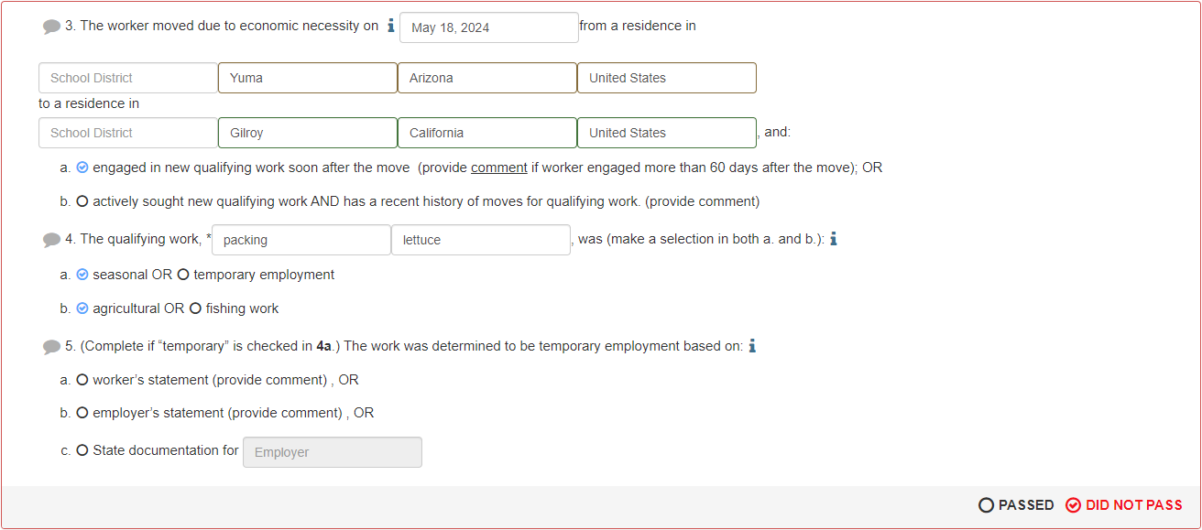
Again, the Reviewer should evaluate the content based on their thorough training and complete knowledge of eligibility criteria, including any specific requirements provided by their supervisor.
Many items in this decision block, when selected, require comments that are automatically copied into Section II. So, reviewing this decision block may require the Reviewer to simultaneously evaluate any corresponding content in Section II. This applies to 3a, if the worker engaged in work more than 60 days after the move; 3b, which contains additional notes on prior moves, when applicable; and the options under item 5, when the qualifying work was temporary. After the Reviewer completes their careful QA review, including any linked comments in Section II, they should mark this decision block as PASSED or DID NOT PASS.

Decision Block for item 6
This decision block focuses on only one item, the Qualifying Arrival Date (QAD), as shown in figure 8.
Figure 8: Decision Block for Item 6
This singular focus on the QAD highlights its critical role in the COE, as it determines the child(ren)’s eligibility period. The Reviewer should evaluate the QAD in relation to the worker’s move date (item 3 in figure 7) and the 2bi dates, if applicable. The QAD should never be before the worker’s move date in item 3. Relative to the 2bi dates, the QAD should always be the latter of the two dates. In addition, the Reviewer should consider whether any applicable comments (in the prior decision block and Section II) affect the viability of this date or call into question the overall scenario that is being used to establish eligibility.

Reviewing Section II, Comments
As indicated previously, Section II contains comments that support key eligibility factors and/or clarify how the initial eligibility determination was made by the Recruiter. This section includes three distinct review areas: a decision block for the primary comments, a statement requiring a Yes/No radio button selection, and a second decision block specifically for Round-Trip Move documentation.

Decision Block for Comments and Special Conditions
The first decision block in Section II covers the text area for any applicable Section I comments, and it also covers any Special Conditions, as shown in figure 9.
Figure 9: Decision Block for Comments and Special Conditions
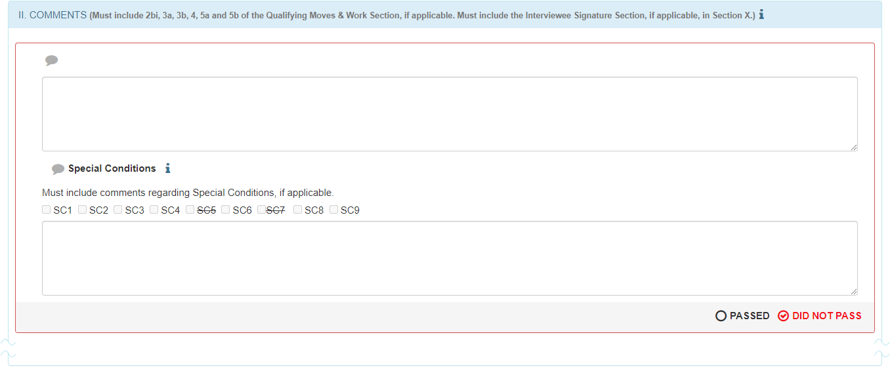
One of the most challenging tasks for the Reviewer is to carefully stitch together the information provided in Section I with the comments in Section II to see if the result is a coherent and sufficient scenario that clearly meets all eligibility criteria. Consequently, a significant portion of the Reviewer’s time should be spent reading and re-reading comments. If sufficient, based on the Reviewer’s training and experience, then they would mark this decision block as PASSED. However, if the comments are insufficient or need further editing to be clearly understood, the Reviewer should mark this decision block as DID NOT PASS and provide instructions or questions to the Recruiter via the callout icons.
Note that Help Text is available to the Reviewer while evaluating this area. For example, the Help Text around the Special Conditions is especially useful because some are used less often, and it helps to easily reference details for each, as needed.

Subsequent Qualifying Move
Embedded within Section II, the Reviewer will find a question that requires a Yes/No selection, as shown in figure 10.
Figure 10: Radio Buttons for Subsequent Qualifying Move

Although this question is not in the original COE form, it was added here so that Subsequent Qualifying Move data can be tracked in MSIN via the COE Review Log. Returning to the radio buttons, the Reviewer should consider the facts in the previous sections and indicate here if the move that confers eligibility to the children was a Subsequent Qualifying Move.

Decision Block for Round-Trip Move
Since round-trip moves are only a subset of all move types, the Round-Trip Move section is marked as Not Applicable by default, as shown in figure 11.
Figure 11: Decision Block for Round-Trip Move
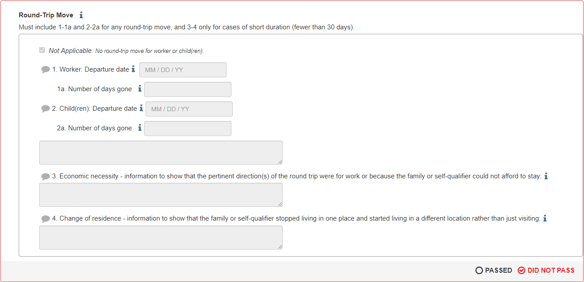
The Reviewer should consider the COE documentation, including notes in Section II and addresses in Section III, to judge whether Not Applicable is the correct selection. In addition to the information in the COE, the Reviewer can also compare any available child records with historical address information. After completing all data quality checks recommended in both state and local training, the Reviewer should select PASSED or DID NOT PASS.
In situations where round-trip details are entered into this section, the Reviewer should evaluate the notes for logical consistency with the information in the previous sections. Furthermore, while scrutinizing the explanations in items 3 and 4, the Reviewer should apply their expert knowledge to ensure the proper standards are met for Economic necessity and Change of residence. Using their best judgment, the Reviewer should proceed to select PASSED or DID NOT PASS.

Reviewing Section III, Family Data
This section can accommodate several valid variations. Because of this variability, the section is not encapsulated in a PASSED or DID NOT PASS decision block. Instead, Reviewers should consider whether the content, or lack of content, makes sense relative to the information in the previous sections.
For example, consider figure 12 below, where both Legal Parent/Guardian and Current Parent/Guardian information was entered.
Figure 12: Section III, Family Data
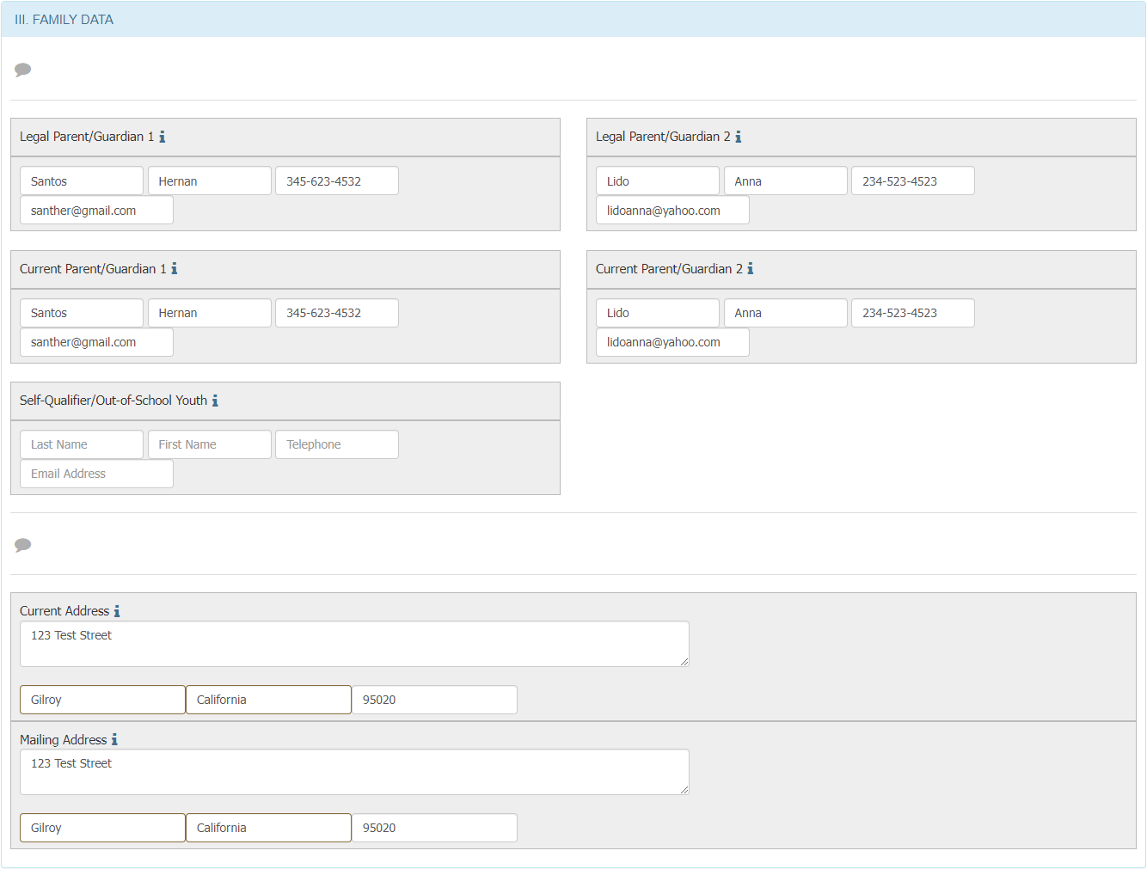
This represents the most common scenario, where children are under the care of two adults who meet the definitions of both categories. This means that Legal Parent/Guardian 1 will be the same as Current Parent/Guardian 1, and so on.
A second common scenario is when children are qualified under Current Parent/Guardians who are not the same as their Legal Parent/Guardians. An example of this is when children are temporarily living with an aunt, uncle, or older sibling who is standing “in loco parentis,” meaning in the place of the parents. In this situation, we would expect to see different names in the four parent/guardian areas (noting that phone numbers and emails are optional).
A third common scenario is when a youth is a self-qualifier, meaning that the youth is both the child and the worker. In this case, the fields for Current Parent/Guardian would be blank, but the fields for Legal Parent/Guardian may have content (though it is not required).
A less common scenario is when a youth’s eligibility is established through a spouse, who is the established migratory agriculture worker or fisher. In this case, all four parent/guardian fields would generally be blank.
If the Reviewer finds any discrepancies while reviewing each specific case, they can use the callout icon (shown in grey in figure 12 above) to document why they are returning the COE to the Recruiter for corrections or clarifications.
Regarding the Current Address and Mailing Address fields, these should always include valid location data. Note that the Current Address must always be in California. The Mailing Address is also required because other reports in MSIN, such as the Enrollment Report, rely on this information to help subgrantees extract mailing lists.

Reviewing Section IV, Child Data
This decision block includes the list of children who may be eligible for the MEP, assuming the Reviewer completes their QA process and verifies the COE. Figure 13 shows two fictitious children and their MEP-related data.
Figure 13: Section IV, Child Data
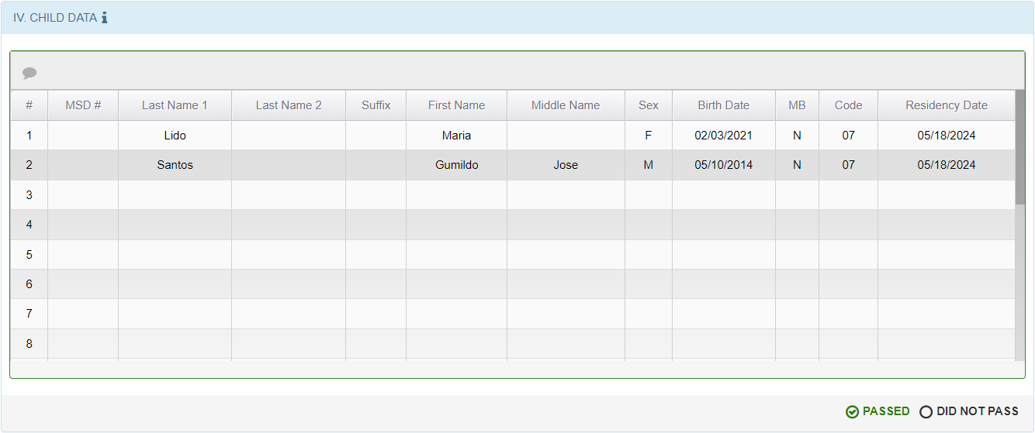
As with the previous decision blocks, the Reviewer should rely on their training to determine whether this information meets both state and local requirements. The primary guidelines for these data elements are found in the COE instructions within the I&R Manual. Again, state standards are the minimum requirements, and the Reviewer’s supervisor may ask them to follow more specific review processes.
While completing their review, the Reviewer should consider the following points:
- When a child listed in this section does not have a Migrant Student Directory (MSD) number, it is especially important to consult another database, if feasible, to confirm that the names and birth date are accurate. For example, the Reviewer may consult a district database or CALPADS (assuming they have access). This step is important because not having an MSD is a likely indicator that the child is new to the MEP in California. In contrast, a child who has an MSD number has probably already cycled through the California Statewide Student Identifier (SSID) matching process in MSIN, which typically includes making minor name and demographic data corrections, thereby increasing the odds that the information is accurate.
- In rare cases, the Reviewer may find that the wrong child was added to the COE by mistake. This can happen because Recruiters are taught to conduct a search and select from the results list, whenever possible. On laptops, the rows in the results list can be quite narrow, leading to the inadvertent selection of a neighboring row. The Reviewer can sometimes spot this type of error by noticing unexpected name or age differences when comparing the erroneous row to the other children listed in Section IV.
- The column labeled MB stands for Multiple Birth and should always show either a Y (yes) or N (no). It is far more common to see mostly Ns. But when the Reviewer finds a Y, then they would expect to see at least one more row for a different child who has the same Birth Date. Using the same logic, if there are two (or more) children with the same Birth Date, then the Reviewer should see that each of these has a Y under the MB column.
- In most cases, the Residency Date is likely to be the same for all children on the COE. But when the Reviewer sees a difference, this should be clearly explained in Section II: Comments. In addition, residency dates should make sense relative to the moves on page 1 of the COE. Although the Residency Date is often the same as the QAD for inbound qualifying moves, this may not be true if the family has changed residences again (such as within town) after their initial arrival. If in doubt, the Reviewer should consult the definition of Residency Date in the I&R Manual to confirm that all dates make sense relative to each other.
These are just a few general tips, and the Reviewer may receive supplemental steps from their supervisor. If the Reviewer has any doubts whatsoever while completing their review, they can find details for each data element in the I&R Manual, or they can click on the nearest Help Text “i” to get definitions.

Reviewing Sections V–VI, Data for School, Birthplace, Ethnicity, and Race
The information in this decision block corresponds to the children listed in Section IV, where school #1 below (figure14) corresponds to child #1 in figure 13.
Figure 14: Sections V–VI
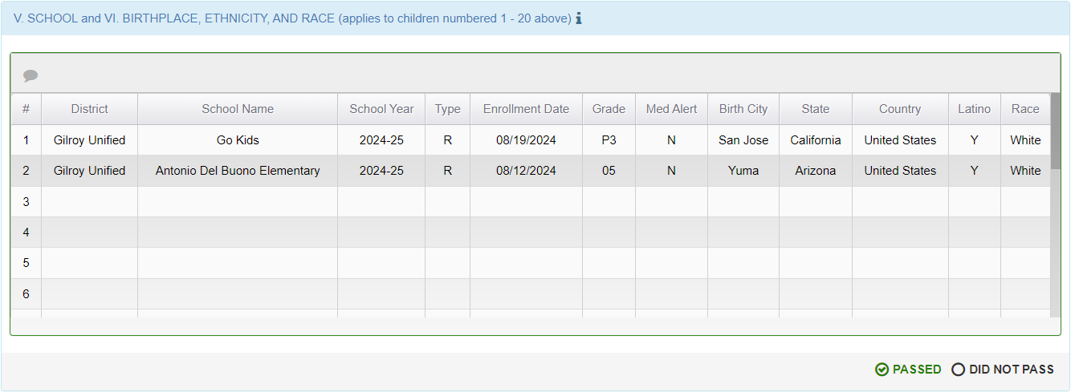
While reviewing this section, the Reviewer should consider the following points:
- For each row, the school and grade information should make sense relative to the corresponding child’s current address and age.
- For Type R (regular) enrollments, there should be an Enrollment Date, and all other fields should have content. In contrast, Type N (non-attending) enrollments should not have an Enrollment Date.
- School Year should be based on the applicable district calendar. In large regions covering multiple counties, there could be a lot of variance, particularly in the fall when children are returning to school on different dates in different places (where the first day of school marks the transition from one school year to the next).
- Birth location information should be consistent, where the city corresponds to the correct state, which corresponds to the correct country.
In addition, the Reviewer may receive supplemental steps from their supervisor regarding enrollments, given their district’s/region’s level of access to local databases. For instance, in a Direct-Funded District, the Reviewer may be required to cross-reference enrollment information with their district data system. Or in a regional office, the Reviewer may be required to cross-reference enrollments with CALPADS (if this access is available).

Reviewing Section VII, Interviewee Signature
This section will look different depending on whether the Reviewer is reviewing a Paper COE or an eCOE. Regarding the Paper COE data entry screen, Recruiters and Data Specialists can use it to enter information that was officially collected on a hard copy COE. When viewed in MSIN, this type of COE will not have signature images (as the official signatures are on the hard copy). Therefore, if the Reviewer sees that signature images are missing in this section, they should check to ensure that the COE was, in fact, entered as a Paper COE.
In contrast, eCOEs should have all fields completed, including signature images, as shown in figure 15.
Figure 15: Section VII, Interviewee Signature
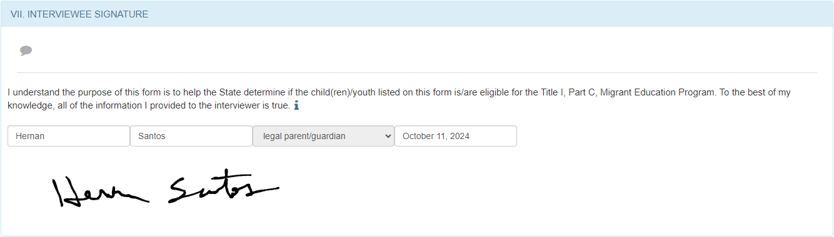
To summarize, eCOEs should always have signature images, but Paper COEs will not. If the Reviewer sees anything unexpected, they should double-check the COE type and contact the MSIN Service Desk to resolve the issue.
Assuming the content in this section looks as expected, the Reviewer should also consider the following tips:
- The name appearing here must be identified elsewhere in the COE. It could belong to the worker (from Section I), a parent/guardian (from Section IV), or someone who was a parent/guardian at the time of the qualifying move (as explained in Section II, when applicable). It should be clear to the Reviewer who the “signer” is and their relationship to the children on the COE.
- Under the “Relationship to the child(ren)” drop-down menu, “spouse” is far less common than the other options. When the interviewee is a spouse, the Reviewer should ensure that this makes sense relative to the worker (Section I), any comments (Sections II and X), and the parent/guardian information (Section IV), if any.
- Regarding the date, in Paper COEs, this should match the hard copy (not when the information was entered into MSIN). In eCOEs, the date should be consistent with subsequent dates in Sections VIII and IX.
As noted in other sections, these are general guidelines that align with the features in MSIN; the Reviewer may also receive supplemental steps from their supervisor.
Again, if the Reviewer notices an issue that warrants returning the COE to the Recruiter for corrections or clarifications, they should use the grey callout icon (under the section heading) to add their comment(s) or question(s).

Reviewing Section VIII, Interviewee FERPA Signature
Completing this section is optional. However, most interviewees choose to sign this section as well, as shown in the fictitious eCOE below (figure 16).
Figure 16: Section VIII, Interviewee FERPA Signature
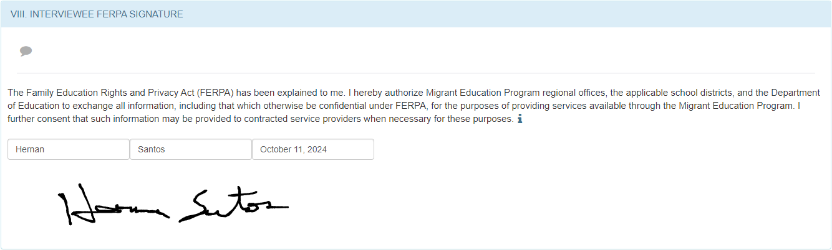
The Reviewer should confirm that the names, dates, and signatures match those in the previous section. Again, note that eCOEs must have signature images, but Paper COEs will not.

Reviewing Section IX, Eligibility Data Certification
For eCOEs, the Reviewer should see two completed fields and a signature image in this section, as shown in figure 17.
Figure 17: Section IX, Eligibility Data Certification
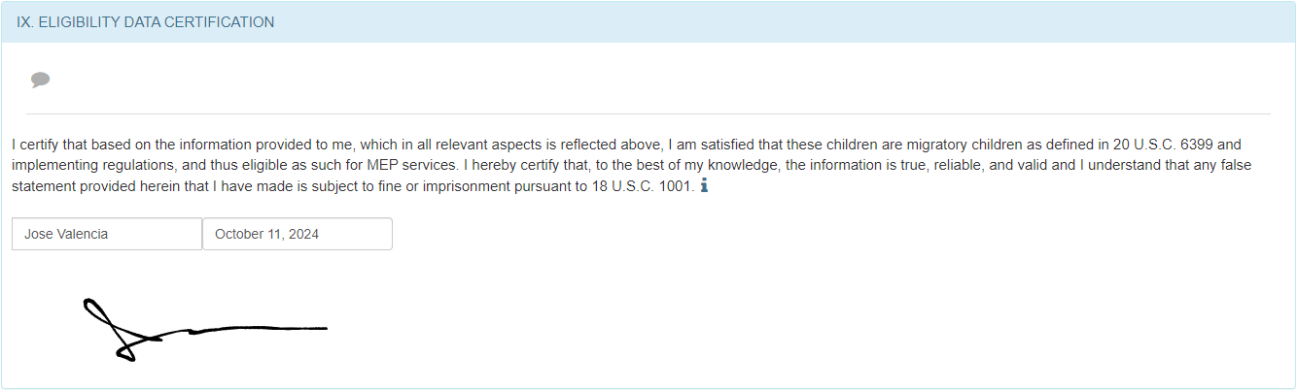
In contrast, Paper COEs will only have the Recruiter name and date (no signature image).
Note that both the eCOE and Paper COE pages will restrict the name field to users who have the Recruiter role. In rare cases, the Reviewer may see an error here (such as a missing name) if the Recruiter role was removed from the original Recruiter’s account before the COE was fully approved. The Reviewer should contact the MSIN Service Desk if they see any anomalies.

Reviewing Section X, Local Comments
The Local Comments section (figure 18) may be blank, unless the conditions in the header note apply.
Figure 18: Section X, Local Comments
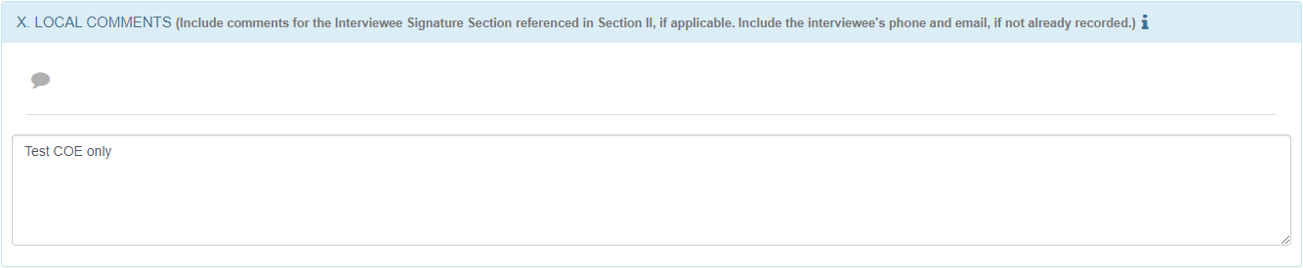
While reviewing Section X, the Reviewer should consider whether other sections in the COE make it likely, or logical, that they should also see comments here.
As noted in many other sections, the Reviewer may receive supplemental steps from their supervisor if there is something subgrantee-specific they require.

System Comments
There is one more comment area found at the very bottom of the Review page. These comments are saved with the COE, but they remain outside of the COE document, meaning outside of the PDF or printed COE. These are called “system comments” because they reside in the MSIN system, not the COE document. System comments are generally optional, unless the Reviewer’s supervisor has subgrantee-specific requirements for them and their team.
Figure 19, below, shows two fictitious comments.
Figure 19: System Comments
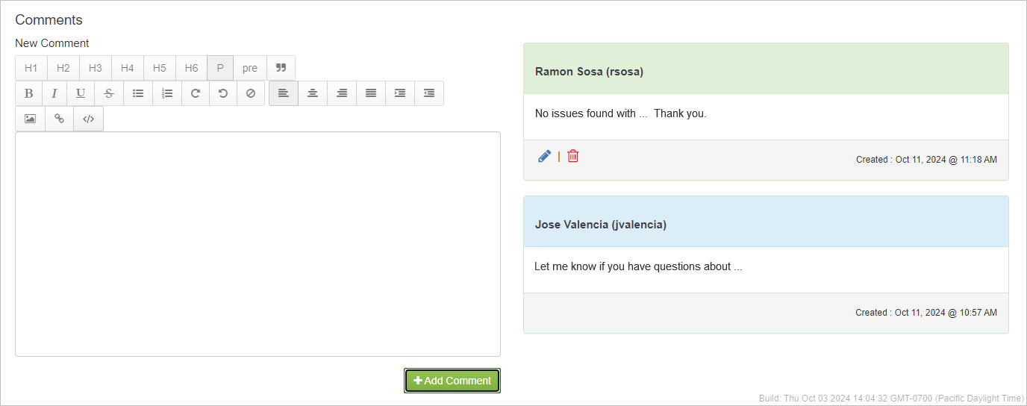
Note that system comments are drafted on the left and saved on the right side of the page. Once saved, the author’s name appears at the top, and the comment window includes a date stamp on the bottom right. Each author can always edit or delete their system comments.
In terms of the COE review process, here are a few common use cases:
- A Recruiter adds a system comment about a child’s atypical enrollment information so that it makes sense to the Reviewer.
- A Reviewer uses a system comment to request a correction or clarification around an issue that spans multiple items (where using the individual callout comments might be confusing).
- Either party can use system comments to acknowledge or explain minor errors that do not affect eligibility.
The Reviewer can use system comments in many other ways. However, they should remember that eligibility-related notes must be in one of the comment areas within the COE form itself (so they will appear in the PDF or printed versions), not in system comments. Furthermore, system comments must not be used for personally identifiable information (PII), such as social security numbers, insurance numbers, specific health conditions, medications, diagnoses, and other forms of protected information.

Reviewer Action: Approving a COE
Given that approving a COE is the most common outcome of the review process, this scenario will be covered first. As shown in figure 20, Reviewer Action refers to a panel that is hidden by default (collapsed rather than expanded).
Figure 20: Reviewer Action Panel, Collapsed
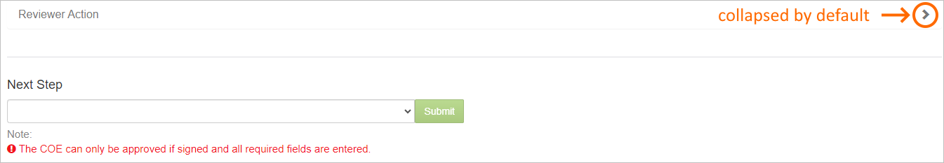
This hidden condition serves to remind the Reviewer that something required is missing above. In addition, the option to approve the COE, under the Next Step drop-down menu, is disabled by default to prevent the accidental approval of incomplete COEs.
In contrast, when the Reviewer marks all decision blocks as PASSED (and they select a Yes/No option next to “Subsequent Qualify Move?”), then the Reviewer Action panel will automatically expand. The system also populates the Reviewer name and the current date automatically, as shown in figure 21.

Figure 21: Reviewer Action Panel, Expanded
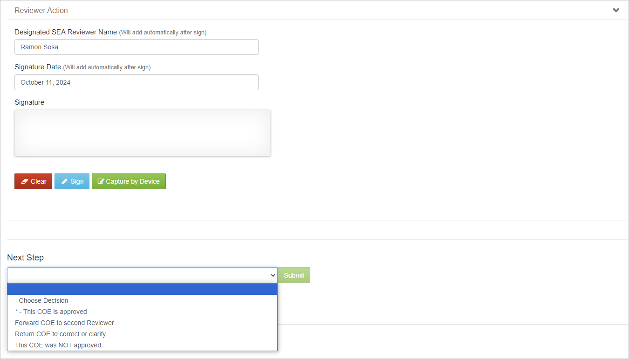
In the Next Step drop-down menu, note that the option for approving a COE remains disabled because the Signature area is still blank. The Reviewer cannot highlight or select the approved option if any required field is missing. However, after the Reviewer writes their signature and clicks the Sign button to save it, the Next Step option to approve the COE becomes enabled, as shown in the blue highlighted area in figure 22.
Figure 22: Next Step, Approve Option
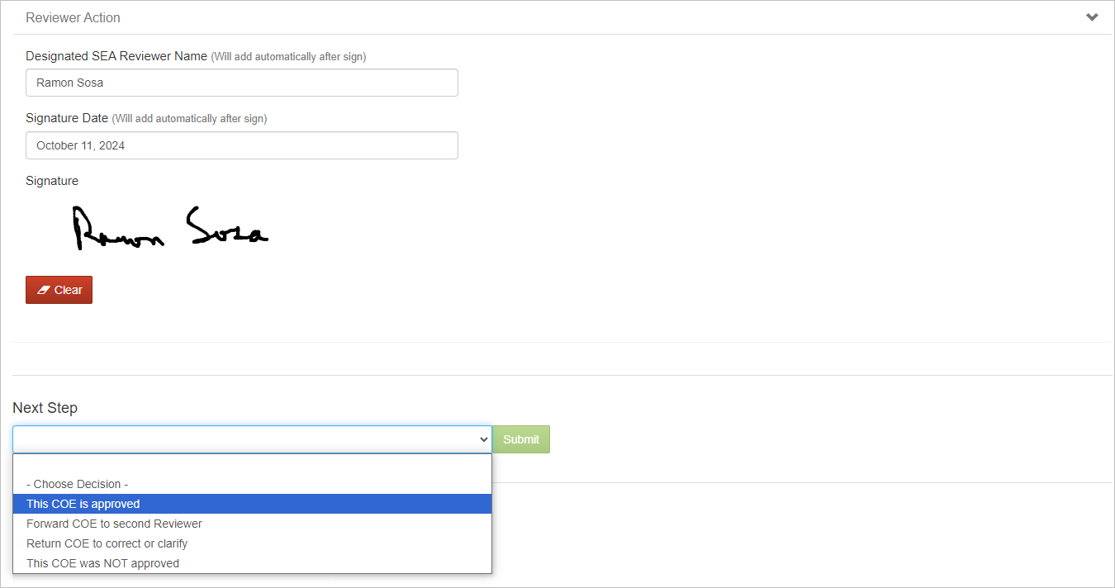
Note that the green Submit button remains disabled until the Reviewer chooses an option. But after they fully select a drop-down option, such as This COE is approved, the Submit button becomes enabled. Clicking Submit triggers a popup to confirm the Reviewer’s selection (figure 23).
Figure 23: Next Step, Confirmation
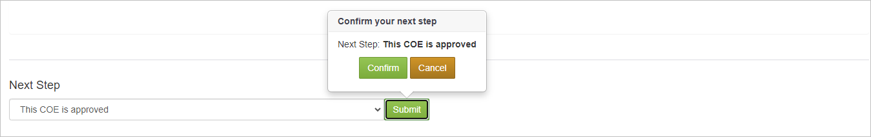
Once the Reviewer clicks Confirm, they should make sure to wait for the COE approval to fully complete (i.e., wait for the spinning arrows to stop). This may take anywhere from several seconds to a minute, depending on how much traffic the system is experiencing, the Reviewer’s connection speed, and other factors. For the children on the COE, their child records are either being created (for new children) or updated (for returning children), which takes time.
After the COE approval process is finished, the Reviewer can access all their completed work under the Workbench menu, in their My Archive folder (figure 24).
Figure 24: My Archive
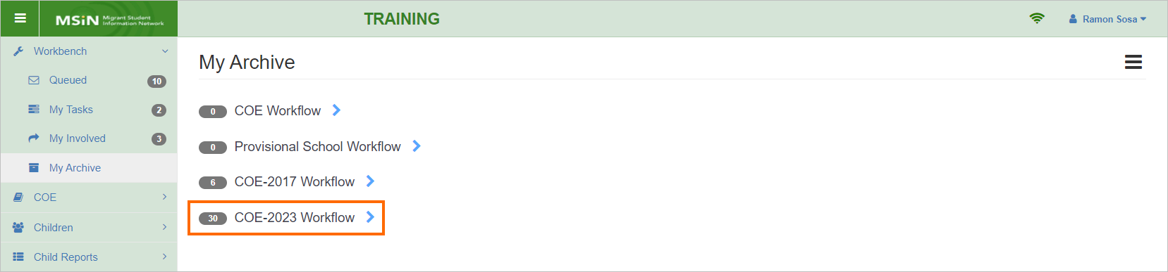
Note that all recent COEs will be under the latest COE workflow. At this point, the Reviewer has completed all steps in the eCOE review process. But for Paper COEs, the Reviewer still needs to physically sign the hard copy and file it in a safe location.

Forwarding a COE to a second Reviewer
The second item in the Next Step drop-down, Forward COE to second Reviewer, is optional. The Reviewer can use it to send a COE to another Reviewer in the same Region or Direct-funded District (DFD). The following are common use cases for this option:
- A new Reviewer is undergoing supervised training, so sending their COEs to a second Reviewer provides an opportunity to receive feedback, while maintaining high quality control standards.
- A subgrantee has COE quality concerns, such as from a specific district or Recruiter, and wishes to implement a two-stage process for reviewing those COEs, which is typically done for a defined period.
- Occasionally, a Reviewer wants support from an experienced colleague when faced with a challenging or rare eligibility scenario.
The Reviewer should consult with their supervisor if they have any questions regarding these use cases, as their Region or DFD may have its own policies for using this Next Step option.

Returning a COE for corrections or clarifications
The Reviewer can use the third item in the Next Step drop-down, Return COE to correct or clarify, to send a COE back to the user who created it. Common reasons for returning a COE include the following:
- The COE does not meet one or more eligibility criteria, but it seems that editing a field or comment could solve the issue.
- Supporting comments in Section II or X need to be edited so that a third-party reviewer can easily understand them.
- The COE needs additional comments to meet documentation requirements, such as in the Special Conditions and Round-Trip Move sections.
This is only a short list among many possibilities. The Reviewer’s leadership team may have added their own policies to specify when and how this Next Step option should be used in their local area.
Note that when the Reviewer returns a COE to the Recruiter or Data Specialist, they will see it in a modified version of the COE Review page, called the Fix COE page. This page has edit restrictions that could result in the Recruiter needing to get new interviewee signatures. The Fix COE page is covered later in this guide, including details about its protected fields.

Denying a COE
The fourth item in the Next Step drop-down, This COE was NOT approved, should be used in rare instances when the information on the COE cannot be “fixed” (i.e., corrected or clarified) and it does not meet all MEP eligibility criteria. This option should always be the last resort. MEP staff have invested significant efforts and resources to create each COE. Consequently, Reviewers should be speaking openly and often with their local Recruiters and Data Specialists, striving to exhaust every option before deciding to deny a COE.

Workbench and COE workflows
It is important for Reviewers to have a clear understanding of how the COE review process is integrated in the MSIN system, particularly through a feature known as the Workbench. The Workbench is a set of folders that house COEs in specific stages of the COE life cycle. The folders are organized like an email application. For example, the My Tasks folder is like Drafts/Inbox, My Involved is like Sent, and My Archive is like All Mail/Archive. The workflow progression is also similar: the COE is created, then sent for review, then archived when fully completed. In MSIN, COEs are always in a specific state (describing their current condition), and the state generally corresponds to a folder, as shown in figure 25.
Figure 25: Workflow States and Folders
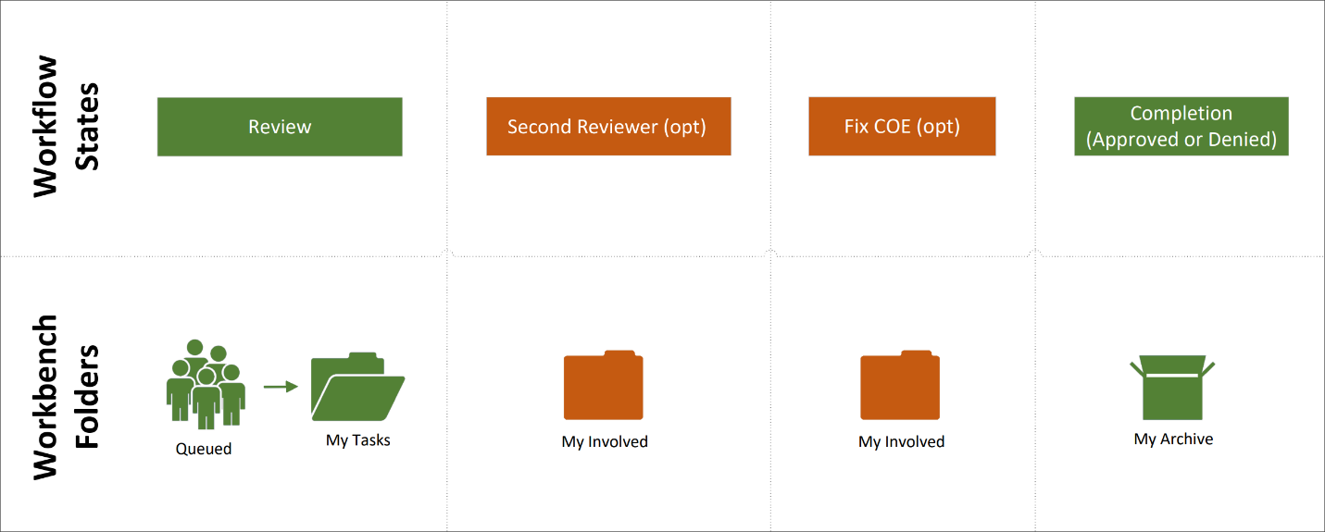
Note that figure 25 presents the Reviewer perspective. Starting with the green items on the left, when a Recruiter or Data Specialist transitions their COE to Review state, this automatically places it in the Queued folder. Queued is a shared folder that only Reviewers can access, meaning that all Reviewers in the same Region or DFD will see the same pool of unclaimed COEs. Following the process described in the first section of this guide (Claiming a COE from the Workbench), a Reviewer can move any COE in the shared Queued folder to their private My Tasks folder. COEs that a Reviewer has claimed will remain in their My Tasks folder until they transition them to another state. Ultimately, the COEs that a Reviewer finishes reviewing will end up in their My Archive folder, in either Approved or Denied state, as represented by the green icon on the far right of figure 25.
The next section builds on these ideas and walks through the relationships between workflow states, Workbench folders, and common workflow paths. The optional workflow states shown in orange above, Second Reviewer and Fix COE, will be addressed in the upcoming workflow diagrams.

COE Review workflow
To provide a broader context, the following diagrams include a swimlane for the Recruiter/Data Specialist perspective, and a corresponding swimlane representing the Reviewer perspective. While it is not necessary for Reviewers to know every step taken by other roles, it is helpful to have a general understanding of the different workflows.
Figure 26 illustrates the COE Review workflow, which is the primary workflow that Reviewers follow to approve or deny COEs.
Figure 26. COE Review Swimlane Diagram
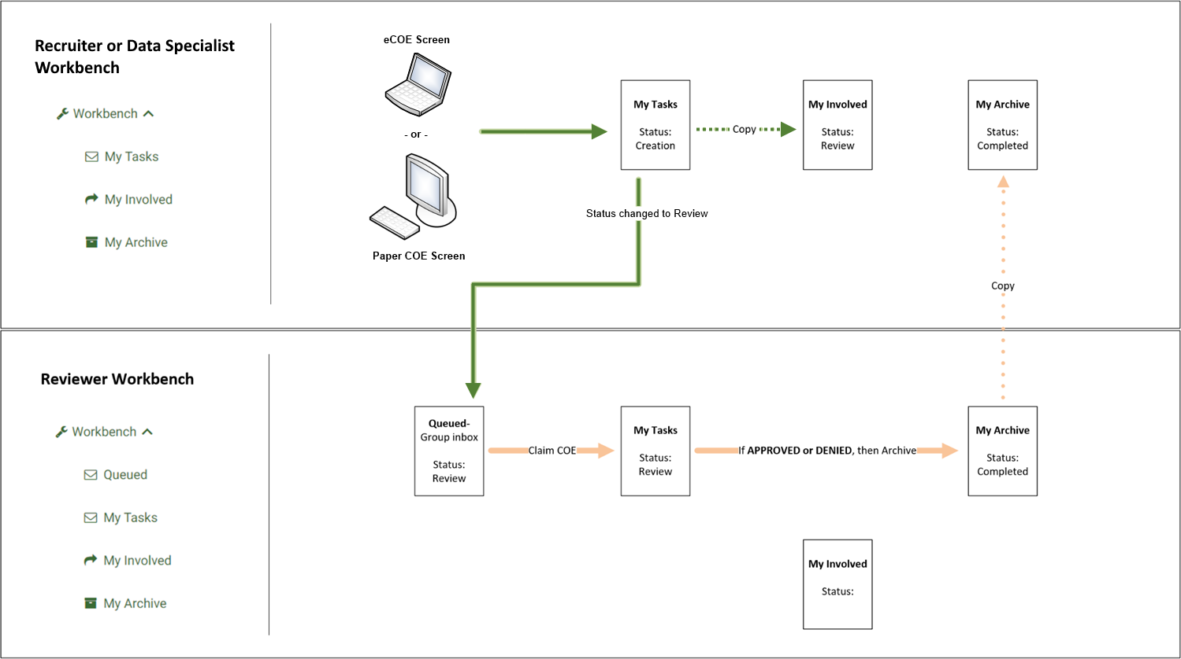
Notice that this diagram includes a screenshot of a Recruiter’s or Data Specialist’s Workbench menu (green icons and text on the left), which is organized vertically and progresses from top to bottom. The same folders are represented in the swimlanes horizontally, from left to right, only because this makes for a more compact diagram.
Starting with the laptop and desktop computer icons, they represent eCOE and Paper COE pages in MSIN. The green-colored arrows represent the actions taken by Recruiters or Data specialists, whereas the peach-colored arrows represent Reviewer actions. Notice that from the Reviewer perspective, both types of COEs enter the Reviewer swimlane via the Queued folder. Looking at the Workbench screenshot on the left, note that Queued is only visible to Reviewers (not present in the Recruiter or Data Specialist Workbench). Another detail to notice is that a copy of the COE is always saved in the Recruiter’s or Data Specialist’s My Involved folder. In short, the green arrows represent the pathway to hand over COEs for review, via the Queued folder.
The next steps occur within the Reviewer swimlane. In subgrantee areas with multiple Reviewers, the Queued folder (like a group Inbox) facilitates dividing up the work. Individual Reviewers will claim certain COEs based on their local assignment model (such as by Recruiter, by city, etc.). The COEs that a Reviewer claims will move into their My Tasks folder. Once the Reviewer finishes the review process, they can decide to approve or deny the COE, or they can initiate one of the optional workflows (described later). Assuming the Reviewer approves or denies the COE, the outcome is a Completed state (Completed: Approved or Completed: Denied). Selecting either option does two things at once: 1) moves the completed COE into the Reviewer’s My Archive folder, and 2) makes a copy of the completed COE in the Recruiter’s or Data Specialist’s My Archive folder (peach-colored dotted line).

Second Reviewer workflow
The following diagram (figure 27) adds one more swimlane to represent an optional workflow, which is to send a COE that the Reviewer evaluated to a second Reviewer. Each subgrantee decides when and how to use this option, if at all. Reviewers should check with their supervisors to confirm if this option applies in their area. Focusing on the diagram below, the green pathway which hands over the COE to the Queued folder is the same as the prior diagram.

Figure 27: Second Reviewer Swimlane Diagram
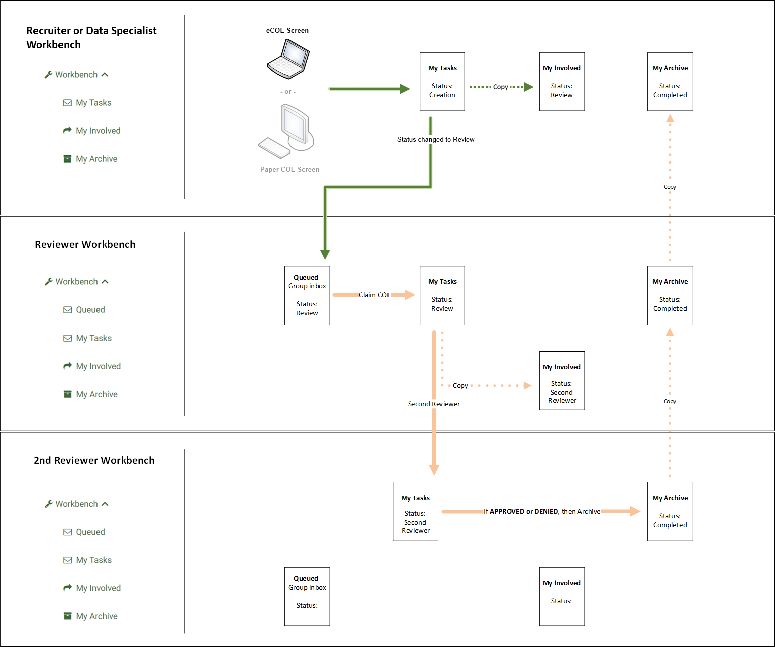
Notice that the primary difference in the new swimlane is that the COE moves from the first Reviewer’s My Tasks directly into the second Reviewer’s My Tasks (Queued is typically not used by the second Reviewer). This occurs because the first Reviewer selects who the second Reviewer will be, as part of their Next Step selection. For example, figure 28 shows that a Region 1 Reviewer wants to send the COE to a second Reviewer.

Figure 28: Next Step, Second Reviewer Selection
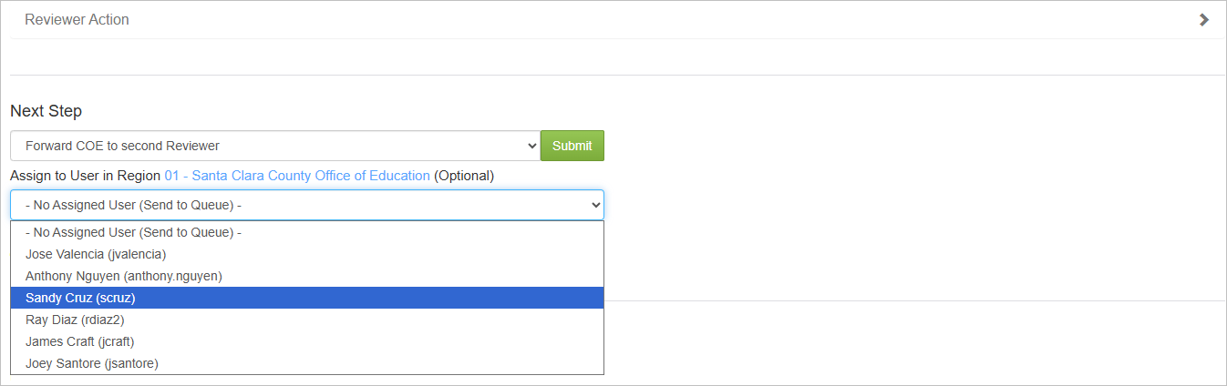
Notice that selecting Forward COE to second Reviewer will trigger the appearance of another drop-down menu, where any Reviewer in the same Region or DFD can be chosen as the second Reviewer. For example, Sandy Cruz is highlighted as the second Reviewer in the screenshot.
Next, the second Reviewer (Sandy) would perform her review and either approve or deny the COE. This would copy the completed COE into the My Archive folders of all the users who worked on it. Alternatively, any Reviewer can choose to return the COE to the Recruiter/Data Specialist for corrections or clarifications, as described in the next section.

Fix COE workflow
The following diagram adds an optional workflow, using red arrows, to represent when a COE is returned for corrections or clarifications. Before going into detail, note that this feature was originally developed for eCOEs. It is far less useful for Paper COEs, given that the primary document is actually the hard copy COE, and the person who enters it in MSIN is simply copying the data into the Paper COE form. This means that Reviewers should only return Paper COEs when they find relatively minor data entry errors. In contrast, serious eligibility conflicts (found in the hard copy COE as well) will result in the Paper COE getting denied rather than sent back for corrections.
Figure 29 illustrates the steps in the Fix COE workflow.
Figure 29: Fix COE Swimlane Diagram
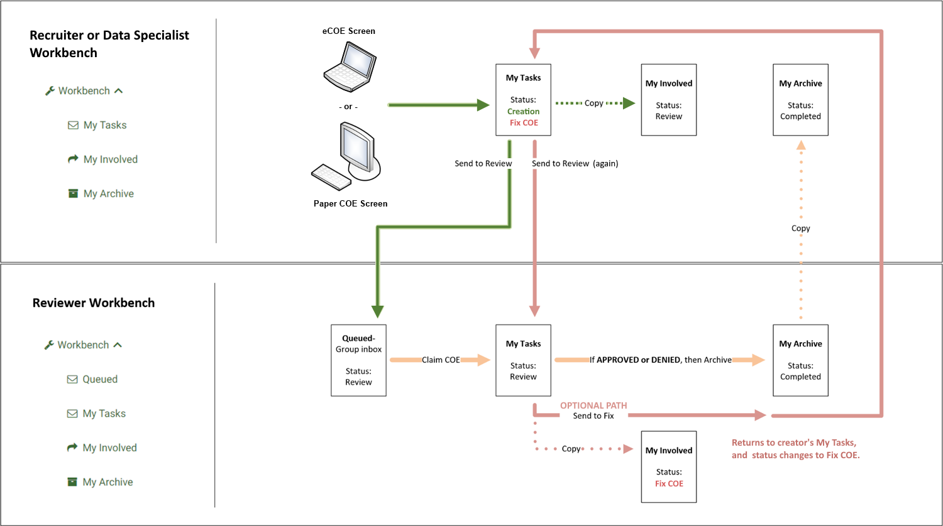
Reviewers may initiate the Fix COE workflow at their discretion. They can trigger this red loop by using the Next Step drop-down menu to switch the COE’s state from Review to Fix COE, thus moving it from the Reviewer’s My Tasks folder back to the Recruiter’s or Data Specialist’s My Tasks folder (the person who created/entered the COE). At the same time, a copy of the COE is retained in the Reviewer’s My Involved folder, and the MSIN application automatically sends an email notification to the Recruiter or Data Specialist. Since the Fix COE workflow is only used on occasion, email notifications help prompt the relevant Recruiter or Data Specialist to pay special attention to these cases.
Once the Recruiter or Data Specialist has made the corrections or clarifications requested by the Reviewer, they can return the COE directly to the Reviewer’s My Tasks folder by using the Next Step drop-down menu to switch it from Fix COE back to Review state. This will also trigger a new email notification for the Reviewer, so they can prioritize the fixed COE and finish the verification process.

Fix COE email notifications
The email notifications feature warrants a closer look, using examples. When the Reviewer returns a COE to the Recruiter or Data Specialist who entered it, that person will get an email from the MSIN system. For example, suppose that Jose Valencia (Reviewer) returned a COE to Ramon Sosa (Recruiter) for corrections. Ramon’s email would look like figure 30.
Figure 30: Recruiter Notification
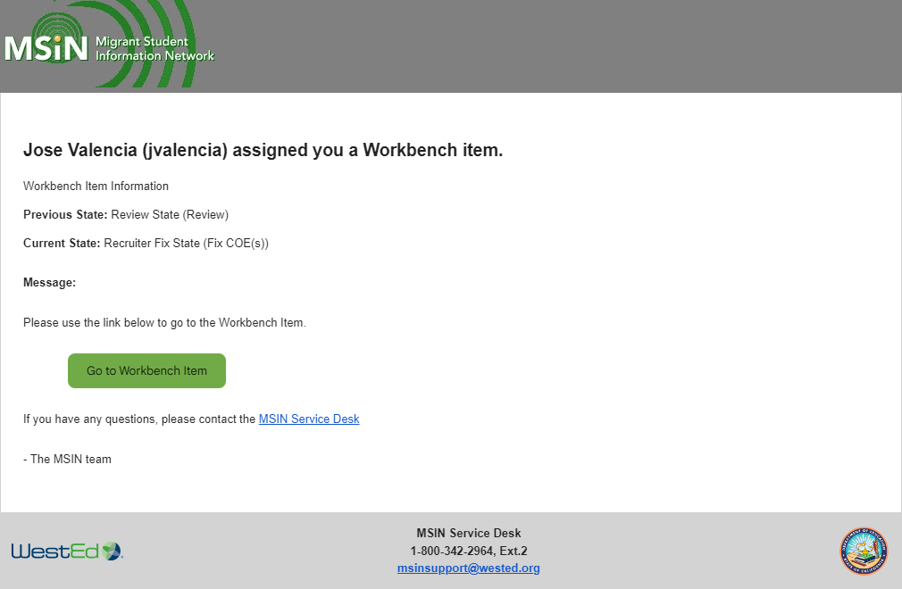
Ramon would click on the green button labeled Go to Workbench Item to open his COE, which is now in his My Tasks folder. Ramon would make the requested correction(s) and then send his COE back to the Reviewer, Jose.
Once sent, Ramon’s COE would move back into Jose’s My Tasks folder. Jose would simultaneously receive an email, as shown in figure 31.
Figure 31: Reviewer Notification
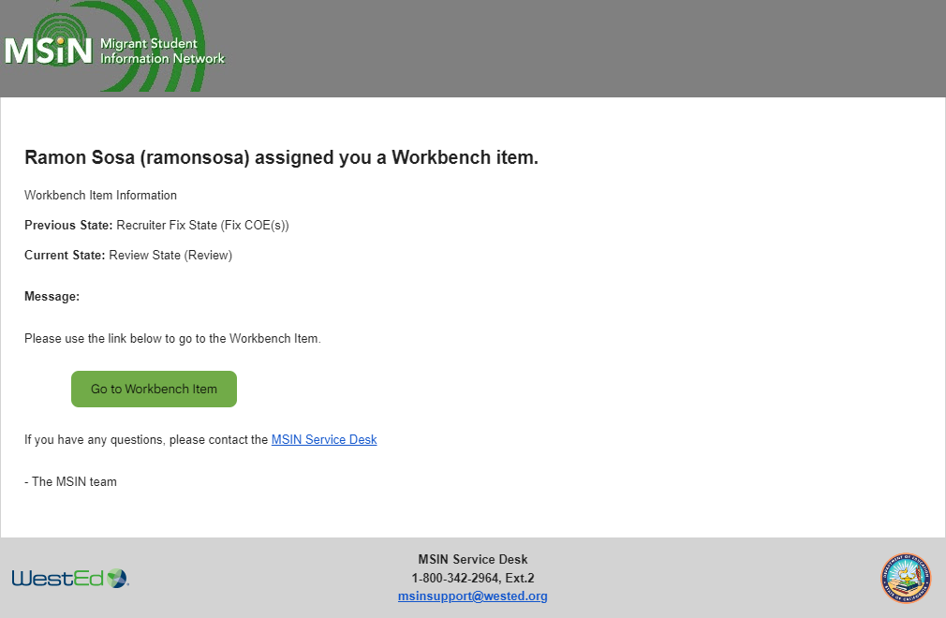
Jose would either click on the green button to continue verifying Ramon’s COE, or he could open it directly from his My Tasks folder. Either way, the email notification serves as a prompt to continue this work as soon as possible, given the delay caused by the initial return for corrections.
This sequence raises the question of how Recruiters should actually make corrections or clarifications on their returned COEs. The following section provides a general overview of this topic.

Fix COE edit page
Even though Reviewers do not work directly on the Fix COE page, they may find it helpful to have a broad understanding of the Recruiter’s tasks. For example, suppose one of Ramon Sosa’s eCOEs was returned for corrections by a different Reviewer named Sandy Cruz. Ramon can always access the COE from his Workbench. Figure 32 shows the steps to open a COE in Fix COE state, starting with clicking on My Tasks (arrow 1).
Figure 32: My Tasks, Fix COE Workflow
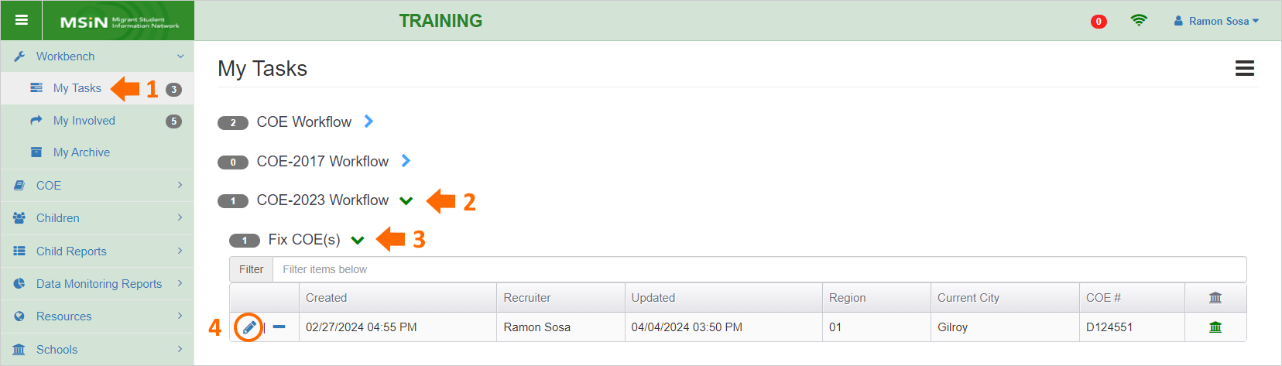
The COE Ramon wants to open is under the COE-2023 version heading (arrow 2) and under Fix COE(s) status (arrow 3). Next, he would click on the pencil icon (circle 4) to open the COE in a special editing page that has two tabs, as shown in figure 33.
Figure 33: Tabs in Fix COE Page
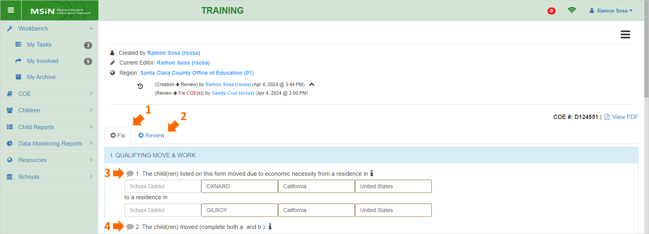
The first tab, Fix (arrow 1), is used to make changes. The second tab, Review (arrow 2), shows an exact copy of the COE Review page that Ramon’s Reviewer (Sandy Cruz) used to evaluate his eCOE. The second tab is there for transparency, but Ramon will stay on the Fix tab to complete his edits.
Before moving on to the editing process, it may be helpful to summarize the differences Ramon is likely to notice on this page. First, there is a workflow summary along the top. It shows the name of the eCOE creator (Recruiter) and the current editor. In this case, because the Recruiter (Ramon Sosa) is fixing his eCOE, the name is the same. Below that, Ramon will also see the eCOE’s transition history. It shows the name, date, and time for the first transition, from Creation to Review state. Next, it shows when Sandy Cruz (Reviewer) sent the eCOE back to Ramon (Review to Fix COE state).
In addition, within the Fix tab, notice the grey callout icons next to items 1 and 2 (arrows 3 and 4 above). As covered earlier in this guide, the Review page has callout icons next to each item or section, and these same icons are visible on the Fix COE page. For example, suppose that Sandy added a request in Section 1, item 4. The icon in front of item 4 would look like figure 34.
Figure 34: Callout Icon, Item 4
Because it now has content, the icon is red, and it shows a count of the notes within. This example means that there are two notes related to the qualifying work fields. Clicking on the red icon (arrow below) will allow Ramon to read the Reviewer’s note(s) and respond, if needed. Figure 35 shows example notes within the callout icon.
Figure 35: Example Notes in Callout Icon
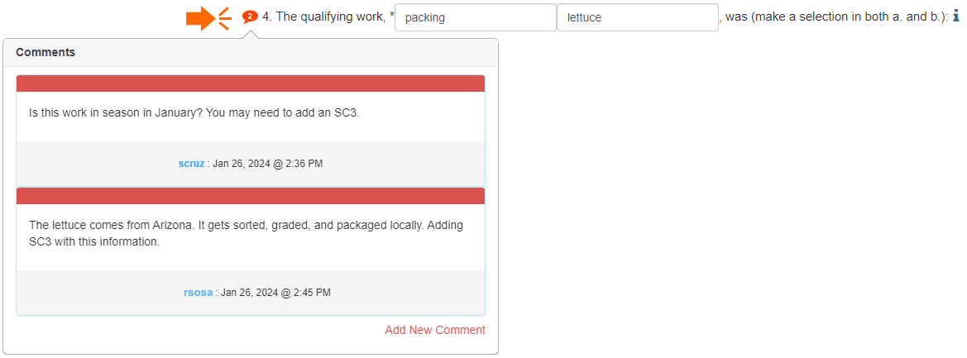
These specific comments are only for illustrative purposes, but they should convey that concise notes are preferred, both from the Reviewer and the Recruiter. Furthermore, a requested edit may not always require a response; it might be enough for the Recruiter to simply fix the issue and send the COE back to the Reviewer for approval.
In general, making any requested edits is straightforward because the fields in the Fix tab are the same as the original COE. However, since COEs are legal documents, making any substantive change(s) in eligibility-related information will require new signatures from the original signer (parent/guardian, self-qualifier, or spouse). The Fix tab, therefore, includes pop-up warnings to remind Recruiters that if they edit certain fields, known as protected fields, this will erase existing signatures and force them to obtain new ones.

Fix COE protected fields
The fields in figure 36 are highlighted to show which COE fields are protected in the Fix tab. The areas highlighted in yellow are protected fields, which cannot be edited; otherwise, the application erases the signature areas, and the Recruiter will need to get new signatures from the Interviewee. The areas highlighted in blue are also protected, but more flexible. Blue fields allow Recruiters to change existing content without affecting signatures; but adding new content in a previously blank field, or fully deleting existing content, will erase signatures.
Figure 36: Protected Fields
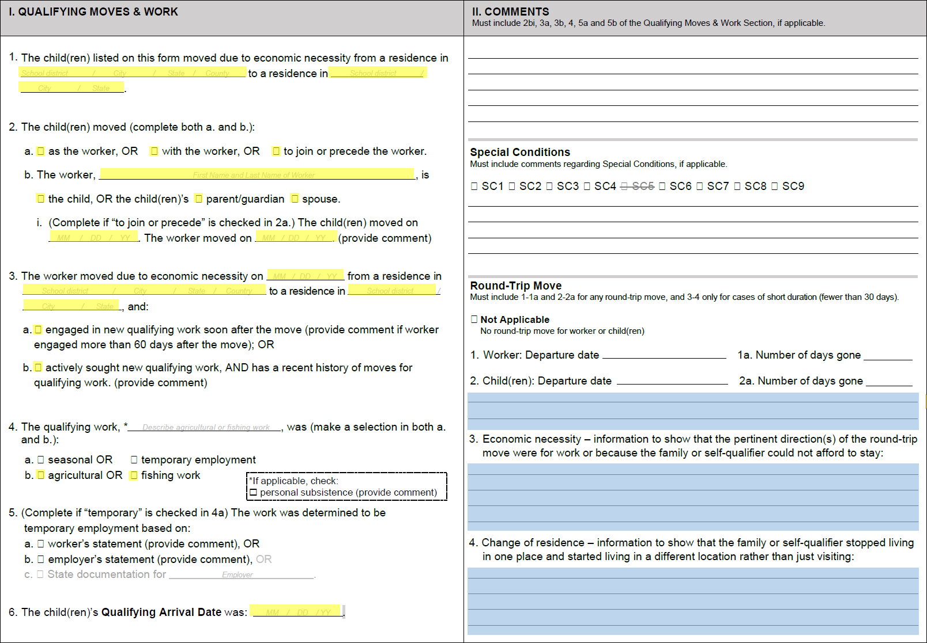
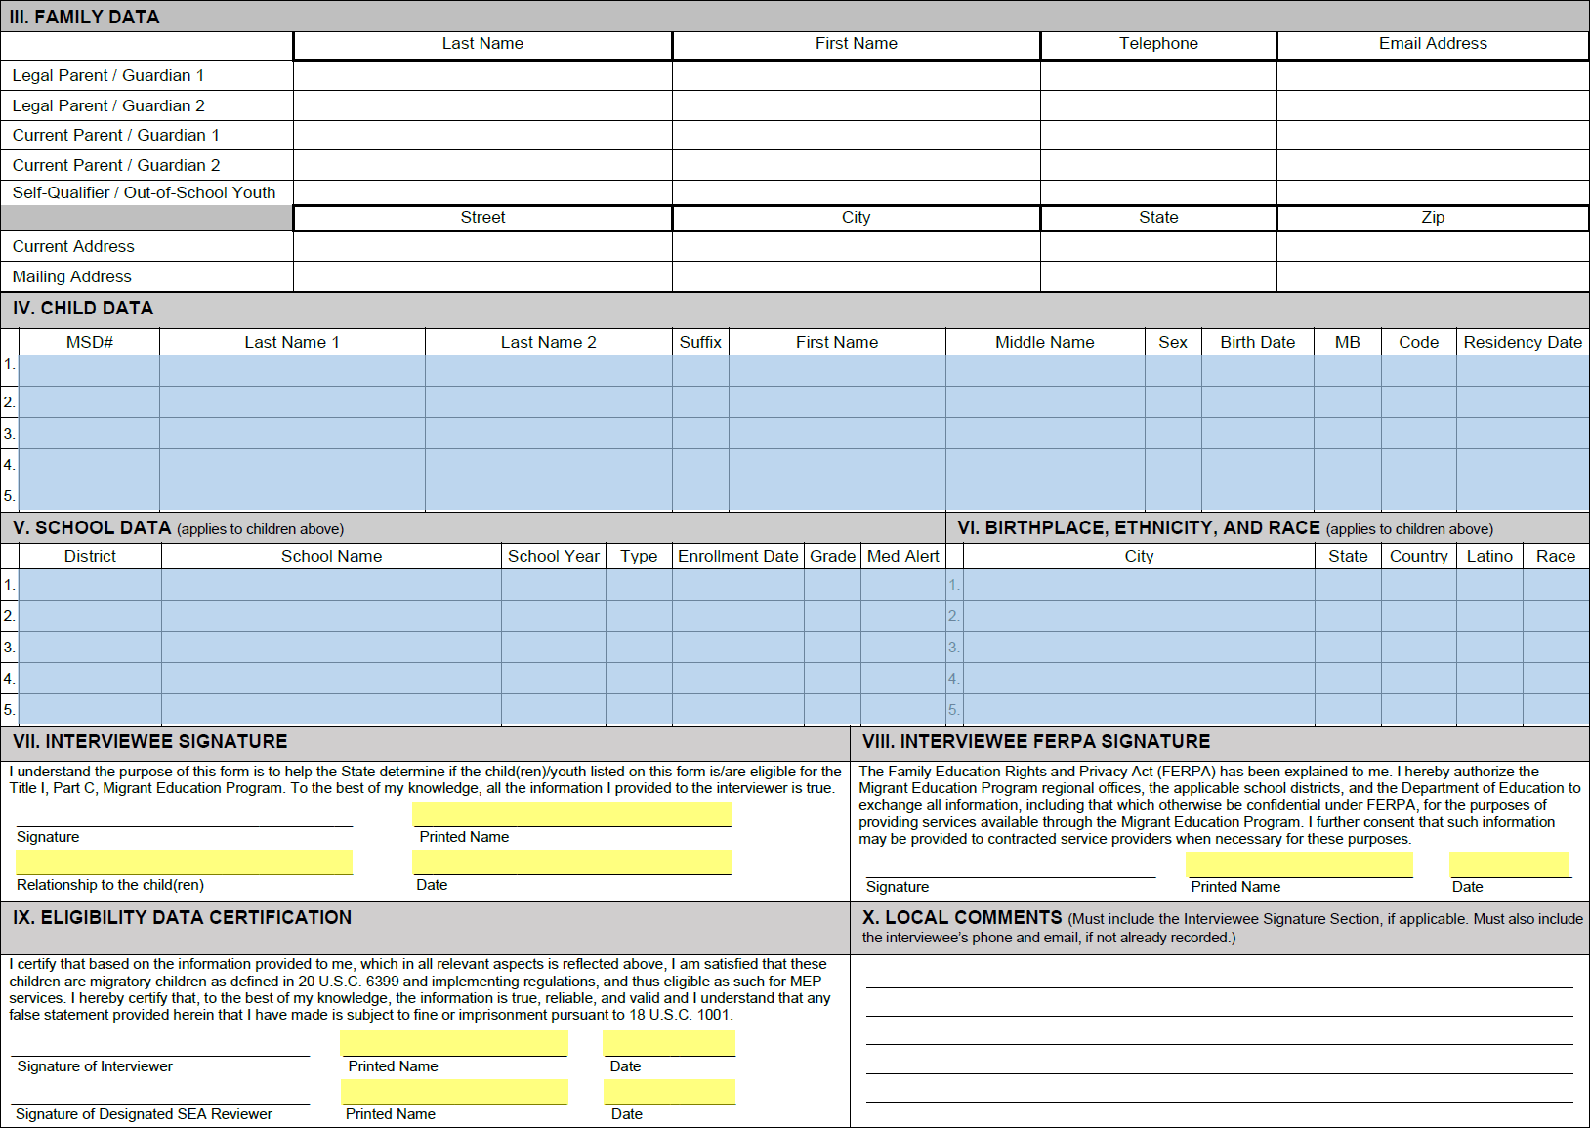
To recap, there will be situations when a minor clarification is enough (edits in unhighlighted or blue fields) and others where significant changes are needed (edits in yellow fields), including new signatures, depending on the correction or clarification the Reviewer requested from the Recruiter/Data Specialist. The protection features embedded in the COE forms are meant to allow flexibility while safeguarding the integrity of the eligibility-related data.
Returning to the example above (figure 35), Ramon would make the edits that his Reviewer (Sandy) requested, such as adding a new Special Condition 3 (SC3) comment. Since this is not a highlighted field, the change would not require new signatures. Ramon would simply double-check the COE and send it back to Sandy for final review and approval.

My Data Entry + Review workflow
MSIN users with the Recruiter or Data Specialist role, who also have the Reviewer role, can access one more workflow that only applies to the Paper COE (not eCOE). This workflow allows a Reviewer (with the Recruiter or Data Specialist role) to enter a Paper COE and then immediately review it themselves, as shown in figure 37.
Figure 37: Diagram for My Data Entry + Review
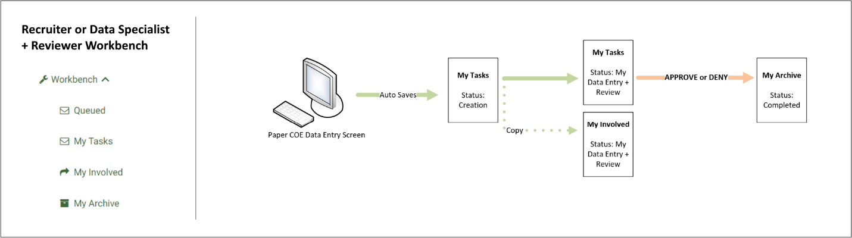
Notice that the Paper COE essentially stays in the same user’s My Tasks folder until it is approved or denied (one of the Completed states). The main idea is to streamline the data entry and review processes by allowing a single user (with the correct roles) to complete all the tasks, from entering the data to approving or denying the Paper COE. However, the MSIN application is hardcoded to prevent any user from reviewing a COE that they created as the Recruiter. This means that a Reviewer can only use this workflow to enter and review a Paper COE that someone else provided to them as a hard copy COE. This rule is meant to prevent conflicts of interest, as the recruitment process must always be separated from the review process.

Additional Resources
As emphasized throughout this guide, Reviewers are encouraged to reference the Help Text in the Review page, as needed. For more in-depth explanations around eligibility concepts or rationales for specific procedures, consulting the I&R Manual is strongly recommended. Furthermore, the California MEP Help Center (https://mephelpcenter.wested.org) stores user guides and helpful training content from past events, such as presentation files and supporting documents. Please use these resources while practicing hands-on in the Training MSIN environment (https://trainingmsin.wested.org), which is also highly recommended. Hands-on practice is especially helpful to new MEP staff, though even experienced staff can benefit from reviewing features they use less often.
For specific questions not covered in this guide, please consult with local supervisors, managers, and experienced colleagues. Any remaining questions or concerns may be submitted to the MSIN Service Desk by email (msinsupport@wested.org) or phone
(1-800-342-2964, option 2).

Going forward, this guide will refer to Designated SEA Reviewers as Reviewers, or “the Reviewer” in specific examples.
The COE instructions in the I&R Manual are found in the California Migrant Education Program Help Center.
Note that reviewing Paper COEs and eCOEs follows the same process, except as indicated in the instructions for Sections VII–IX. With Paper COEs, the Reviewer should also have the hard copy present while performing their review because it is the primary document and the corresponding entry in MSIN must be a faithful copy.
Bolding is used to highlight icons, buttons, tables, and other things that appear within corresponding MSIN screenshots/figures.
The data quality prompts and checks are described in detail within the MSIN user guides for the eCOE and Paper COE, which are posted in the California MEP Help Center.
An independent reviewer can be a CDE consultant, WestEd staff, an Office of Migrant Education (OME) consultant, or any quality assurance designee who is authorized by these entities to review COEs or conduct re-interviews.
Even though the eCOE and Paper COE have embedded guardrails that should not allow a QAD before the worker’s move date, it is best to double check that there are no logical conflicts.
For the defining characteristics of Subsequent Qualifying Moves, please see the I&R Manual and/or training materials from annual I&R training events, as listed in the California MEP Help Center.
For a refresher on who can be a parent/guardian for the purposes of the MEP, please see the Non-Regulatory Guidance, pages 14–15.
There could be extremely rare exceptions. For instance, it is possible to imagine a family with twins where the children have different move histories and therefore don’t appear in the same COE. Or where one of the twins never makes a qualifying move and is therefore excluded from the COE. In these cases, the Reviewer would expect to see a child with MB=Y but the other children, if any, would have MB=N. In short, please consider the recommendations above as general guidelines, with possible exceptions.
When reviewing a Paper COE, the Reviewer should always have the hard copy COE to confirm that information was entered accurately in MSIN (i.e., the information should match in both). The hard copy COE is considered the primary document.
Contact the MSIN Service Desk by email (msinsupport@wested.org) or phone (1-800-342-2964, option 2).
See the I&R Manual for the guidelines Recruiters should follow when using this section, particularly when they add comments regarding remote recruiting exceptions.
This caveat applies to eCOEs that include signatures, but it does not apply to Paper COEs because the signatures are on the hard copy (not in MSIN).
Note that a Recruiter can enter their own Paper COE (based on their hard copy COE), but they must always send it to Review state (never to My Data Entry + Review) because the Reviewer must be a different person.

