Creating Electronic Certificates of Eligibility (eCOE)

Introduction
The purpose of this guide is to provide instructions on using the eCOE pages in MSIN as tools for recruitment. It is assumed that the reader is already proficient in eligibility concepts. In addition, it is also assumed that the reader is already familiar with the COE instructions in the California Identification and Recruitment Manual (I&R Manual). Whereas the I&R Manual covers specific details about what is needed (data types) and why (rationales), this guide focuses on how to use the features found in the eCOE pages.
The target audiences for this guide are MSIN users with the Recruiter role and subgrantee staff, such as supervisors, who train and support Recruiters.
This guide covers the following eCOE topics, specifically for the California COE2024 version:
- Creating a new eCOE
  - Saving form data
- Entering information for Qualifying Moves & Work (Section I)
  - Table: Assistance features in Section I
- Entering information for Comments (Section II)
  - Comments for Special Conditions
  - Comments for Round-Trip Moves
- Entering information for Family Data (Section III)
  - Table: Assistance features in Section III
- Entering information for Child Data, related School Data, and related Birthplace, Ethnicity, and Race (Sections IV-VI)
  - Table: Assistance features in Sections IV-VI
- Entering information for the Interviewee and the Recruiter (Sections VII-IX)
- Entering Local Comments (Section X)
- Saving completed eCOEs
- Understanding the Workbench
  - Overview of eCOE workflows
  - Fix COE email notifications
- Editing eCOEs in Fix COE state
  - Protected Fields
- Using the Copy COE features
- Using System Comments
- Using the eCOE PDF features
- Additional Resources

Creating a new eCOE
To create eCOEs, your account must include the Recruiter role. There are a couple of ways to check this: by clicking on the User Profile link (arrow 1 below) and reviewing the System Role(s) table (arrow 2), and/or by opening the COE menu and looking for the Create eCOE menu item (arrow 3).
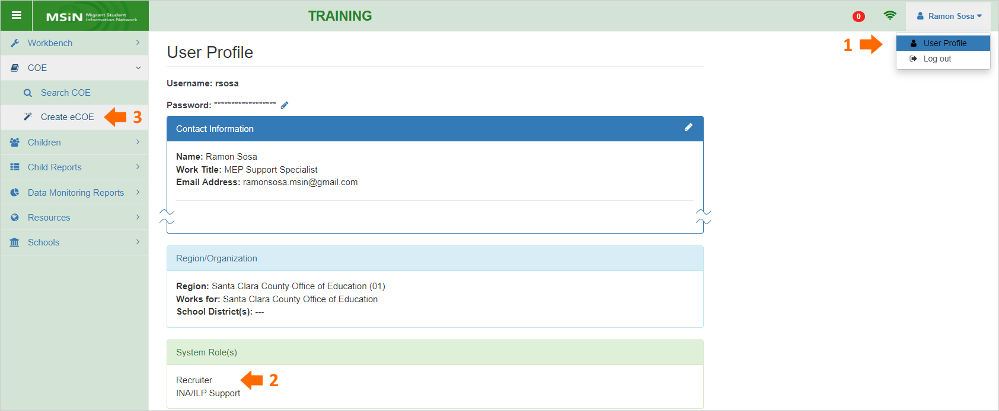
An MSIN user with the correct account setup would see the characteristics shown in the screenshot above.
You can create a new eCOE form by clicking on the Create eCOE menu item. This will load the form and update the eCOE count icon, which is the red circular icon on the top right corner (arrow below) that shows the number of eCOEs currently saved in the browser. For example, the screenshot above shows 0 and the screenshot below shows 1 (after creating a new eCOE form).
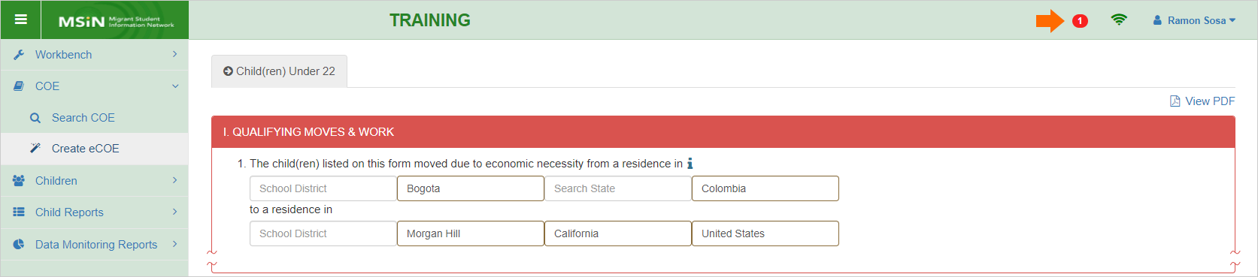
It is important to understand that the eCOE is saving in your browser, on your local computer.
If you navigate to a different page in MSIN and then want to return to your eCOE(s), you can click on the red count icon (arrow above). This will open a page named Local Worksheets, which lists the eCOEs currently stored in your browser. The following screenshot shows one row corresponding to the eCOE we just started above.
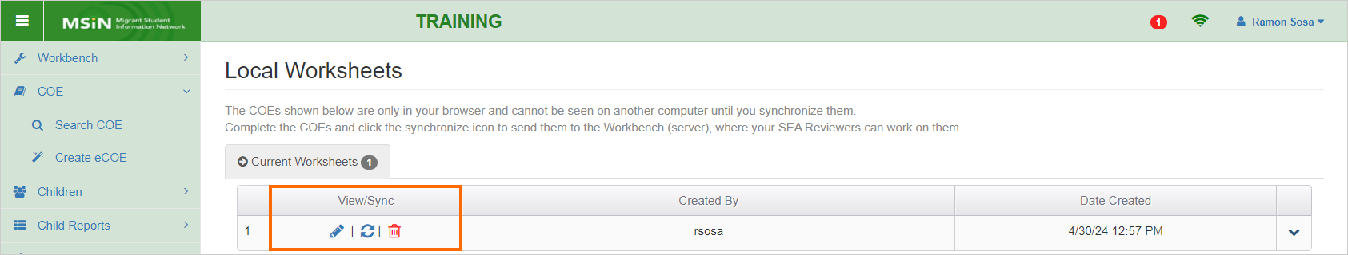
Notice the icons in the View/Sync column (orange box above). They correspond to the following functions:
The pencil icon will load the eCOE form so that you can finish editing it.
The next icon, circular arrows, is for synchronizing (sending) your eCOE from the browser (your local computer) to the Workbench (the database).
Lastly, the trash icon is used to delete your eCOE. Keep in mind that deleting an eCOE from this page is a permanent action.
Recruiters should aim to complete their eCOEs as soon as possible, inputting all the required fields, and then sending the completed forms to the Workbench. Think of Local Worksheets as a temporary location, whereas the Workbench stores COEs permanently in the MSIN database and makes them viewable by your regional or district team. We will cover the recommended process for sending eCOEs to the Workbench later, in the section titled "Saving completed eCOEs.”

Saving form data
Returning to the eCOE form itself, it is important to know how the system saves information. After you enter content in a field, the act of exiting the field triggers the system to save what you just entered. Saving occurs automatically each time you click into the next field or each time you Tab into the next field. You can confirm this is happening by looking for a temporary Syncing message at the top of the page, as shown below (arrow 1).
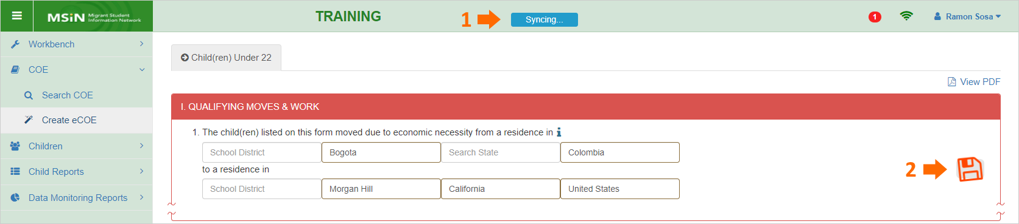
In addition to the automatic saving, you can manually save your work at any time by clicking on the floating disk icon shown on the right edge of the eCOE form (arrow 2). This method re-saves all previous fields in a batch. When using this icon, please pause a few seconds until the Syncing message at the top of the page disappears (to show that saving has finished).
Now that we have covered creating a new eCOE and how saving works, let us continue with the first section of the form.

Entering information for Qualifying Moves & Work (Section I)
The Qualifying Moves & Work section in the California COE2024 is essentially a copy of the corresponding section in the National Certificate of Eligibility. This means that the requested information and the section layout was predetermined at the federal level. However, the digital version in MSIN (eCOE) makes it possible to add assistance features—rules, restrictions, and prompts—that help Recruiters enter high quality data, consistent with eligibility rules, as they progress through the form. Much of the following content describes how the assistance features work in the eCOE.
In addition, as we walk through each section, notice that statements or data elements will often have supplemental Help Text (represented with blue i icons). Help text is meant to define terms and/or provide instructions or reminders.

Move locations
The following screenshot shows the first part of the eCOE, which is based on the hard copy of California COE2024. It begins with the migratory children’s move from and move to locations (arrows below).
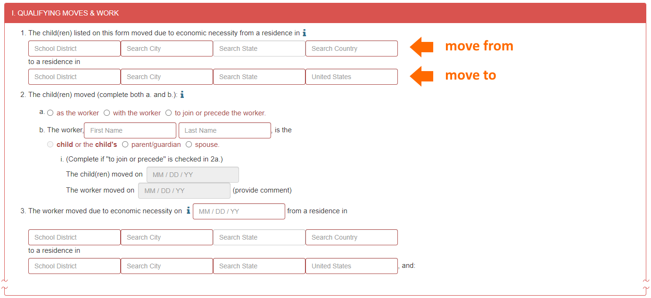
Starting at the top, let us focus on the City, State, and Country fields in items 1 and 3. We will return to the School District fields later, as they are rarely used.
At first glance, it might seem like the City, State, and Country fields are just simple text boxes. But they actually have multiple features. For example, the same set of fields are meant to do two different tasks, as follows:
- Search: Enables Recruiters to search and select City-State-Country combinations that already exist in the MSIN database (this saves time typing each field individually and avoids creating duplicates).
- Create: Allows Recruiters to add new City-State-Country combinations that do not exist in MSIN (such as for a newly formed city).
Given this flexibility, it is important to use these fields as intended, otherwise Recruiters will unintentionally create erroneous or duplicate City-State-Country combinations. Here are the recommended steps to Search for an existing combination:
- Begin by typing in the city field (type 3-5 letters, for example).
- Pause to allow existing combinations to load (these appear in a pop-up window below the city field).
- If the city you want is listed, then select it (this will automatically populate all three fields).
This sequence works most of the time because the MSIN database was initially populated (in 2016) with all known combinations in the United States and popular combinations from Mexico and Canada. For example, to add Dunsmuir, California, as the move from location, you would type the first few letters, as shown here:
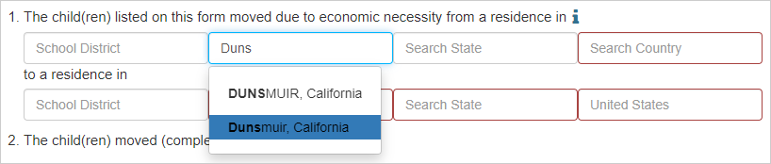
Since the desired City-State-Country combination already exists in the database, the options will populate below, and you can simply select the correct one. In this case, a previous user added the city in upper case as well, but you can select the original mixed case version (blue highlight) for better readability. It is important to always select from the existing options, if possible, because this practice prevents the unintentional creation of duplicates.
If you do not see the city you need, then the same set of fields is used to create a new City-State-Country combination. Here are the recommended steps to Create a new combination:
- Type the new city fully and accurately (double check spelling).
- Pause a few seconds to confirm that the city does not exist in MSIN (no pop-up window below or no matching options below).
- Next, use your mouse to click into the state field and begin typing.
- Pause to allow existing states to load and select the one you need from the pop-up window below the state field.
- If you do not see the state you need, then fully type out the new state and confirm that it is spelled correctly before continuing.
- Repeat steps 3-5 for the country field.
For example, suppose we follow these steps to add the new city of Pioneertown, California, as shown below.
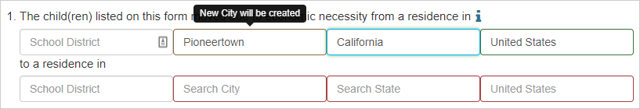
Notice that the application displays an on hover message to indicate that Pioneertown is considered a new city and it will be added to the database. After the COE is fully verified, Pioneertown will appear when searching cities in the future and the next user can simply select it as an option in the pop-up window. This process makes it easy to create missing City-State-Country combinations, but it also makes it easy to add misspelled cities and duplicates. Please take your time to ensure that you are adding new cities intentionally and accurately.
Note: For both searching and creating City-State-Country combinations, we do not use the Tab key. This is because tabbing will actually select the first combination that loads in the city pop-up window, even if it does not get a chance to fully appear. For example, if you type as fast as possible and quickly tab through the fields, this will often lead to unintended selections, spelling errors, and duplicates. This happens because the fields were primarily meant to conduct a search, which involves pausing and selecting among the returned options.
Tip: Recruiters should always try to find an existing City-State-Country combination first (by typing in the city field, pausing for the options to load, and then clicking on the desired city). Any other process can lead to many errors (unintended selections, misspellings, etc.) and duplicates.
Returning to the school district fields, these are only used when the two cities in the location pairs (item 1 or 3) are the same. In this case, which is relatively rare, you must enter information in both school district fields to document moves across school district boundaries. If the system detects missing school district information, then the fields will be outlined in red, as shown in the example below.
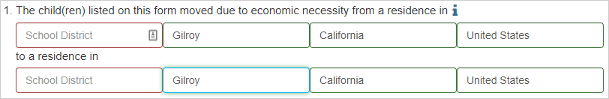
This visual cue is used for other required fields as well. At this point, you must enter different information in the two school district fields.
The location fields in items 1 and 3 also incorporate rules for the state fields in the move from locations, as follows:
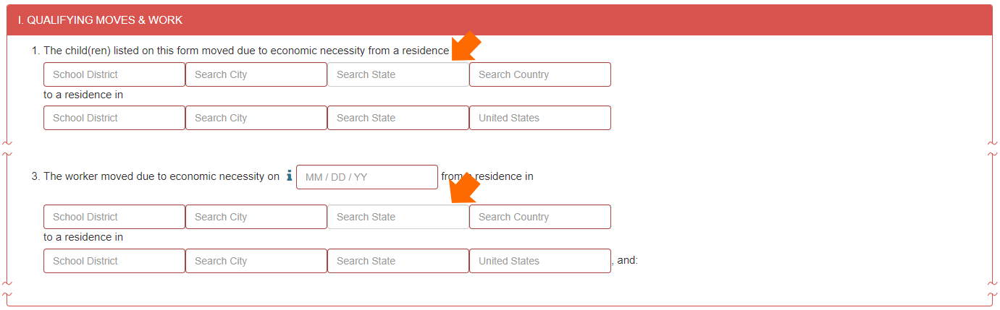
Notice that the state fields in the first row of items 1 and 3 (arrows above) are not outlined in red by default (therefore not required). This is because some move from countries, such as El Salvador, Guatemala, Honduras, and others, do not have states. For these situations, the state field should be left blank. Make sure to remove any unintentionally selected state or abbreviation before continuing. On the other hand, if the move from country is the United States, Mexico, or Canada, the state field is required.
In the second row of items 1 and 3, the move to locations, the country field says “United States” in light text. This is meant to remind Recruiters that only moves arriving to US locations are acceptable, per eligibility rules. The country field is therefore restricted and cannot be overridden with a different country.

Worker options (2a, 2b, and 2bi)
2b has two text fields for the worker’s first and last name. These fields are required and will only accept text input (no digits or special characters). If a worker’s name would normally have an accent or other special characters, please omit them and only enter plain text (Nunez instead of Núñez).
The worker options in items 2a and 2b are represented by radio buttons, and they only allow one selection per item. Furthermore, your selection in 2a modifies which options are available in 2b to prevent logical conflicts. For example, if you select as the worker in 2a (below), this will trigger the application to automatically select the radio button indicating that the worker is the child… in 2b.
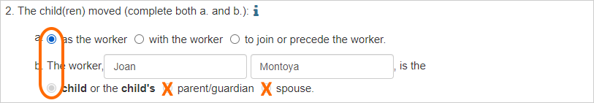
Notice that the other 2b radio buttons are grey and unavailable. Similarly, if you select with the worker in 2a (below), the application will block child… in 2b and make parent/guardian or spouse available to select.
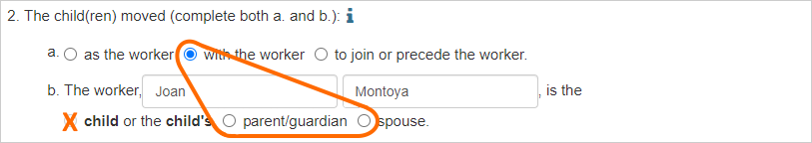
The third option for 2a, to join… (below), also restricts the 2b radio buttons and it adds required date fields in 2bi.
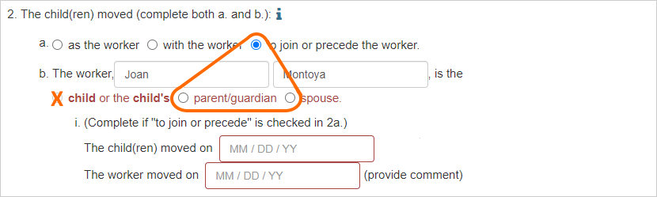
The 2bi date fields are disabled and grey by default. But selecting to join… in 2a will make them active and required.
The to join… option also triggers a pop-up window for you to enter a required comment explaining why the worker and child(ren) moved on different dates, and whether the worker moved from a different location than the child(ren).
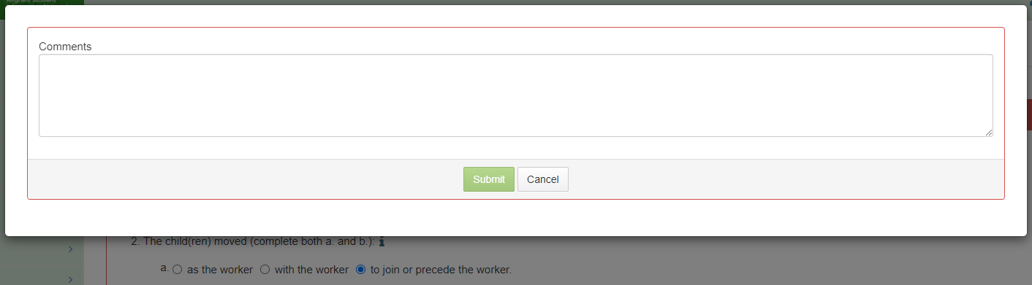
This pop-up window is essentially a prompt. It helps collect required comments and, upon submission, the content is copied into the primary text box in Section II, Comments. This kind of device (pop-up prompt) is used in other parts of the eCOE as well.
To summarize, to join… moves have several parts, and they should be entered in the following order:
- Click the to join… radio button in 2a (triggers a pop-up to collect comments).
- Enter a brief explanation (submit to copy text into Section II; the system adds the “2bi:” prefix).
- Enter the worker’s name.
- Select parent/guardian or spouse in 2b.
- Enter both dates in 2bi.
For more information on what constitutes an acceptable 2bi comment or special instructions for approved exceptions, please consult the California COE instructions chapter in the I&R Manual.

Date fields
Dates are critical in eligibility determinations. The eCOE therefore includes features that mitigate the potential for mistakes when entering dates.
In general, date fields in the eCOE will only accept values going back three years. This is because MEP eligibility rules dictate that qualifying moves must have occurred in the preceding 36 months (from the date of the interview).
Even though they look like generic text fields, when you click on a date field in the eCOE (shown below), this triggers a pop-up calendar window that includes date limits.
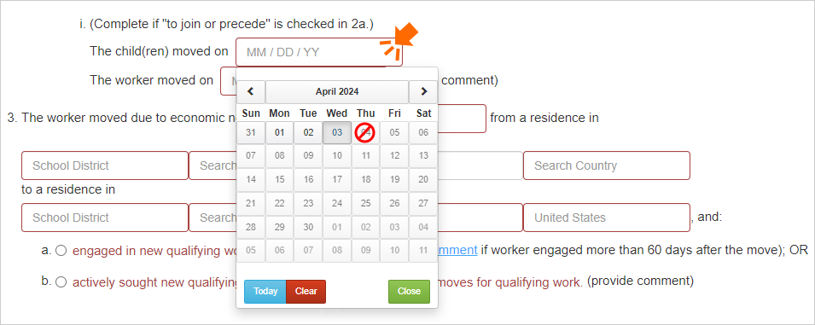
For example, if today is April 3, 2024, as shown in the screenshot, you will not be able to select April 4th. Notice that future dates are light grey and hovering your pointer over them displays a red symbol indicating they are not selectable. Similarly, if you try to enter a date before the preceding 36 months (from the date of the interview), the calendar will not allow it. These features—visually representing dates on a calendar and restricting invalid options—help you avoid errors that could easily occur if you were simply typing dates.
Returning to the pair of dates in 2bi, you should confirm that they are within 12 months of each other, in addition to being in the preceding 36 months. If the 2bi dates are beyond 12 months of each other, and you and your supervisor agree there is a special circumstance, then you should follow the California Department of Education’s (CDE) protocol outlined in the I&R Manual. If the case is approved as an exception by the CDE, then comments are required. MSIN does not automatically restrict the date range because exceptions are sometimes allowed. Please consult the I&R Manual for more details.

Worker qualifying move (3, 4, 5)
A core eligibility definition is that a migratory worker is someone who makes a qualifying move (due to economic necessity, from one residence to another, and across school district boundaries) in the preceding 36 months. In addition, a migratory worker must have engaged in new qualifying work (seasonal or temporary work in agriculture or fishing). Item 3 collects the worker’s qualifying move date, using the same features described earlier (calendar with date limits) and the move from and move to locations, with the same restrictions described earlier.
Furthermore, item 3 includes a pair of radio buttons, 3a and 3b, that require one selection but not both. Per COE instructions in the I&R Manual, you should select 3a when the worker engaged in new qualifying work within 60 days of moving. If the worker engaged in new qualifying work more than 60 days after moving, and the CDE has approved the reasons for the exception (following your submission per the protocol in the I&R Manual), then you should click on the comment link to trigger a pop-up comments window. This pop-up window is visually the same as the 2a: to join… version shown earlier, except that submitting will copy the content in Section II with a “3a:” prefix.
Conversely, clicking on 3b triggers a large pop-up window with required fields to document that the worker actively sought new qualifying work and they have a recent history of moves for qualifying work.
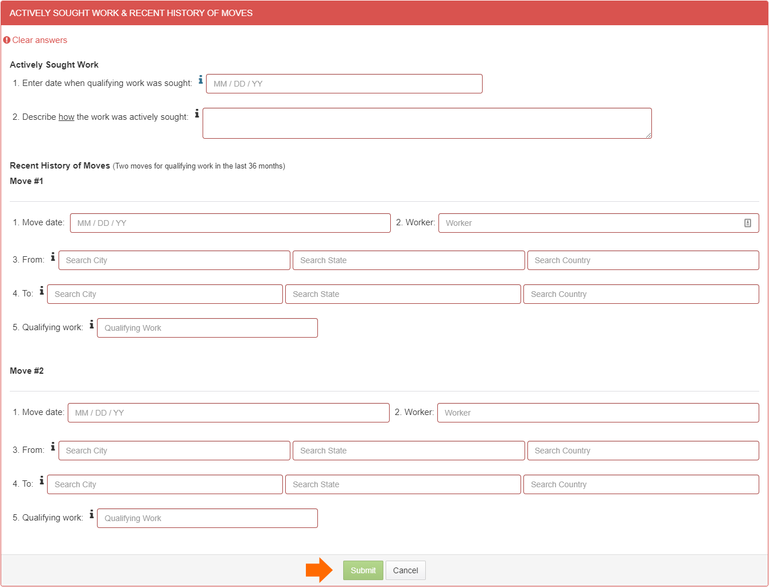
All fields must have content, otherwise the green Submit button (arrow) will remain disabled. After you enter the required information and click Submit, this will copy the content into Section II, Comments. Here is an example to show how the content is labeled:
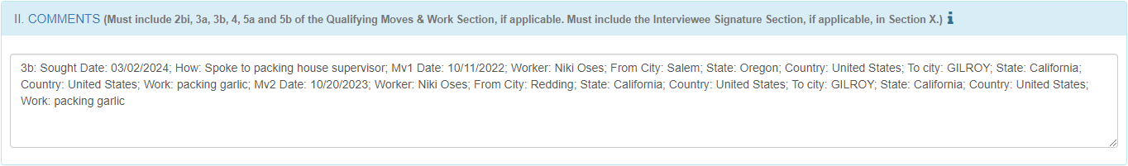
Notice that there is a prefix for the item (3b:) and for each required data element. If any edits are needed, they should be made directly in Section II (as the pop-up window was only a prompt to collect the necessary information).
In contrast, if you start entering information in the 3b pop-up window and then decide to Cancel, this will trigger the following warning:
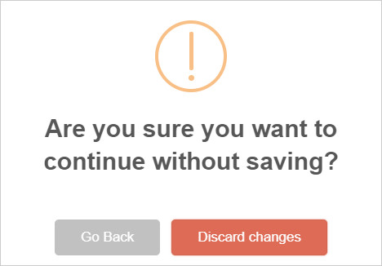
This decision point helps prevent accidental exiting from the Actively sought… pop-up window, which is important because so much information is at stake, and you would not want to lose it by mistake. Clicking Go back (grey button) will therefore return you to the pop-up window so you can continue entering the required information.
Clicking Discard changes (red button) will close the pop-up window and remove the 3b radio button selection. This is because 3b should not remain inadvertently selected, yet without the required content.
Item 4 has two text fields for the qualifying work, consisting of an activity (verb) and a crop or animal (noun). These fields are required and will only accept text input (no digits or special characters). For more details on acceptable qualifying work information, please see the I&R Manual.
4a consists of a binary decision regarding seasonal or temporary work and 4b requires a decision about agricultural versus fishing work. These radio button options are straightforward, except one. If you select temporary employment in 4a, then item 5 becomes active and required, as shown below.
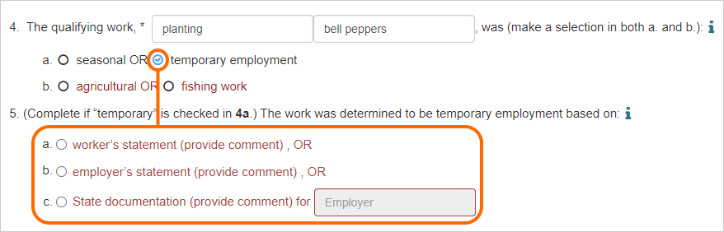
Clicking on 5a, 5b, or 5c will trigger a pop-up window to collect notes and, upon submission, the notes get copied in Section II, Comments, with a prefix corresponding to the selected radio button. Please see the I&R Manual for details regarding temporary employment options, including examples of acceptable comments.
To the right of Item 4b, there is an optional checkbox to indicate that the new qualifying work was for personal subsistence. If checked, this will trigger a pop-up window to collect notes; upon submission, the notes get copied in Section II, Comments, with a “Personal subsistence:” prefix. Because these cases are rare, we strongly recommend reviewing applicable scenarios with your supervisor, consulting the I&R manual for specific instructions, and possibly submitting your case for review by the CDE if you have any remaining doubts.

Qualifying Arrival Date (6)
The Qualifying Arrival Date, or QAD, is critical because it marks the beginning of a migratory child’s eligibility period.
This field (arrow above) has an additional data quality safeguard, on top of the date features we covered earlier. The application will compare the QAD in item 6 with the worker move date in item 3. The QAD must be on or after the worker move date to remain consistent with eligibility definitions. If the QAD is before the worker move date, this triggers the following warning:
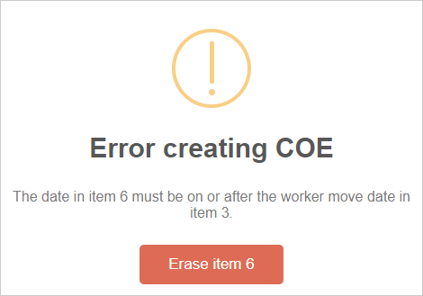
Since there is a date conflict, the QAD will be erased. You must reevaluate both dates, the worker move date and the QAD, to determine which one you will correct.
As demonstrated above, Section I is densely packed with assistance features that help ensure high data quality. This is especially important because key eligibility information is documented in this section and many items are also Minimum Data Elements (MDE) that MSIN submits to the national migratory child data system, the Migrant Student Information Exchange (MSIX). For easy reference, the most important data quality features are summarized in the table below.

Table: Assistance features in Section I
Item or field | Rule, restriction, or prompt | Purpose
Item 1 | The children’s “move from” location is always required and consists of the city, state, and country fields. Note that the state field is optional for countries without states but becomes required if the “move from” country is the United States, Mexico, or Canada. | Helps ensure the children’s qualifying move is correctly documented
Item 1 | The “move to” country must always be the United States (cannot be another country). | Helps ensure alignment with eligibility rules
Item 1 | If the “move from” city is the same as the “move to” city, then both school district fields become required. | Helps ensure the move is across school district boundaries
Item 2a | The user must select a radio button (required field). | Helps prevent omissions
Item 2a | Clicking the radio button for “as the worker” triggers the application to select “child” in 2b and disables the remaining radio buttons (parent/guardian and spouse). | Helps prevent illogical 2a and 2b combinations
Item 2a | Clicking the radio button for “with the worker” triggers the application to disable “child” in 2b and the user must select one of the remaining radio buttons (parent/guardian or spouse). | Helps prevent illogical 2a and 2b combinations; a self-qualifier is no longer possible
Item 2a | Clicking the radio button for “to join or precede the worker” triggers a pop-up text box and, upon submission, its input gets copied into Section II with a “2bi:” prefix. Also, the application disables “child” in 2b and the user must select one of the remaining radio buttons (parent/guardian or spouse). Lastly, selecting “to join or precede the worker” makes the date fields in 2bi active and required. | Helps prevent illogical 2a and 2b combinations; ensures that “to join or precede” moves include related dates and comments
Item 2b | The worker first name and last name are always required, and the fields only accept text input. | Helps prevent errors and omissions
Item 2b | The user must select a radio button (required field). | Helps prevent omissions
Item 2bi | The date fields are disabled by default and only become active and required when the radio button for “to join or precede the worker” is selected in 2a. Both date field calendars go back only 3 years from today’s date (i.e., if today’s date is 11/29/23, no further back than 11/29/20). Also, the calendars do not allow future dates. | Prompts the user to provide required inputs; ensures alignment with eligibility rules
Item 3 | The worker move date is always required. | Helps prevent omissions
Item 3 | The calendar goes back only 3 years from today’s date (interview date), and it does not allow a future date. | Helps ensure alignment with eligibility rules
Item 3 | The worker’s “move from” location is always required and consists of the city, state, and country fields. Note that the state field is optional for countries without states but becomes required if the “move from” country is the United States, Mexico, or Canada. | Helps ensure the worker’s qualifying move is correctly documented
Item 3 | The “move to” country must always be the United States (cannot be another country). | Helps ensure alignment with eligibility rules
Item 3 | Either 3a or 3b must be selected, but not both. | Helps prevent omissions and contradictions
Item 3a | Clicking on the optional “comments” link triggers a pop-up text box and its input gets copied into Section II with a “3a:” prefix. | Copies comment in the appropriate location, with the correct prefix
Item 3b | Clicking the 3b radio button triggers a pop-up window with prompts to collect all required fields for this option. If fully complete, the user can submit the input into Section II with a “3b:” prefix. Canceling the modal will clear the 3b radio button. | Reminds user of the required fields; copies comment in the correct location; prevents accidental 3b selections
Item 4 | The activity and crop/animal are required fields, and they only accept text input. | Helps prevent errors and omissions
Item 4a | Either “seasonal” or “temporary employment” must be selected, but not both. | Helps prevent omissions and contradictions
Item 4a | Clicking “temporary employment” enables item 5 and requires one radio button selection (5a, 5b, or 5c). | Prompts the user to provide required inputs
Item 4b | Either “agricultural” or “fishing work” must be selected, but not both. | Helps prevent omissions and contradictions
Personal Subsistence | Clicking the personal subsistence checkbox triggers a pop-up text box and, upon submission, its input gets copied into Section II with a “Personal Subsistence:” prefix. | Copies comment in the appropriate location, with the correct prefix
Item 5 | The radio buttons are disabled by default but selecting “temporary employment” in 4a enables them and makes one selection required. | Prompts the user to provide required inputs
Item 5a | Clicking the 5a radio button triggers a pop-up text box and, upon submission, its input gets copied into Section II with a “5a:” prefix. | Copies comment in the appropriate location, with the correct prefix
Item 5b | Clicking the 5b radio button triggers a pop-up text box and, upon submission, its input gets copied into Section II with a “5b:” prefix. | Copies comment in the appropriate location, with the correct prefix
Item 5c | Clicking the 5c radio button triggers a pop-up text box and, upon submission, its input gets copied into Section II with a “5c:” prefix. | Copies comment in the appropriate location, with the correct prefix
Item 6 | The QAD is always required. | Helps prevent omissions
Item 6 | The calendar goes back only 3 years from today’s date (interview date), and it does not allow a future date. | Helps ensure alignment with eligibility rules
Item 6 | After a date is selected, the application compares it to the date in item 3. If the date in item 6 (QAD) is before the date in item 3 (worker move date), this triggers a pop-up message asking the user to double check the dates. Closing the warning message clears the conflicting date in item 6. Entering a new date triggers the comparison again. The user can only continue if the date in item 6 is on or after the date in item 3. | Helps prevent logical conflicts and ensure alignment with eligibility rules

Entering information for Comments (Section II)
Section II is used to collect comments that support your eligibility determination. The text box under the heading is generally populated via the pop-up windows in Section 1, when applicable. For example, the comments in the following screenshot imply that “to join…” was selected in 2a, which triggered the pop-up to collect 2bi comments. In addition, the Recruiter selected 5a, which triggered the pop-up to collect notes explaining the worker’s temporary work.
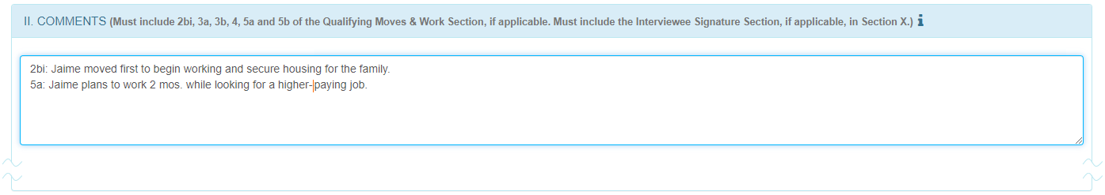
Notice that you can edit these text entries directly to make corrections or add supplemental content, as needed. For more information about appropriate content for this text box, consult the I&R Manual.

Comments for Special Conditions
Section II also includes features specific to Special Conditions (SC). Clicking any of the SC check boxes (with the exceptions of SC5 and SC7, which are disabled) triggers a pop-up window to collect notes.
For example, suppose you want to provide more details about a rare type of qualifying work. You would click on the SC3 checkbox, and this would open a comments window, as shown below.
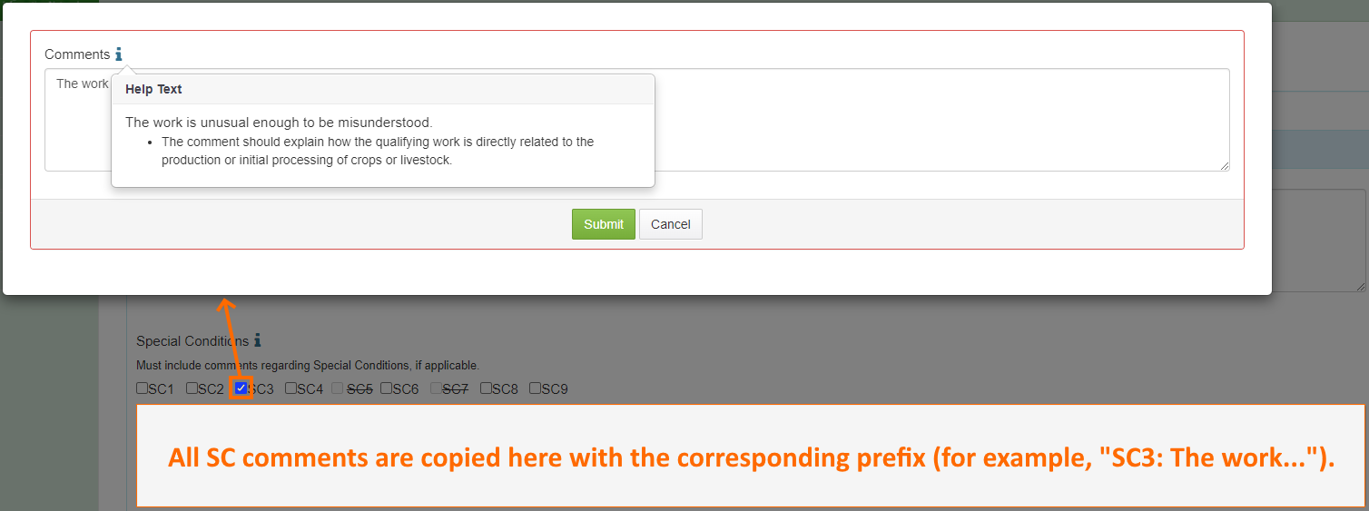
Within the pop-up window, you can click on the blue i icon to consult the Help Text for specific details or reminders. This helps you confirm you are using the correct SC and your documentation is complete.
Like those in Section I, the pop-up windows for SCs are essentially prompts that, upon submission, copy content into the text box below. If any edits are needed afterward, they should be made directly in the text box. Furthermore, if you made a mistake by checking the incorrect SC, you would simply remove the incorrect checkmark and then delete the corresponding notes in the text box.

Comments for Round-Trip Moves
This section is disabled by default, with a checkmark in the Not Applicable option. If a Recruiter determines that round-trip documentation is needed, they should uncheck Not Applicable to enable the section. The first four fields (1, 1a, 2, 2a) are outlined in red to prompt a response, but the embedded rules do not always require all four data elements. The following graphic shows common data element combinations.
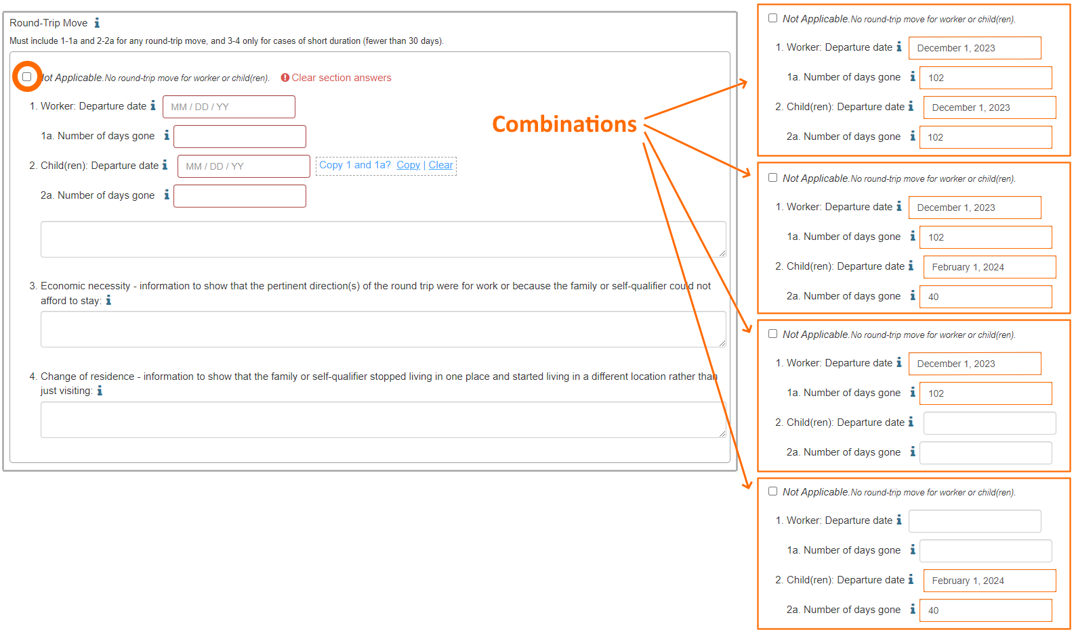
The most common situation is for families to move together (worker and children), including when they make round trips. This would be documented by adding information in all four fields (1, 1a, 2, 2a). To make this a little faster, you can add data in 1 and 1a and then use the blue copy link (Copy 1 and 1a?) to paste the same data into 2 and 2a, as shown in the first combination above.
The remaining combinations correspond to rarer situations. It is possible for the worker and child(ren) to move on different dates, meaning that their number of days gone will also differ, as shown in the second example above. Or the worker can make a round trip without the children, so 2 and 2a would remain blank (third example). Lastly, the child(ren) could make a round trip, but not the worker, meaning that 1 and 1a would remain blank (fourth example). Any of these combinations will satisfy the required field rules and allow you to continue.
The text box below 2a is an optional field used to clarify complex situations. Items 3 and 4, which are also text boxes, are not required by default. But 3 and 4 become required (with a red outline) if 1a and/or 2a are less than 30 days. This is because round trips under 30 days require additional explanations to ensure that eligibility rules are satisfied. For more specific instructions, definitions, and examples, please see the Help Text (i icon) next to each field or refer to the I&R Manual.

Entering information for Family Data (Section III)
By default, the names and contact information fields in Family Data are not outlined in red, meaning they are not required. This is because there is a wide variety of situations and leaving the fields unrestricted provides greater flexibility. For example, some recruitment situations do not require Parent/Guardian information at all, such as when interviewing an emancipated youth. In other situations, only one set of fields is truly applicable, such as for a single parent/guardian or an older sibling who is acting “in the place of a parent.”
However, assistance features were added in this section to prevent inadvertent omissions. For example, if you enter a last name, then the corresponding first name becomes required, as shown below.
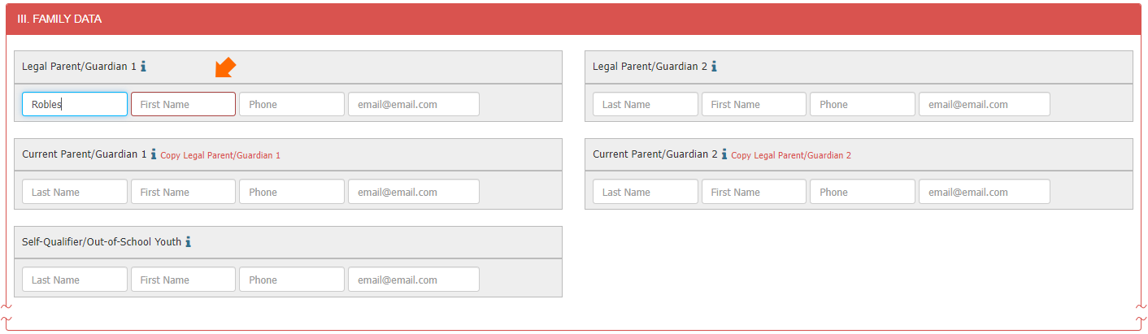
Conversely, if you enter a first name, then the corresponding last name becomes required. These rules prevent incomplete names and apply to the Legal Parent/Guardian and Current Parent/Guardian fields.
Additional rules prevent having orphan contact information, such as phone numbers and email addresses without corresponding names. For instance, if you add a phone number, the name fields become required, as shown below.
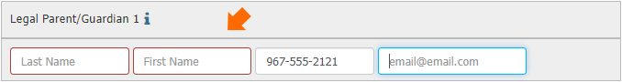
All phone and email entries must be in a standard format. An incomplete email address, for instance, generates the following warning in red text.
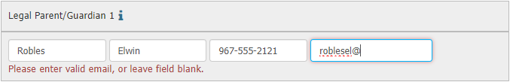
Again, the fields can be left blank if the person does not have the information. But once you begin to enter data, the rules begin to apply.
The fields for Self-Qualifier/Out-of-School Youth have an additional assistance feature. While completing Section I, if you selected “as the worker” in 2a, the system automatically copies the worker names you entered in the 2b fields. This is illustrated below for a self-qualifying youth named Gael Oses.
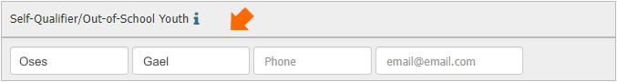
This feature serves two purposes: to align the information in Sections I and III, and to prompt you to add a phone and/or email address for the youth, if applicable.
Next, you must always enter complete current address and mailing address information. The fields for city and state work in the same way as the location searches in Section I. Type a few letters and then select the correct city from the pop-up results table. Note that the current address state will always default to California to ensure logical consistency with eligibility rules (arrow 1 below).
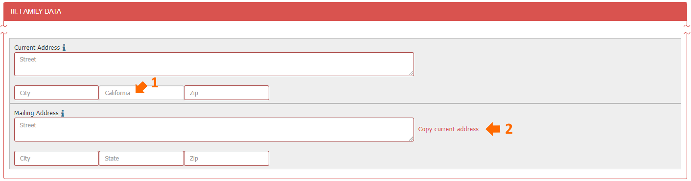
If the mailing address is the same, you can quickly copy the current address using the red link shown above next to the street field (arrow 2). If the mailing address is different or unusual, reference the Help Text or the I&R Manual for specific instructions.
For easy reference, this section’s assistance features are summarized in the table below.

Table: Assistance features in Section III
Item or field | Rule, restriction, or prompt | Purpose
Last Name & First Name | For all persons (Legal Parent/Guardian 1, Current Parent/Guardian 1, etc.), the name fields only accept text. | Helps prevent erroneous input
Last Name & First Name | If one name is entered, then the other becomes required. | Helps collect full names
Phone | Phone fields only accept numbers in a 10-digit format. | Helps collect data in standard format
Phone | If a phone number is added, then the corresponding names become required. | Helps prevent “orphan” information that is not linked to a person
Email | Email address fields only accept standard format (text and/or numbers, followed by the @ symbol and a domain). All domain types (.com, .org, .edu, etc.) are accepted. | Helps collect data in expected format, with less potential for errors
Email | If an email address is added, then the corresponding names become required. | Helps prevent “orphan” information that is not linked to a person
Self-Qualifier Last Name & First Name | When “as the worker” is selected in 2a, the worker names in 2b are automatically copied here. | Helps ensure alignment between sections of the eCOE
Current & Mailing Addresses | All data elements are required. | Helps prevent omissions
Current Address City | Only cities in California are accepted. | Helps prevent illogical inputs
Current & Mailing Address Zip | Zip fields only accept numbers in a 5-digit format. | Helps collect data in standard format

Entering information for Child Data, related School Data, and related Birthplace, Ethnicity, and Race (Sections IV-VI)
The following sections collect child demographic information, school enrollment data, and birthplace data. This information is shown on two tables that have corresponding rows. Each row is numbered and corresponds to one child. The content is organized this way because there is too much information to fit on a single table in the physical COE form. The eCOE mirrors this layout so that Recruiters will find it familiar.
We enter a child’s information by clicking on the first row, as follows:
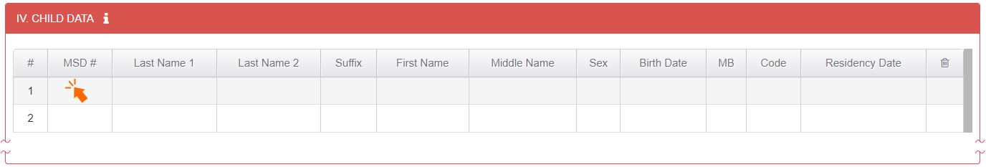
Selecting a row will trigger the following pop-up window that includes search functionality for existing children and school data. This window allows Recruiters to add all the information for a child in one process and then copy it into the tables in the eCOE form.
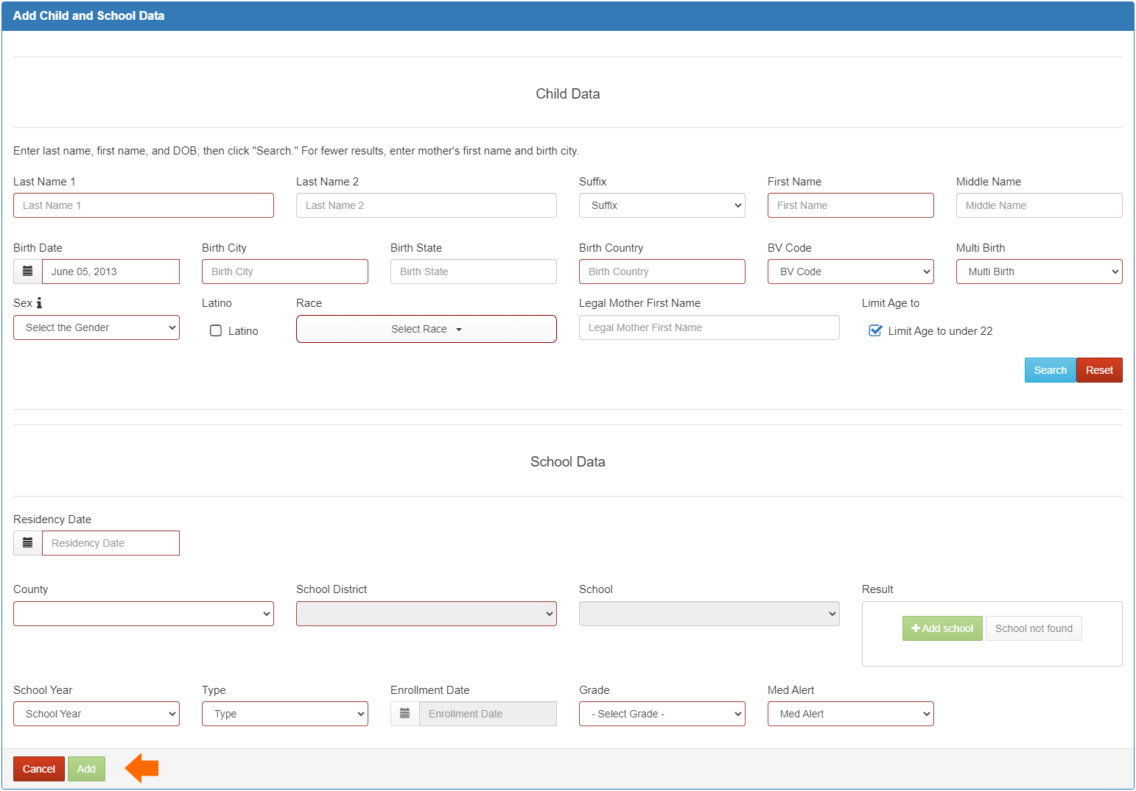
Like the other sections in the eCOE, required fields are outlined in red. In addition, notice that the Add button (lower left corner) is disabled until all required information is fully entered. If you click Cancel, the system will display a confirmation message to avoid inadvertent deletions.
After opening the Add Child and School Data window, the next step is to ask the parent/guardian if their child has been in the MEP before, anywhere in California. If so, or if the parent/guardian is unsure, you should always perform a search and add any existing child record to the eCOE.
The search process consists of entering a last name (arrow 1 below), first name (arrow 2), birth date (arrow 3), and clicking Search (arrow 4) to bring up results, as shown in this screenshot:
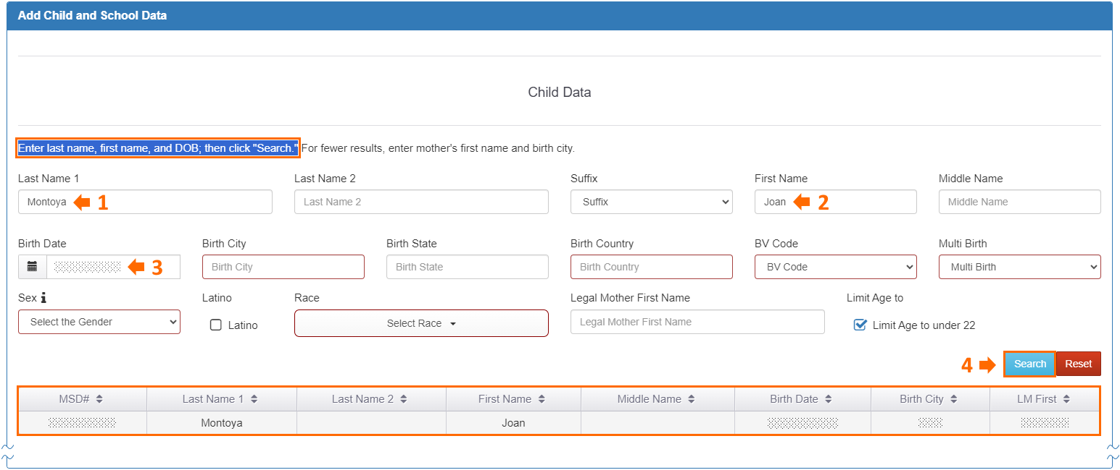
Matching child records will populate in a table below the search button. At this point, you should always confirm key details with the interviewee, such as the child’s birth date and birth location, to ensure you are selecting the correct record. Clicking on a row in the results table will load all the fields in the Child Data section. As a best practice, confirm each data element with the parent/guardian (or the self-qualifying youth) before continuing.
If there are no matches in the MSIN database, you will see the following message: “No Search Results: Please complete the fields above then proceed to School Data.” You can either modify the search parameters and try again, or you can enter new child information by completing the required fields (outlined in red) based on the interviewee’s responses to your questions.
Note that by default the child search is limited to children under 22 years of age (as indicated by the checkbox near the Search button). This helps Recruiters avoid adding youths who are no longer age eligible. Similarly, the birth date field only accepts dates for children under 22 years old, as of the current date.
The birth date field has an additional assistance feature that checks your input against the QAD in Section I. The child’s birth date must be before the QAD to remain consistent with eligibility rules. This helps ensure that children who were born after the qualifying move are not inadvertently added to the eCOE (as they were not present yet to make the move).
The birthplace fields work the same as the City-State-Country fields in Section 1 move from locations, where any country is acceptable, including those without states. As a reminder, you should always search for an existing City-State-Country combination, as follows: enter the first few letters of the birth city, pause to load options, and then select an existing city, if possible. If you do not see the city you need, then the same set of fields is used to create a new City-State-Country combination. Please follow the recommended steps covered earlier in the Move locations section.
For specific information regarding how to determine your selections in the remaining fields (BV Code, Multi Birth, Sex, Latino, and Race) please consult the I&R Manual. In terms of the functionality in the eCOE form, the drop-down fields require a single selection. Race, however, can accept multiple selections when applicable. For example, if a parent/guardian says that their child is both American Indian and White, you would select both options in the Race drop-down menu, as shown here:
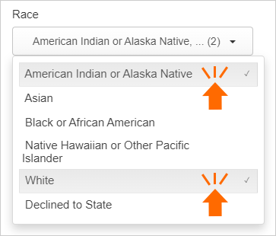
Again, you would follow the instructions and interviewing tools found in the I&R Manual, particularly for the ethnicity and race fields.
The Legal Mother First Name (LM First) field is not a required field; it is for informational purposes only. When you conduct a search, LM First appears in the results table and is meant to help you distinguish between children with similar names. Note that LM First corresponds to the Legal Parent/Guardian 2 field in the child’s record (Demographics tab).

School Data
The School Data section begins with the child’s Residency Date, which is defined in the MSIX MDE list as “the calendar date that the child entered the school district in which they currently reside.” In practice, because school assignments are linked to the family’s address, this date is generally the same as when the family moved into their present address. For example, the most common scenario is for a whole family (parents and children) to arrive in your area to do qualifying work. In this case, the QAD and Residency Dates for the children will be the same as when they arrived in their present residence.
Consider the following screenshot:
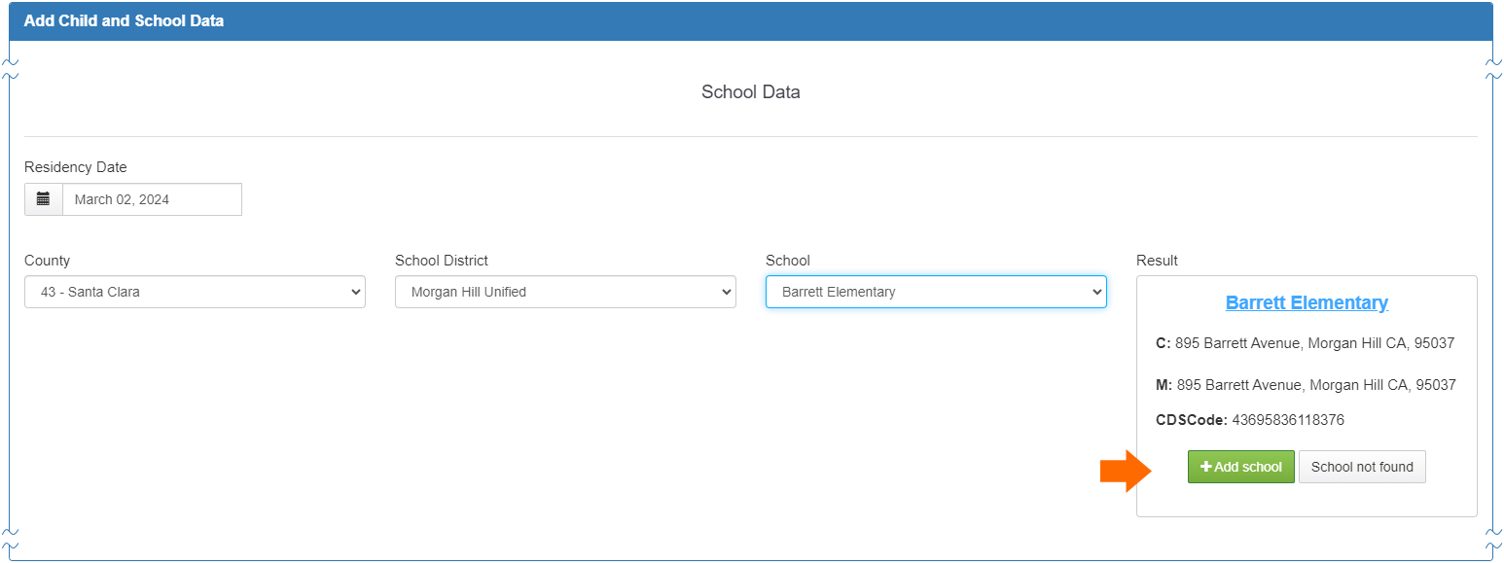
These inputs indicate that on March 2, 2024, the child began living in a residence in your area, which will generally determine where they will attend school. This example shows that the child is enrolled (or will enroll) at Barrett Elementary (part of the Morgan Hill Unified School District in Santa Clara County).
Keep in mind that there are many scenarios that could affect the Residency Date. With the advent of remote learning options, the same caveat applies to your school selection. Consult the I&R manual for additional considerations and examples.
When entering the school information, it is important to understand how the drop-down menus work. First, select a county option and pause for the school district menu to fully populate. Next, select a school district option and pause for the school menu to fully populate. The application needs a few seconds to filter down the options, otherwise you may see too many in the following menu. Once you select a school, you will notice additional information, such as the school’s address, under the Result heading. Click +Add school (arrow above) to confirm your inputs.
If the school you need is not listed in the dropdown, you can create a provisional school, meaning a new school that needs to be added to the MSIN database. Leave the school drop-down blank and click the button labeled School not found. This will bring up the required fields for provisional schools, as shown below (outlined in red):
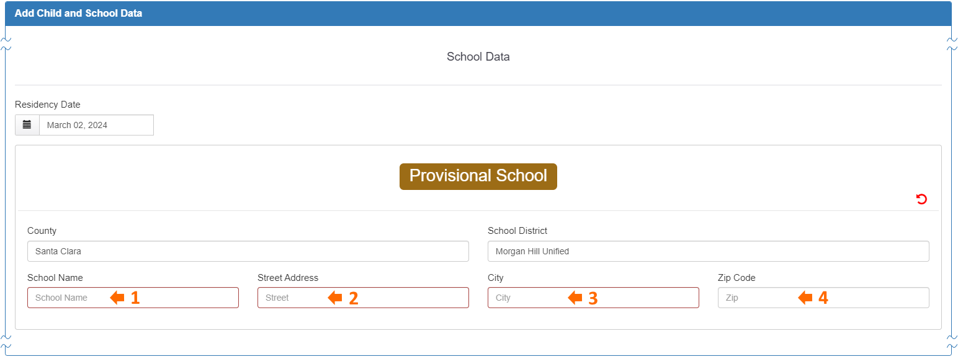
Add the new school’s name and address (arrows 1-4 above). This will allow you to move on to the next fields, which collect enrollment and health data, as shown here:
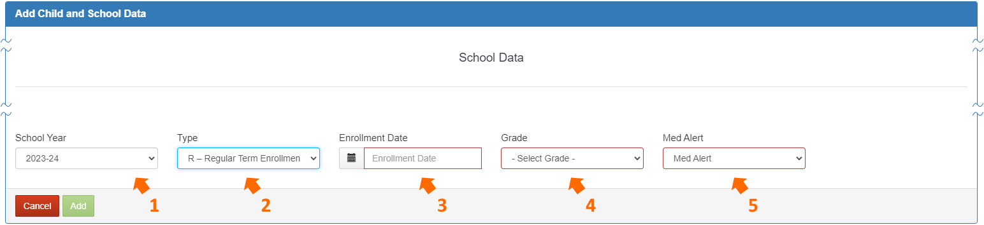
Select the applicable school year based on the date of the interview and the local district calendar (arrow 1). Next, in the Type field, select whether the child is actively enrolled (R-Regular Term Enrollment), or they are non-attending (N-Non-attending) (arrow 2). For children who are currently attending school, always select Type R. In contrast, Type N may apply to multiple scenarios. Use Type N for children who are currently on a school break or who are otherwise not in school for any other reason. Type N also applies to non-attending Out-of-School Youth (OSY), such as those who are “here-to-work” and do not plan to enroll in school.
The following field, Enrollment Date, is disabled by default, as shown in the screenshot below, but becomes required if you select R-Regular Term Enrollment (arrow 3 above). This assistance feature ensures that you only enter applicable data, as non-attending children (Type N) will not have enrollment dates.
Next, you would enter a grade level (arrow 4). For children who are currently attending school (Type R), enter their actual grade level. In contrast, when a child is not currently receiving school instruction (Type N), such as during summer break, enter the grade level they will begin once school starts again. Furthermore, for non-attending children (Type N) who are too young to enroll, select a grade-age level (P0-P5) based on their current age. OSY will also be Type N and their grade will always be NA (for non-attending). If a youth returns to school to receive adult instruction, then they will be Type R, with an enrollment date, and their grade will be AD (for Adult Education).
Note that this is a brief overview of how you would enter school information. To understand the various combinations of school and enrollment data that are possible, consult the instructions for these data elements in the I&R Manual, which includes a helpful table with specific examples.
Lastly, enter the Med Alert code (A-Acute, C-Chronic, N-No identified problem, U-Unknown) that best applies to the child (arrow 5 above). The Add button will become enabled as soon as all required fields are completed, as shown below.
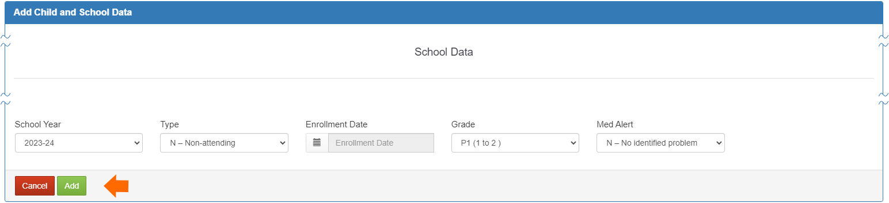
If you click Add, this immediately copies all the data in the window to the corresponding fields in the eCOE tables, Sections IV-VI.
In contrast, if you click Cancel, either by mistake or because you decided not to include the child, this triggers the following warning:
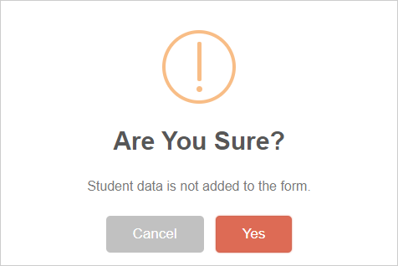
Having this decision point helps prevent accidental exiting from the Add Child and School Data window, which is important because so much information is at stake, and you would not want to lose it by mistake. Clicking Cancel will therefore return you to the previous window so you can continue editing and ultimately add the child to the Section IV-VI tables in the eCOE. On the contrary, if you truly wanted to exit the window without adding the child to the eCOE, you would confirm by clicking Yes (to discard the data).
To summarize, consider the following entries for three fictitious children:
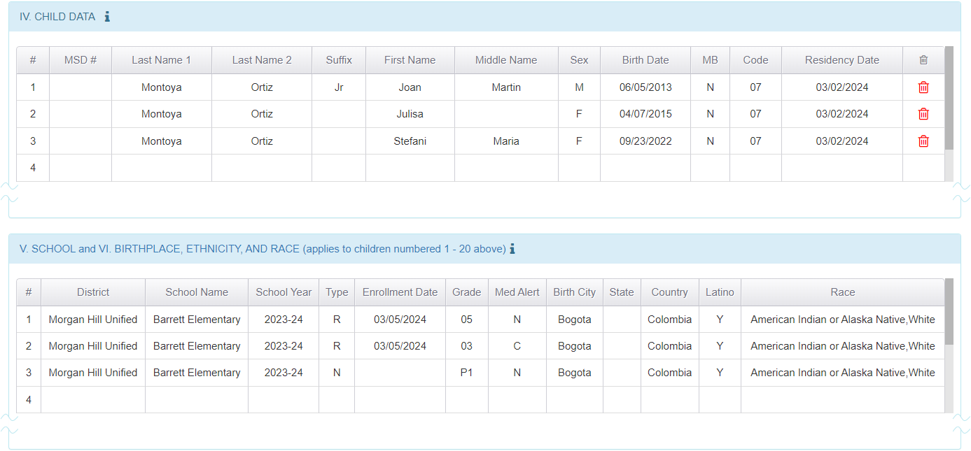
Each child was added one-at-a-time by fully completing the fields in the Add Child and School Data window. In this example, we can tell that all three children are new to the MEP because they do not have Migrant Student Directory (MSD) numbers. Otherwise, when children are added by selecting an existing record (after conducting a child search), their row will include an MSD#.
At this point, the best practice is to review the children’s information again, looking for potential errors and omissions. Any child can still be edited, if needed, by clicking on their row to bring up their Add Child and School Data window again.
If you need to remove a child, click on their trash icon in the final column of the first table (shown above). Again, consequential actions like this will trigger a confirmation warning, as follows:
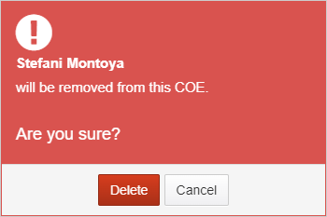
Notice that the warning identifies the child (Stefani Montoya) who will be removed if you click on the Delete button. If so, the third row on both tables, corresponding to Stefani, would be cleared. Keep in mind that this is a permanent action. If you mistakenly confirm the deletion of a child (and their corresponding school data), you will need to re-enter all their information again and re-add them.
For easy reference, the assistance features in the Add Child and School Data window are summarized in the table below.

Table: Assistance features in Sections IV-VI
Item or field | Rule, restriction, or prompt | Purpose
Last Name & First Name | At minimum, a Last Name and First Name are required. Related name information is prompted but optional. | Helps collect full names
Birth Date | A date is required. | Helps ensure alignment with eligibility rules
Birth Date | The calendar only goes back one day less than 22 years from the current date (interview date). | Helps prevent eligibility rule conflicts regarding age
Birth Date | After a date is selected, the application compares it to Section I, item 6 (QAD). The child’s birth date must be before the QAD, otherwise a warning will appear. | Helps ensure that only children who could have made the qualifying move are added to the eCOE
Birth Date | The calendar does not allow a future date. | Helps prevent illogical data
Birth City, Birth State, Birth Country | Birth City and Birth Country are always required, but Birth State is not required for countries without states. | Helps ensure the child’s birthplace is correctly documented
BV Code | A birth verification code is required (MDE 15: Birth Date Verification). | Ensures we collect data elements required for MSIX
Multi Birth | A multiple birth option is required (MDE 11: Multiple Birth Flag). | Ensures we collect data elements required for MSIX
Sex | A sex option is required (MDE 9: Sex). | Ensures we collect data elements required for MSIX
Race | At least one option is required but multiple selections are possible. | Helps collect complex race data
Residency Date | A residency date is required (MDE 70: Residency Date). | Ensures we collect data elements required for MSIX
County, School District, School | A county, school district, and school name are required for enrollment information, corresponding with County-District-School (CDS) codes. | Helps collect complete school information for MSIN and MSIX
School Address, School City | When a new school is added (provisional school), its address (including city) is required. | Helps uniquely identify the school
School Year | A school year is required. | Helps distinguish enrollment lines
Type | An enrollment type selection is required. | Helps convey whether the child is currently receiving instruction
Enrollment Date | If the enrollment type is R, then an enrollment date is required. Conversely, if enrollment type is N, then this field is disabled (no date entry possible). | Helps collect relevant start dates, when applicable
Grade | A grade-age option is required (MDE 42: Grade Level). | Helps ensure we collect complete enrollment data
Med Alert | A medical alert option is required (MDE 46: Med Alert Indicator). | Ensures we collect data elements required for MSIX

Entering information for the Interviewee and the Recruiter (Sections VII-IX)
After you have added the child(ren) and double checked their information with the interviewee, we always recommend returning to the beginning of the eCOE to confirm all qualifying information before you ask the interviewee for their signature. This is especially important because we often have limited time and we may, understandably, rush through the fields. As a result, it is possible that a field or two were inadvertently skipped or they need edits.
The I&R Manual has specific instructions around informing interviewees about the purpose of both signature boxes in the California COE. Here, we will cover the mechanics of entering this information in the most efficient way possible, as shown in the screenshot below.
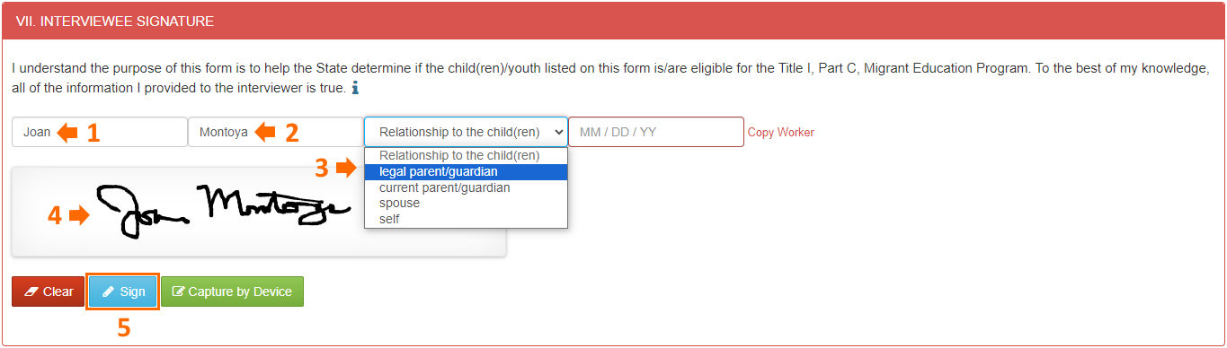
First, type the interviewee’s first and last name (arrows 1-2). Or, if the interviewee is the worker listed in Section I, 2b, you can click on the red “Copy Worker” link to populate the name fields. Next, select an option in the drop-down for Relationship to the child(ren) (arrow 3). At this point you would ask the interviewee to sign in the shaded signature area (arrow 4). This can be done with a mouse, a stylus, a finger on a touch screen, or any other method that leverages your computer’s mouse functionality. Lastly, you would double check that the signature is acceptable and then click Sign to apply it (step 5 above). Clicking Sign will automatically add the current date for you in the remaining field.
Section VIII collects optional, but strongly recommended, signature data. Even though the information is optional, if you add a first name, then a last name will be required, and vice versa. Adding names will also make the date and signature required. These assistance features are meant to prevent “orphan data” that would not make sense on its own but belongs to a set of data elements that make sense together. Since the interviewee’s names were already collected in the prior section, you can click on the “Copy Signer” link to add them quickly, as shown in the first step below (arrow 1).
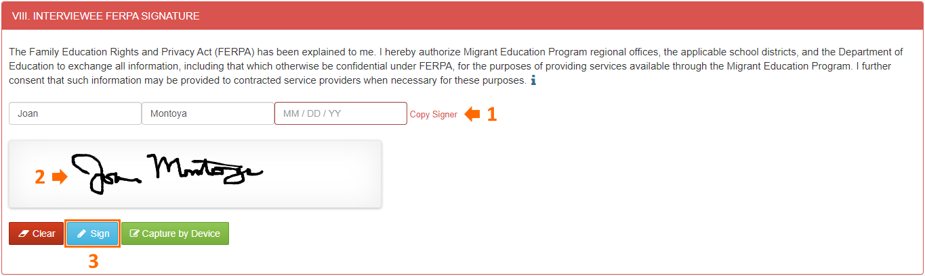
The second step (arrow 2) is to have the interviewee sign in the shaded box. Lastly, the date will populate automatically after you click the Sign button (step 3 above). Notice that this section leverages information from the prior section to help streamline your inputs, minimizing redundant typing and reducing mouse clicks.
Section IX is also set up to require minimal inputs, as shown in the screenshot below.
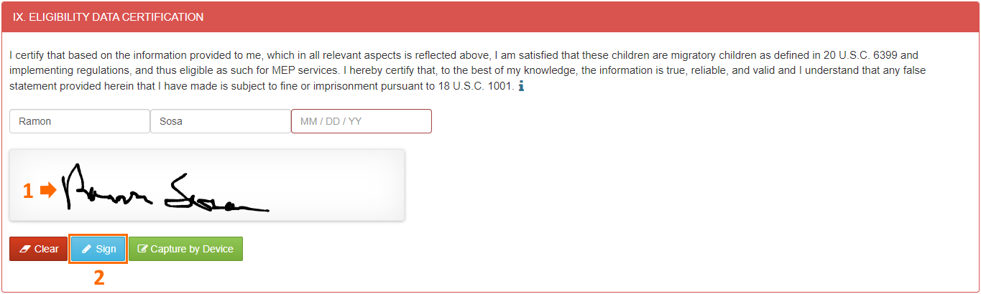
Your first and last name populate automatically based on your login information. Therefore, only two steps remain in this area: 1) enter your signature (arrow 1), and 2) click the Sign button (step 2 above). As in the prior signature sections, the date will populate automatically when your signature is applied.

Entering Local Comments (Section X)
The last section of the eCOE is meant to record additional comments that are not directly related to the Recruiter’s eligibility determination. As shown in the heading below, some details are provided in parentheses, and you can access the Help Text (blue i icon) for even more instructions and/or definitions.
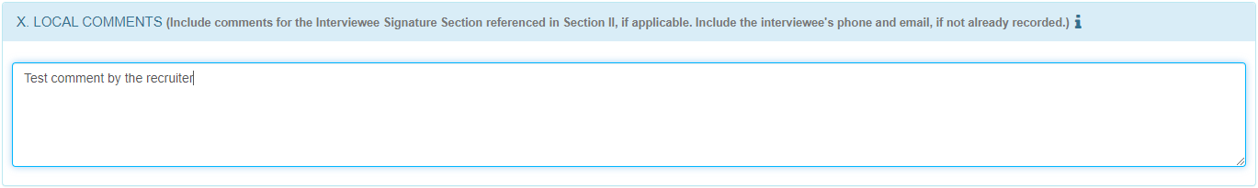
This text box is straightforward and does not include any specific assistance features, other than the spell check functionality which is generally provided by your browser. Consequently, please be careful to use this field only as instructed in official resources, such as the I&R Manual, and as approved by your supervisor(s).

Saving completed eCOEs
Early in this guide, we shared that the information you enter in each field is saved provisionally when you exit the field. Furthermore, you can re-save all prior fields as a batch by clicking the floating save icon on the right margin at any time. When you reach the end of the eCOE form, there is a final save button labeled Save/Check Form, as shown below.
This button triggers a two-pronged process. First, the application walks through the form and evaluates the required fields to ensure they are complete. While this is happening, you will see a “Please Wait” message in the center of your screen. Please pause until the message disappears. Second, the application provides feedback or next steps in a pop-up window.
If one or more required data elements in the eCOE are missing or incomplete, you will see a specific error message directing you to the corresponding field(s). Here is an example error message:
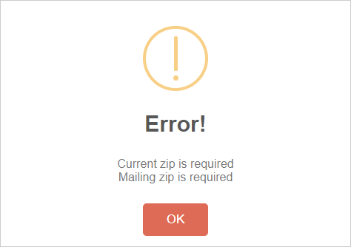
Notice this tells you exactly which fields need attention (current and mailing address zip codes). Every required field produces a unique error message. Clicking the OK button will simply return you to the eCOE form so you can easily find the error and correct it.
On the other hand, if all the required data elements are present, the feedback pop-up will say “Everything seems fine!” and you will need to make a choice regarding the next step. Here is a screenshot showing the two options and the subsequent messages as well.
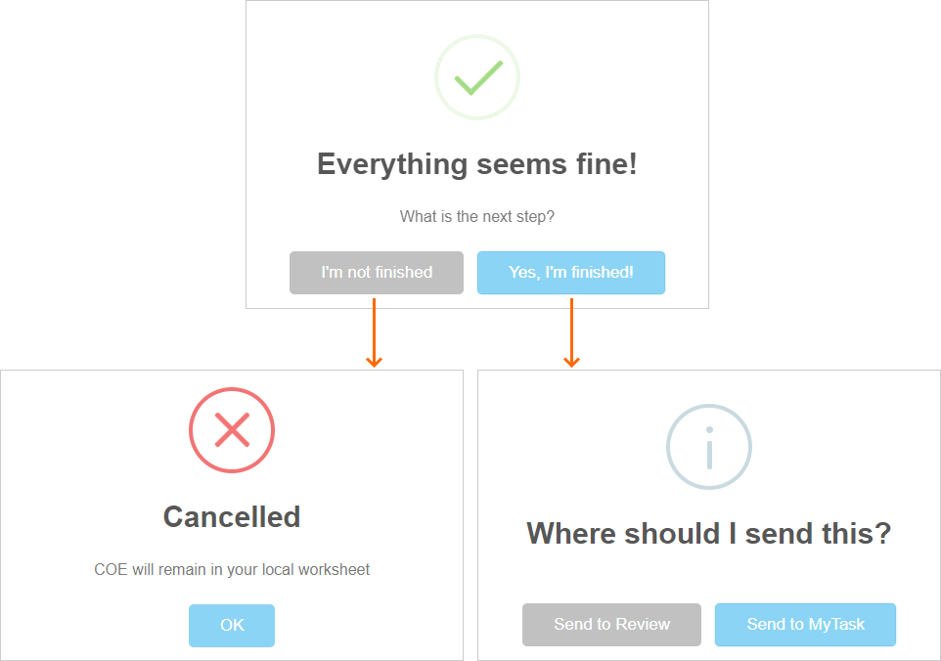
Let’s cover how each option plays out. Generally, when you have finished creating an eCOE and there are no errors pending, it should be sent to Review as soon as possible. But sometimes you may need to delay sending so you can confirm questionable information, especially if you might need to delete the eCOE (since the delete option is only available to you before sending). Or you could be in a situation where your internet connection is unreliable, and you don’t want to risk transmission errors by sending now instead of doing it from your office connection. In these cases, click on the I’m not finished button, and this will cancel the submission process. Canceling will keep your eCOE in the browser so you can send it later, under better circumstances.
Conversely, if you have a reliable internet connection, it is best to send your eCOE directly to the Review process or to your My Tasks folder, which is meant for pending work. Either option moves the eCOE out of your browser and stores it securely in a Workbench folder (in the MSIN database). We will cover the Workbench folders in the next section. For now, it is enough to know that eCOEs you send to Review have been passed on to other staff, whereas eCOEs you send to My Tasks remain on your “to do” list and must be sent to Review later.
For example, suppose Ramon Sosa (fictitious Recruiter) sent an eCOE to My Tasks because he wanted to double check a child’s enrollment information against a school database. He would access the eCOE later by opening his My Tasks folder, as shown below (arrow 1).
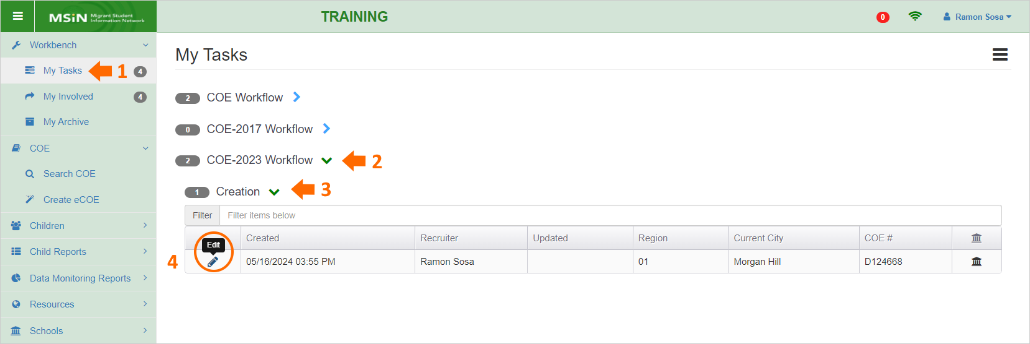
On this page, Ramon’s COEs are organized under headings (think of them as subfolders) by version and status. The eCOE he wants to open is under the COE-2023 version heading (arrow 2) and under Creation status (arrow 3). Next, he would click on the pencil icon to open the eCOE in edit mode (circle 4).
After Ramon makes his final edits and he is confident the eCOE is ready for submission, he can send it from My Tasks to the Review process by using the Next Step drop-down menu. This is found toward the bottom of the page, as shown below (arrow).
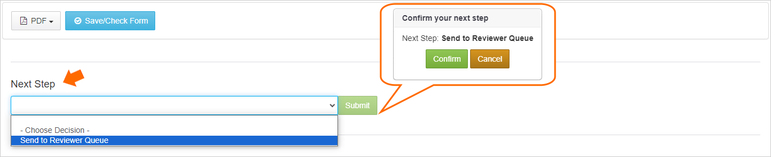
Ramon would now select Send to Reviewer Queue (dark blue highlight), which means to put in line for review, and then click Submit. This will trigger a pop-up, as shown in the orange callout above. Ramon would click Confirm to begin the sending process. You can tell the sending was successful when the application moves to the My Involved folder, which is analogous to the Sent folder in an email application. This concludes the sending process in most cases.
At this point, we have mentioned a couple of Workbench folders (My Tasks and My Involved), so it would be helpful to describe in more detail how the Workbench is organized and how COEs are moved from one step to the next.

Understanding the Workbench
The Workbench is a set of folders that house COEs in specific stages of the COE life cycle. The folder organization is similar to an email application. For example, the My Tasks folder is like Drafts/Inbox, My Involved is like Sent, and My Archive is like All Mail/Archive. The workflow progression is also similar: the COE is created, then sent for review, then archived when fully complete (verified). In MSIN, COEs are always in a specific state (describing their current condition) and the state generally corresponds to a folder, as shown in the diagram below.
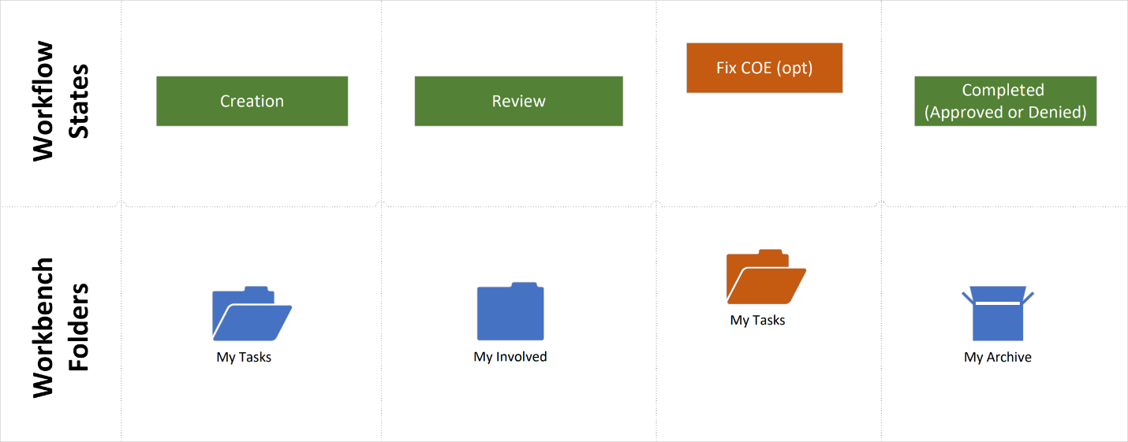
Starting on the left, when a new eCOE is created, it is automatically in Creation state. However, it will not be in My Tasks initially because all eCOEs are stored provisionally in your browser until you deliberately send them to the Workbench. The example in the previous section showed that we can send an eCOE to My Tasks (when more work is needed) or to Review (when the Recruiter is finished). Sending to My Tasks actually places the eCOE in the corresponding folder. In contrast, sending the eCOE to Review means changing its state to Review. From the Recruiter’s perspective, this copies the eCOE into their My Involved folder (like Sent in email). The next step in the COE workflow, the review process itself, happens outside of the Recruiter’s view. But after the Reviewer is finished with their part of the workflow, the eCOE will come back into the Recruiter’s view and they will see it move from My Involved to My Archive. At that point, the eCOE will be in Completed state (either Completed: Approved or Completed: Denied). This is a typical path in the workflow, although it is not the only one possible.
The next section builds on these ideas and walks through the relationships between workflow states, Workbench folders, and common workflow paths. Notice that we have not touched on Fix COE state yet; this will be addressed in subsequent workflow diagram, as an option.

Overview of eCOE workflows
The following diagrams include a swimlane for the Recruiter’s perspective and a corresponding swimlane representing the Reviewer’s work. While it is not necessary for you to know exactly what your Reviewers are doing, it is helpful to understand their role in the different workflow pathways.
The first diagram below will help us review the two typical pathways we described in the previous example, sending an eCOE to My Tasks (Creation state) or sending directly to Queued (Review state).
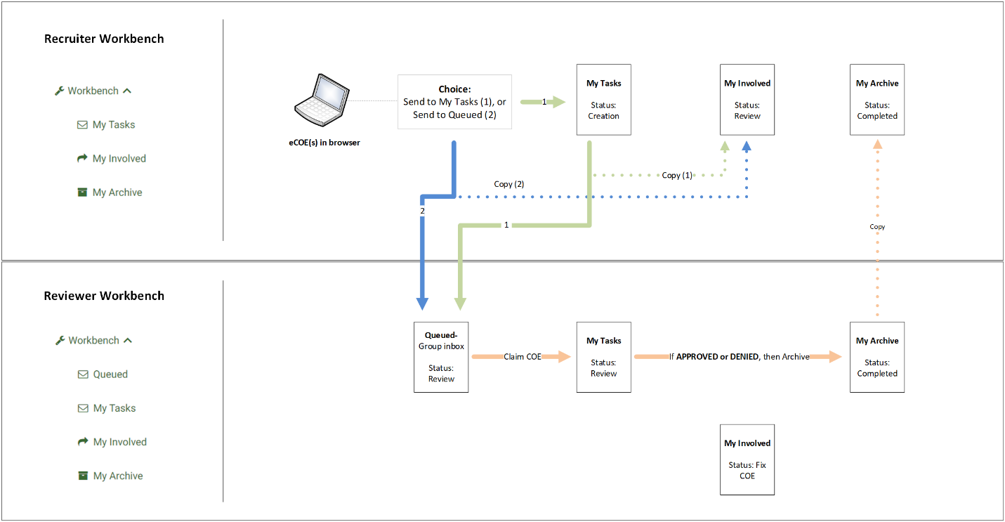
This diagram includes a screenshot of the Recruiter Workbench (green icons and text on the left), which is organized vertically and progresses from top to bottom. The same folders are represented in the swimlanes horizontally, from left to right, only because this makes for a more compact diagram.
Starting with the laptop icon, this represents where eCOEs are initially stored. Once you add information in the required fields, you can decide to send the eCOE to My Tasks (green path, number 1). Or you can send the eCOE directly to Queued (blue path, number 2), which is the first folder in the Reviewer swimlane. Notice that Queued is only visible to Reviewers (see the green icons and text). Another detail to notice is the green path takes one more step (sending from My Tasks to Reviewer’s Queued), whereas the blue path is more direct. In either case, a copy of your eCOE is always saved in your My Involved folder (dotted paths). We can think of both paths as ways to hand off the eCOE to your local team of Reviewers.
The next steps occur within the Reviewer swimlane. In subgrantee areas with multiple Reviewers, the Queued folder (like a group Inbox) allows them to divide up the work. Individual Reviewers will claim certain eCOEs based on their local assignment model (such as by Recruiter, by city, etc.). The eCOEs they claim are placed in their My Tasks folder. Once they finish the review process (peach color path), Reviewers can decide to Approve or Deny the eCOE. Either outcome is a Completed state (Completed: Approved or Completed: Denied). This step does two things at once: 1) move the eCOE into the Reviewer’s My Archive folder, and 2) make a copy of the completed eCOE in the Recruiter’s My Archive folder as well.
The next diagram adds an optional pathway, in red, to represent when an eCOE is returned for corrections or clarifications, as shown below.
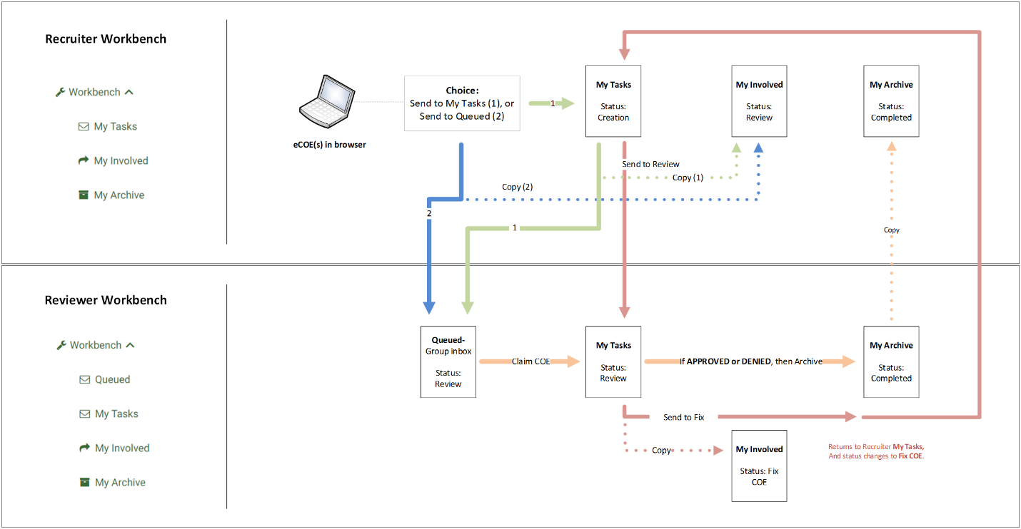
The red pathway above can be initiated by the Reviewer, as needed. They trigger this loop by using the Next Step drop-down menu to switch the eCOE state from Review to Fix COE, thus moving it from their My Tasks folder back to the Recruiter’s My Tasks folder. At the same time, a copy of the eCOE is retained in the Reviewer’s My Involved folder and the application automatically sends an email notification to the Recruiter. Since the Fix COE pathway is far less common than the general Review pathways described earlier, the email notification helps Recruiters pay special attention to these cases.
Once you have made the requested corrections or clarifications, you can return your eCOE to the same Reviewer’s My Tasks folder by using the Next Step drop-down menu to switch it from Fix COE back to Review state. This will also trigger a new email notification for the Reviewer so they can prioritize fixed eCOEs and finish the verification process. Occasionally, an eCOE could be returned to the Recruiter multiple times, therefore completing multiple loops on the red pathway, before receiving final approval. Fortunately, this is the exception rather than the rule.

Fix COE email notifications
Let us take a closer look at the email notifications feature. To recap, when a Reviewer returns your eCOE, you will get an email. For example, if Ramon Sosa (Recruiter) sent his eCOE to Review and Jose Valencia (Reviewer) returned it to him for corrections, Ramon’s email would look like this:
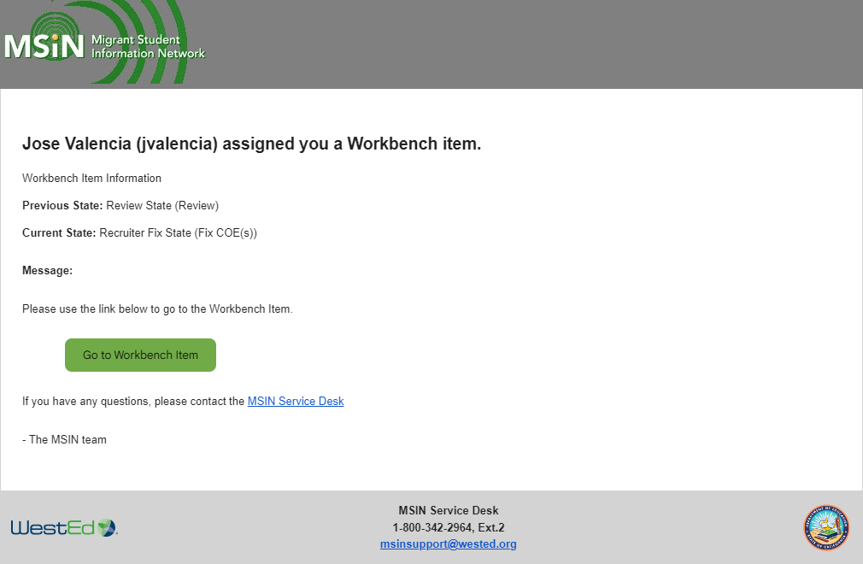
Ramon would click on the green button labeled Go to Workbench Item to open his eCOE, which is now in his My Tasks folder. Ramon would make the requested corrections and then send his eCOE back to the Reviewer, Jose.
Once sent, Ramon’s eCOE would move back into Jose’s My Tasks folder. Jose would simultaneously receive an email, as follows:
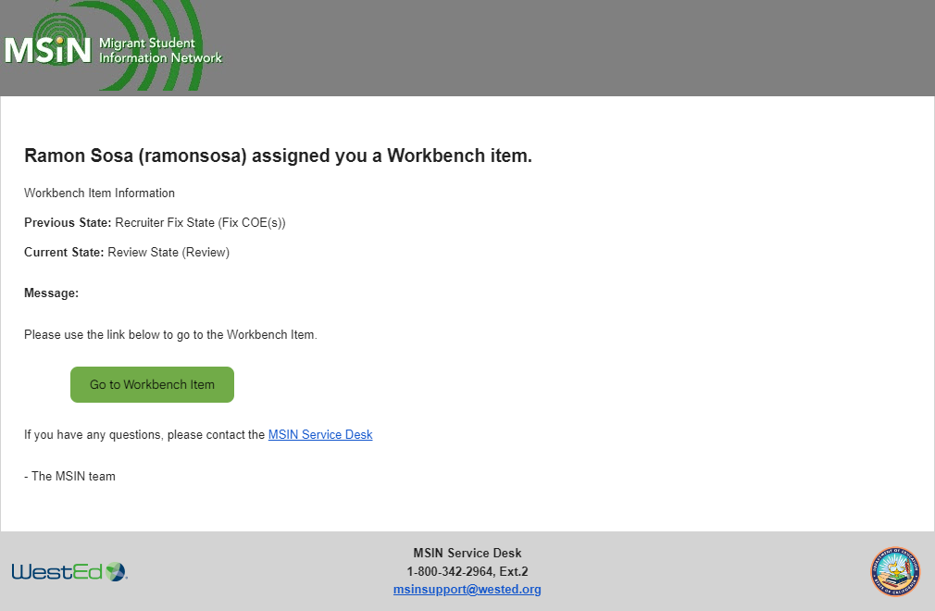
Jose could either click on the green button to continue verifying Ramon’s eCOE or he could open it directly from his My Tasks folder. Either way, the notification serves as a prompt to continue this work as soon as possible, given the delay caused by the initial return.
This sequence raises the question of how Recruiters should make corrections and/or clarifications on their returned eCOEs. The following section provides a general overview of this topic.

Editing eCOEs in Fix COE state
Suppose one of Ramon Sosa’s eCOEs was returned for corrections or clarifications. He can always access it from his Workbench. The following screenshot shows the steps to open an eCOE in Fix COE state, starting with clicking on My Tasks (arrow 1).
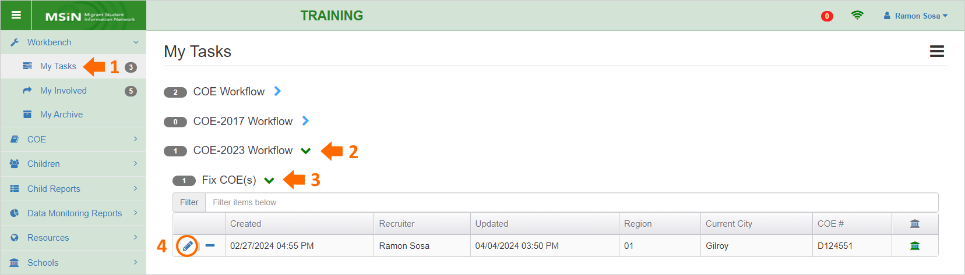
The eCOE Ramon wants to open is under the COE-2023 version heading (arrow 2) and under Fix COE(s) status (arrow 3). Next, he would click on the pencil icon (circle 4) to open the eCOE in a special editing page that has two tabs, as follows:
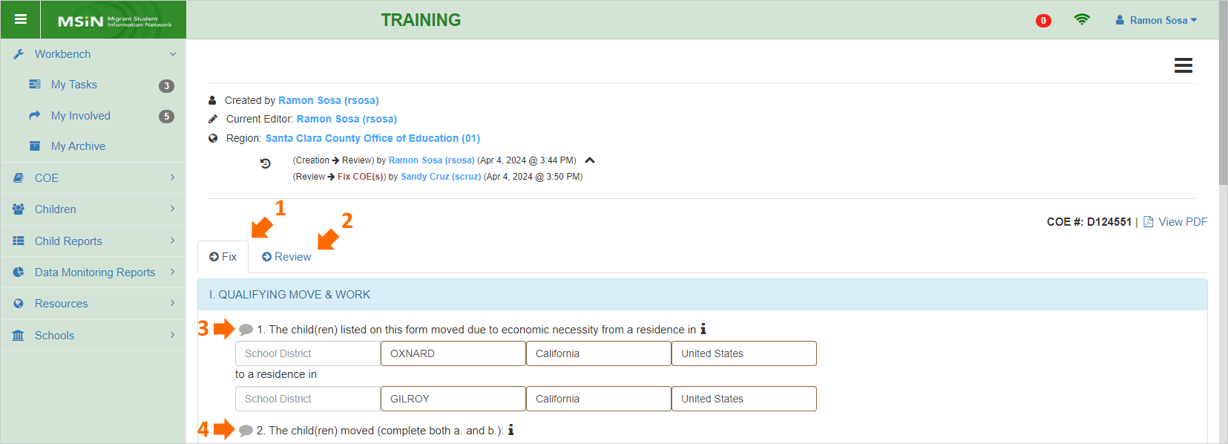
The first tab, Fix (arrow 1), is used to make changes. The second tab, Review (arrow 2), shows an exact copy of the COE Review page that Ramon’s Reviewer (Sandy Cruz) used to evaluate his eCOE. The second tab is there for transparency, but Ramon will generally stay on the Fix tab to complete his edits.
Before moving on to the editing process, let us review the differences you are likely to notice on this page. First, there is a workflow summary along the top. It shows the name of the eCOE creator (Recruiter) and the current editor. In this case, because the Recruiter (Ramon Sosa) is fixing his eCOE, the name is the same. Below that, you will also see this eCOE’s transition history. It shows the name, date, and time for the first transition, from Creation to Review state. Next, it shows when Sandy Cruz (Reviewer) sent the eCOE back to Ramon (Review to Fix COE state).
In addition, within the Fix tab, notice the grey callout icons next to items 1 and 2 (arrows 3 and 4 above). The Fix tab has callout icons next to each item or section. These icons open an input box for adding notes. When a Reviewer wants you to make a correction or clarification, they will add a note next to the item or section, which will turn the callout icon red. Here is an example from Section 1, item 4:
A callout icon with content will be red and show a count of the notes within. This example means that there are two notes related to the qualifying work fields. Clicking on the red icon (arrow below) will allow you to read the Reviewer’s note(s) and respond, if needed. Here are the notes from the callout shown in the screenshot above:
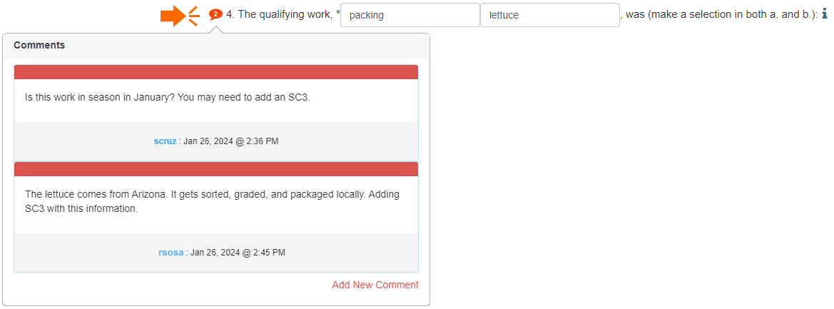
These specific comments are for illustration purposes, but they should convey that concise notes are preferred. Furthermore, a requested edit may not always require a response; it might be enough to simply fix the issue and send the eCOE back for approval.
In general, making any requested edits is straightforward because the fields in the Fix tab are the same as your original eCOE. However, since COEs are legal documents, making any substantive change(s) in eligibility-related information will require new signatures from the parent/guardian or self-qualifier. The Fix tab therefore includes reminders/warnings that editing certain fields, known as protected fields, will require new signatures.

Protected fields
The images below are highlighted to show which eCOE fields are protected in the Fix tab. The areas highlighted in yellow are protected fields which cannot be edited, otherwise the application erases the signature areas, and you will need to get new signatures from the Interviewee. The areas highlighted in blue are also protected, but more flexible. Blue fields allow you to change existing content without affecting signatures, but adding new content in a previously blank field or fully deleting existing content will erase signatures.
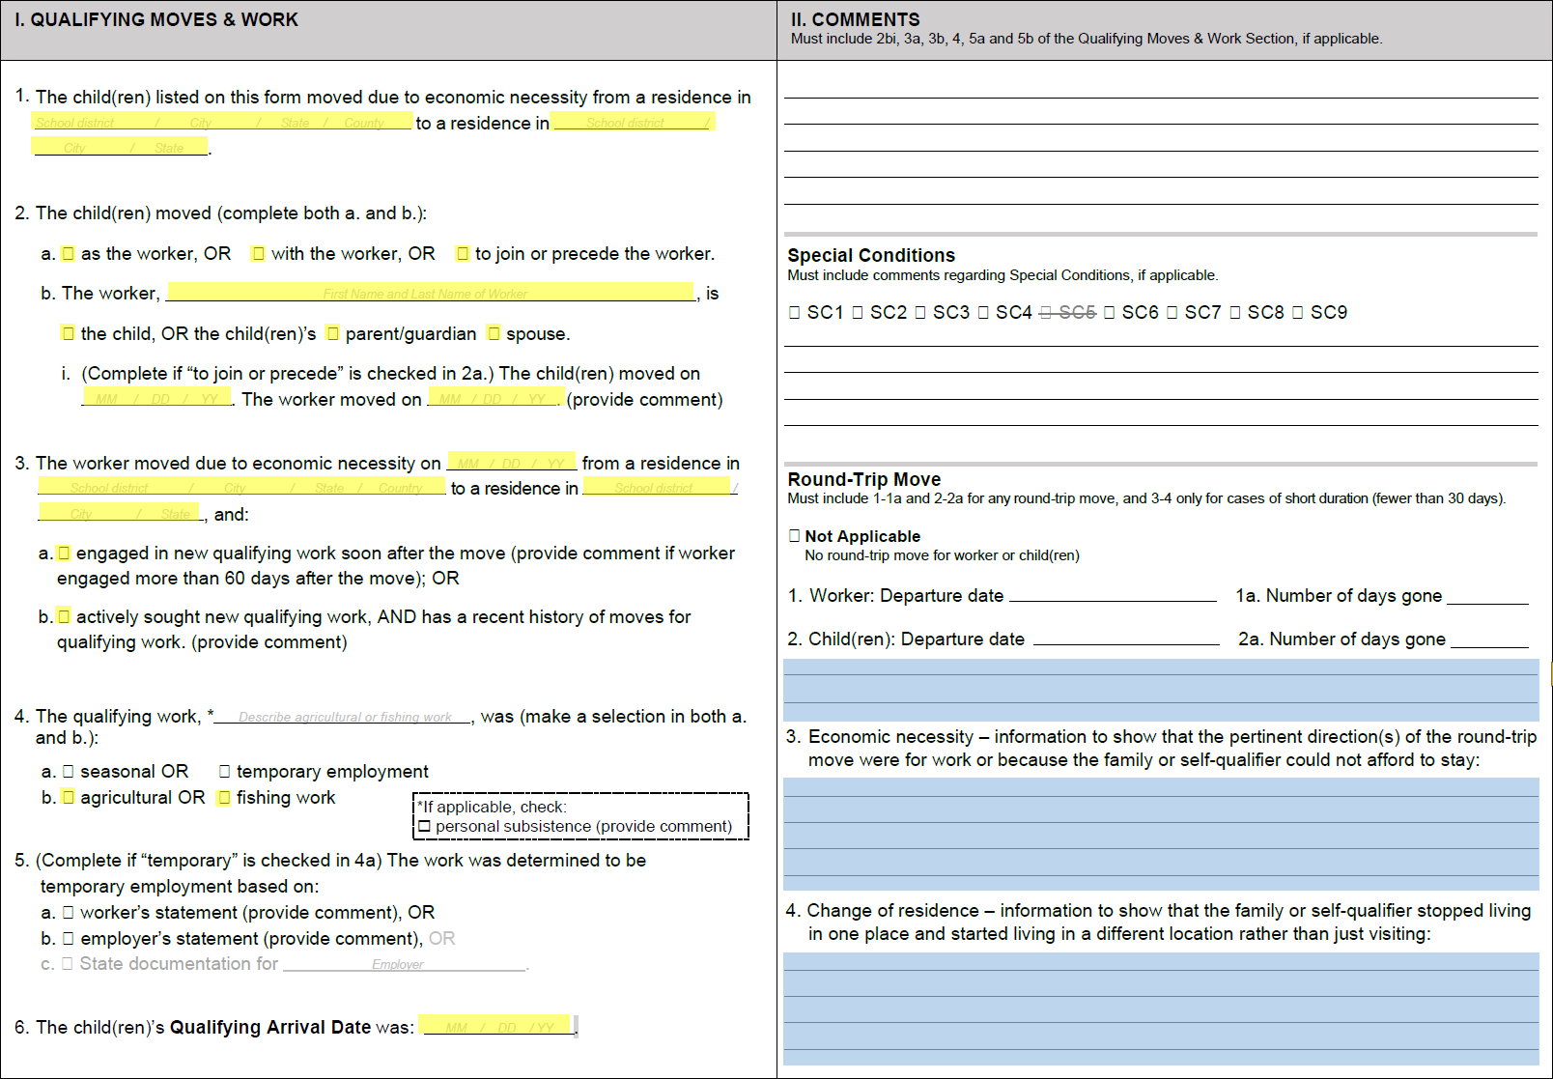
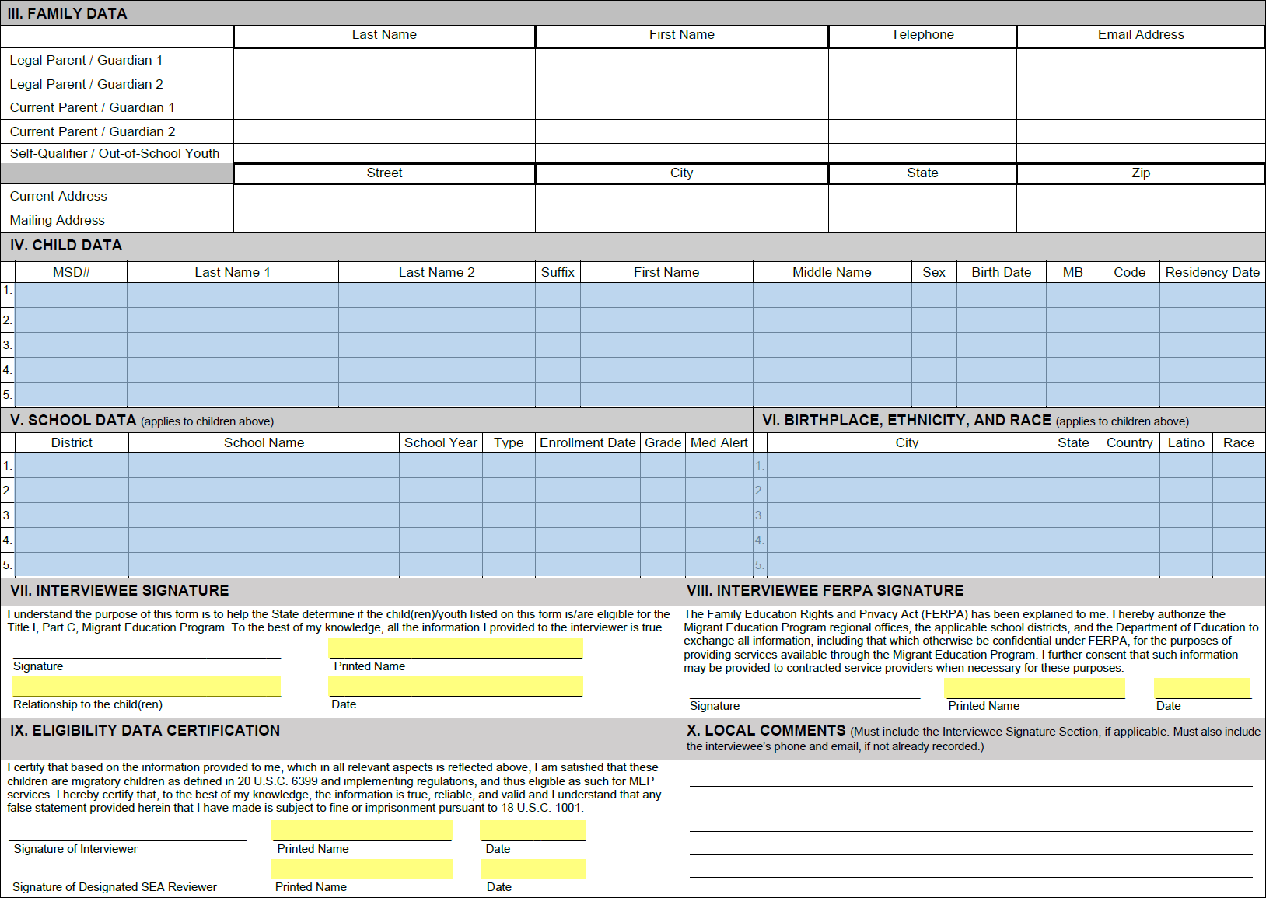
Again, keep in mind that changing the highlighted areas could erase signatures in Sections VII-IX, and both the Interviewee and the Recruiter would need to re-sign. The application will show the following warning before erasing signatures.
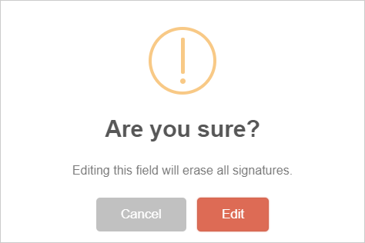
Canceling will restore the original value(s). Clicking Edit will save your changes and erase all signatures. When this happens, you will need to meet with the Interviewee again to share the new content and obtain new signatures, including your own signature as the Recruiter.
To recap, there will be situations when a minor clarification is enough and others where significant changes are needed, including new signatures, depending on your Reviewer’s requests. The protection features embedded in the eCOE are meant to allow flexibility while protecting the integrity of the eligibility-related data.
Returning to the example above, Ramon (Recruiter) would make the requested edits, such as adding a new Special Condition 3 (SC3) comment. Since this is not a highlighted field, the change would not require new signatures. Ramon would simply double check the eCOE and send it back to the Reviewer (Sandy) by using the Next Step drop-down menu, as shown in previous sections.

Using the Copy COE features
The eCOE also includes time-saving copy features for two relatively common situations. Suppose you are interviewing a parent/guardian and, while adding the children, you discover that one child in the parent/guardian’s care moved later than (or before) the rest of the children. Since their eligibility information is different, the child will need to be on a different eCOE. Or suppose that another child in the parent/guardian’s care is actually their nephew, so this child’s legal parent/guardians are different. Both situations would require separate eCOEs for the children with differences.
To begin with, you would create the primary eCOE for the children with the same information. This eCOE falls under the default tab heading, Child(ren) Under 22, as shown here:
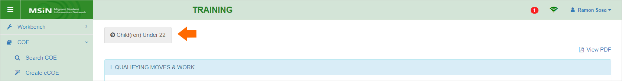
You would complete the required fields and click Save/Check Form to confirm nothing critical is missing. On the right margin, shown below, you would click on the green button labeled Copy COE to bring up two copy options.
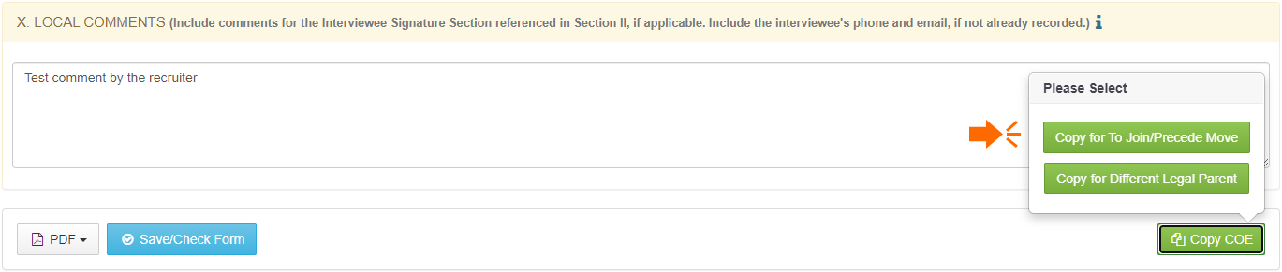
For the first hypothetical situation where one child joined the family later, you would click on the button labeled Copy for To Join/Precede Move (arrow above). The application copies the primary eCOE and provides a confirmation message, as follows:
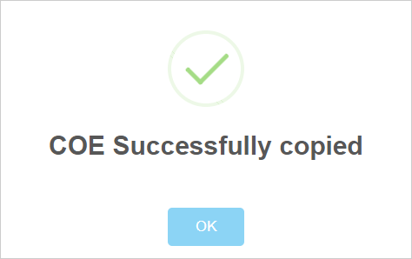
Depending on your browser, you could be prompted to reload the page. Next, the copy would appear as a new tab, labeled Child(ren) Under 22 – To Join Move (arrow 1 below):
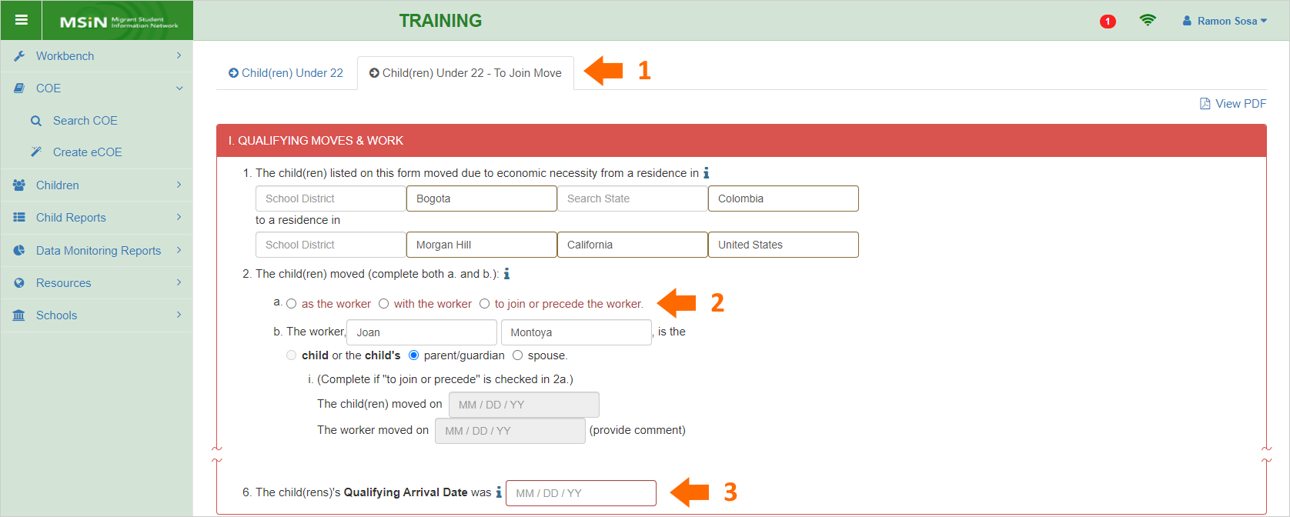
Since the copy is for a “to join or precede” use case, certain fields will remain blank, such as:
- 2a (children’s move relative to the worker) (arrow 2 above)
- 6 (QAD) (arrow 3)
- Sections IV-VI (child and school data)
- Sections VII-IX (signature areas)
You would add the missing information and continue to process the copied eCOE in the same way as any other independent eCOE.
Similarly, for the second hypothetical situation where one child has different legal parent/guardians, you would click on the button labeled Copy for Different Legal Parent. The application copies the primary eCOE and loads a new tab (arrow 1 below), as follows:
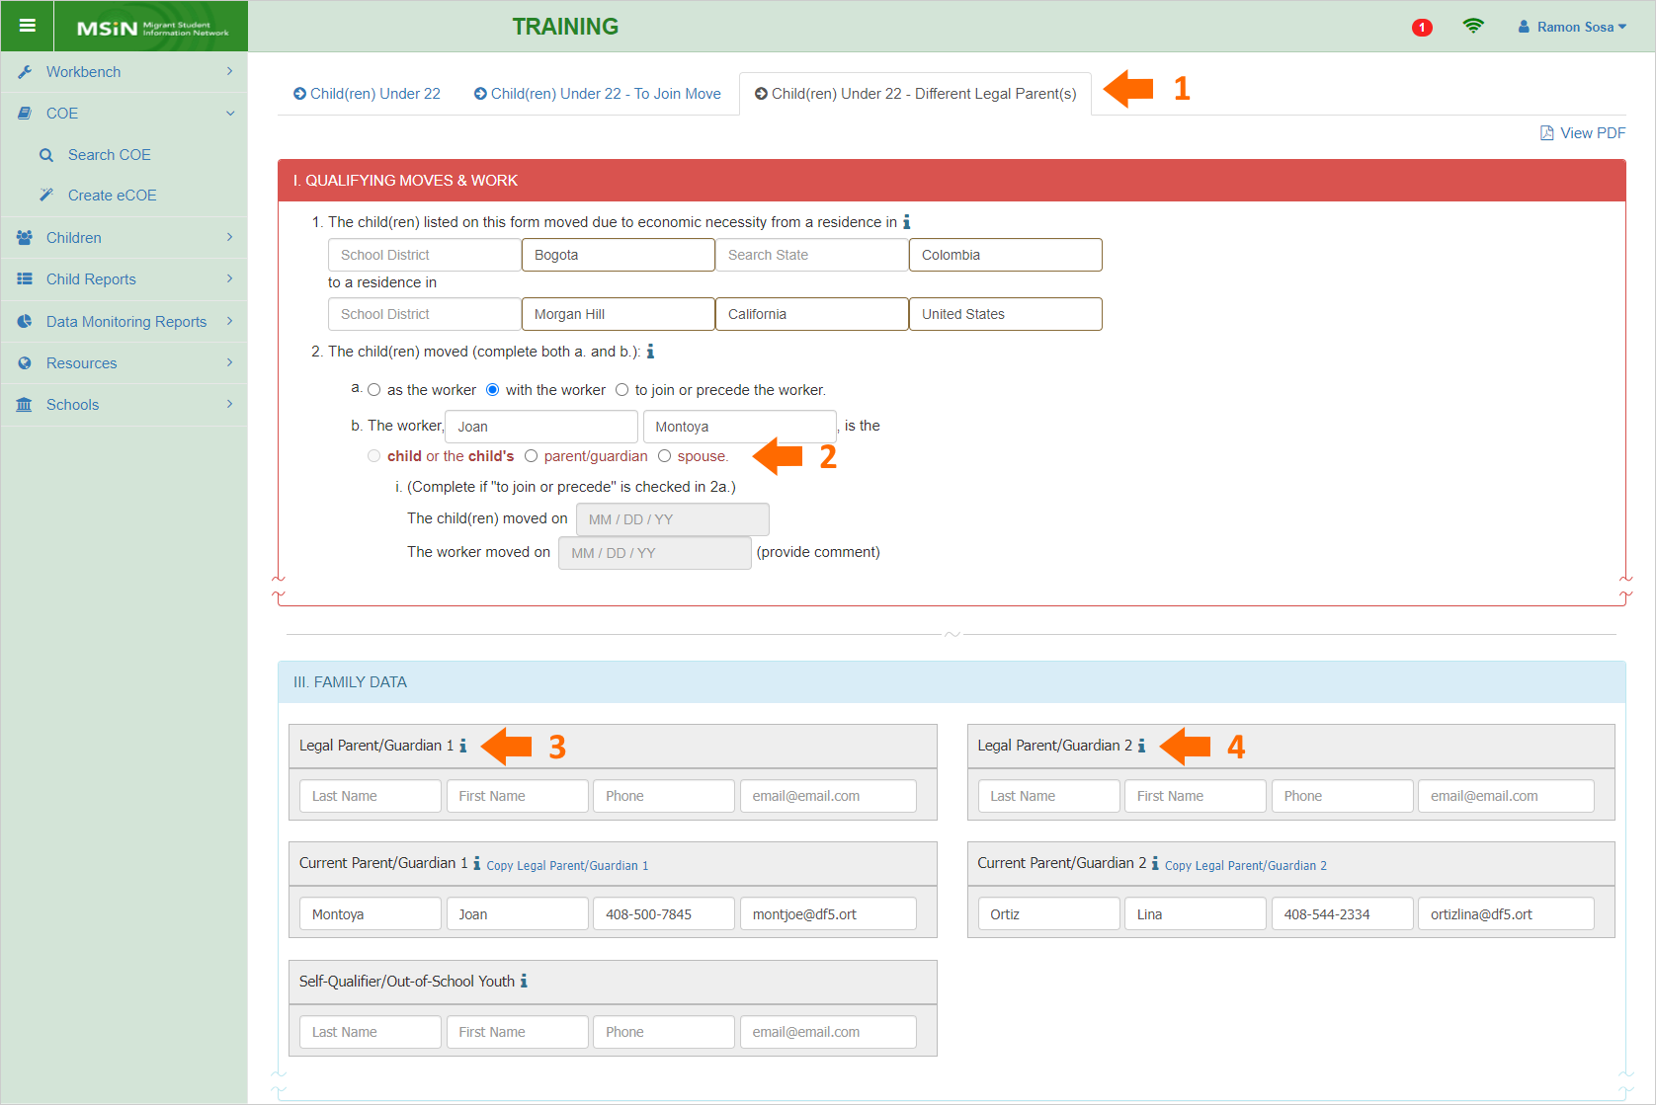
The copy for this use case will also have a few blank fields, such as:
- 2b (worker’s relationship to the children) (arrow 2 above)
- Section III (Legal Parents/Guardians) (arrows 3 and 4)
- Sections IV-VI (child and school data)
- Sections VII-IX (signature areas)
Again, you would add the missing information and continue to process the copied eCOE.
When you use the copy features, the different tabs are represented as distinct COEs in your browser and the Local Worksheets page. However, since the copies are variants of a primary version, they are listed in the same row in Local Worksheets. To see them separately, you would click on the open symbol, as shown in the screenshot below (orange circle).
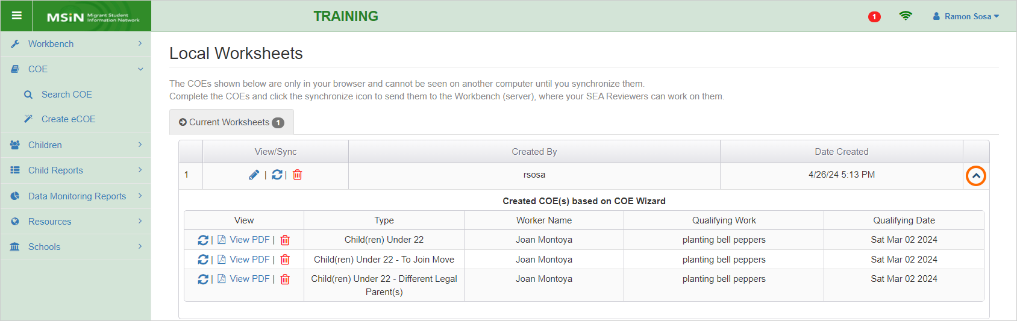
From this page, you can choose to edit (pencil icons), synchronize (circular arrows icons), view (PDF icons), or delete (trash icons) your eCOEs, as needed.
The synchronizing functionality (circular arrows icons) was retained from the previous version of the eCOE for continuity, but it is not the preferred method to send your eCOEs to Review. Instead, we strongly recommend sending each eCOE individually by using the Save/Check Form button at the bottom of the page, which performs a thorough check for completeness. Furthermore, Save/Check Form provides more options, such as sending your eCOE directly to Review. In contrast, the synchronizing icons will only send eCOEs to your My Tasks folder.

Using System Comments
When an eCOE is sent to the Workbench (saved to the MSIN database rather than just the browser), it gets an additional comments box at the end of the page. This is for notes that stay semi-private between the Recruiter and the Reviewer(s) who worked on it. We refer to these as system comments because they are not copied into the PDF of the COE (therefore not on a printed COE). We can think of system comments as semi-private because other MSIN users who have access to viewing COEs statewide (via the Search COE page) will not see them. The only exception is System Administrators, who can view and add system comments in any COE, as needed. Here is a screenshot with one saved system comment and another which is being drafted:
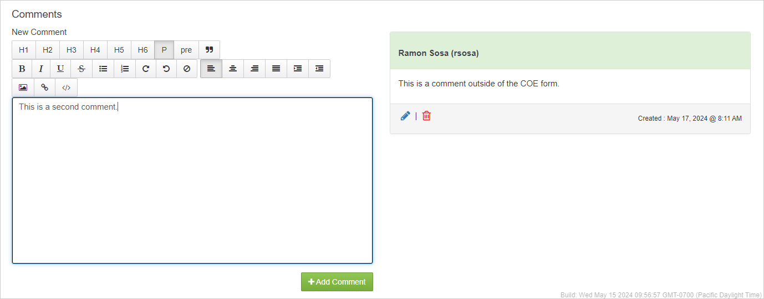
System comments are drafted on the left and saved on the right side of the page. The author’s name appears at the top and the comments include a date stamp. The author can always edit or delete their system comments, regardless of the Workbench folder or eCOE state.
System comments can be used by Reviewers during their verification process, such as when their question or comment does not apply neatly to a specific field or section. Recruiters can use them to respond, knowing that information they share will not end up on the PDF or printed version of the COE. Either party can use system comments after an eCOE is approved to acknowledge or explain minor errors that do not affect eligibility.
Other uses for system comments may also be appropriate, though it is important to remember that sensitive identifying information (such as social security numbers) and health information (such as medical conditions, diagnoses, and medications) should never be entered in MSIN. If in doubt about your use case, please consult with your supervisor or reach out to the MSIN Service Desk (see Additional Resources below).

Using the eCOE PDF features
At any time during the creation of an eCOE, or afterward, you can view or download a copy of the eCOE in hard copy format. A View PDF link is always available on the top right of the page. Clicking this link opens a separate tab and loads the PDF version. Within this PDF tab, there is also an option to download the PDF file.
At the bottom left of the eCOE, there is a PDF button, which shows two options, as follows:
This button works in the same way as the link at the top right of the eCOE, except that you have the option to download the PDF file immediately, instead of needing to view it first.
The primary caveat regarding PDFs of COEs is to be cognizant of the security risks when downloading files, which should be purged regularly from your Downloads folder (or other designated folder) to prevent exposure in the event of a computer loss or security breach. Printed hard copies of COEs should be stored in secure environments, such as locked file cabinets. Remember that COEs contain identifying information, potentially for multiple children, which is protected by state and federal law.

Additional Resources
As emphasized throughout this guide, we recommend referencing the Help Text in the eCOE pages and pop-up windows, as needed. For more in-depth explanations around eligibility concepts or rationales for specific procedures, we recommend consulting the I&R Manual. Furthermore, training content from past events, such as presentation files and supporting documents, is archived in the California MEP Help Center (https://mephelpcenter.wested.org). Please use any of these references to guide you while practicing hands-on in the Training MSIN environment (https://trainingmsin.wested.org). Hands-on practice is especially helpful to new Recruiters, and even experienced staff can benefit from reviewing features that are seldom used.
If you have specific questions not covered in this guide, please consult with your local team of MSIN Power Users, Managers, and fellow Recruiters. You are welcome to submit any remaining questions to the MSIN Service Desk by email (msinsupport@wested.org) or phone (1-800-342-2964, option 2).

The COE instructions in the I&R Manual are found in the California Migrant Education Program Help Center.
Per the COE instructions chapter in the I&R Manual, remember to enter information in mixed case (not all capital letters).
Essential rules, restrictions, and prompts are summarized in the table “Assistance features in Section I.”
All names and identifying information in this guide are fictitious.
This window only tracks whether content is present or absent in the required fields, as defined in the National Certificate of Eligibility (COE) Instructions (COE_Instructions_-_exp_08_31_26.pdf). For more details on what constitutes acceptable content, consult the California COE instructions in the I&R Manual.
If you notice that the matching child’s information needs to be edited, keep in mind that changing their First Name, Last Name 1, or Birth Date will erase the MSD# field. The edited child record will be treated as a new child.
Residency Date is MDE 70 in the document “MSIX Minimum Data Elements - Version 13,” expiring on 1/31/2026.
Once the COE is approved, a local Data Specialist will confirm the new school information and then pass it along to WestEd. If approved, this process will add the new school to relevant menus in the future.
Med Alert codes are only flags for further inquiry. You should never add specific health information in the eCOE form, such as conditions, diagnoses, or medications.
The eCOE also has a green button labeled “Capture by Device” that was originally added to work with old Topaz signature pads. Topaz devices have been deprecated and we highly recommend substituting a method that uses your computer’s mouse functionality instead.

