Administer Services

Introduction
The Administer Services page (also known as the service set-up screen) is found in the System section of the MSIN Menu. This page allows users with the Regional Administrator, Program Manager, and/or Data Specialist role(s) to search for services, adjust service settings, and create new services, as needed. In addition, MSIN users with the I&R Manager and/or Student Services role(s) can search for and view existing services, but they cannot edit or create services.
This user guide covers basic instructions on:
- searching for existing services,
- enabling/disabling services,
- setting up new services, and
- common service set-up scenarios.

Searching for Existing Services
In the MSIN Menu, navigate to the System section, then click Administer Services (#1 below). MSIN automatically selects your region or district, and it selects “Active Services Only” by default.

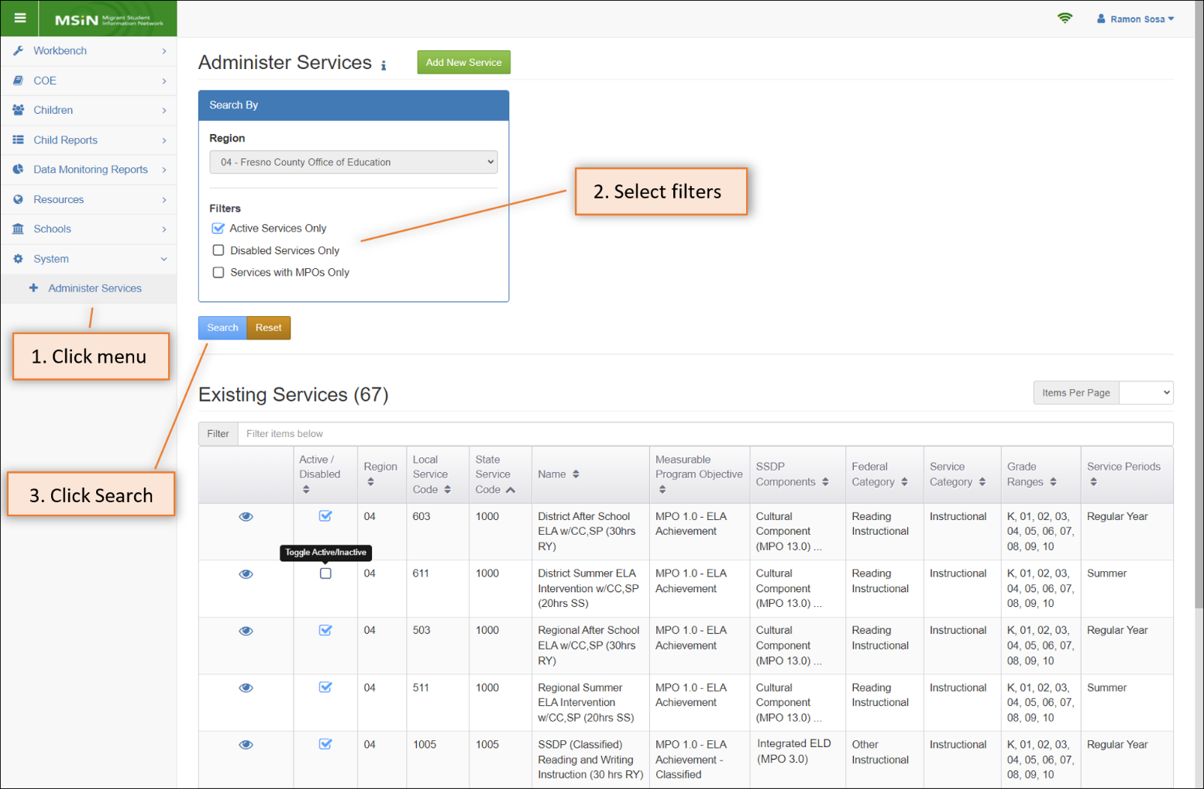

Next, you can change or add filters using the available checkboxes (#2 above). The third checkbox, “Services with MPOs Only,” can be selected in combination with the first or second filter. The last step is to click the Search button to bring up the subgrantee’s existing services (#3 above).

The results table shows the number of existing services (e.g., 67 in the screenshot above) and it provides two controls in each row. The first control is the view icon (eye), which opens a more detailed description of the service. The second control is a checkmark box which can be toggled to enable or disable a service. The remaining columns in the search results table are defined as follows:

Field | Description
Region | The regional office or direct-funded district number
Local Service Code | A unique code number for the service, determined locally by the region or direct-funded district
State Service Code | A unique code number for the service, determined by CDE
Name | A descriptive name for the service
Measurable Program Objective | If applicable, the Measurable Program Objective number and name that aligns with the service
SSDP Components | If applicable, State Service Delivery Plan (SSDP) component(s) that apply to the service (e.g., social-emotional component for school readiness services)
Federal Category | Service type used for federal reporting, as defined by the U.S. Department of Education (ED) data submission specifications (i.e., EDFacts) for the Migrant Education Program
Service Category | Category indicating whether the service is instructional or supportive
Grade Range | Grades for which the service is appropriate and applicable
Service Periods | Service period(s) when the service is offered

Enabling and Disabling Services (Regional Administrators, Data Specialists)
After searching for services, you can use the results table to review and, if needed, toggle the checkmark box in the second column to enable or disable services. If a service will no longer be used, it should be disabled (i.e., unchecked) so that it does not appear as an option in the service entry screens. Disabling unneeded services makes it much easier for data entry staff to quickly find the services they should use to report student participation. Any changes will prompt a confirmation window, as shown in the example below.

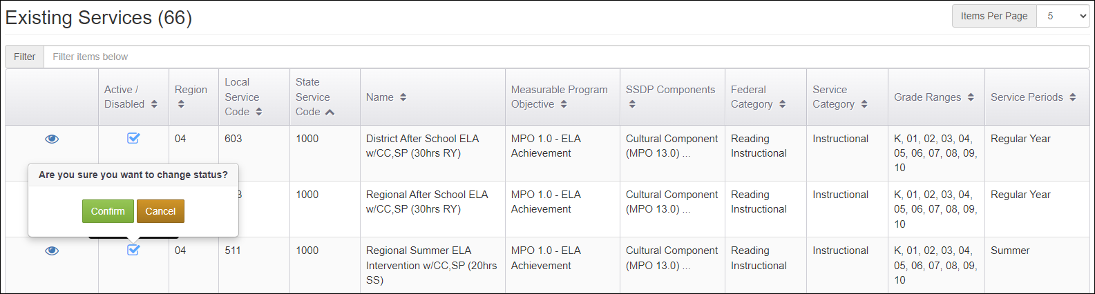

After confirming, the service above (Local Service Code 511) will no longer be checked and the service name (Regional Summer ELA Intervention...) will not appear as an option on the service entry screens. If the service is needed in the future, it can be enabled again by toggling the same checkmark box.

As subgrantees transition into a new school year, under new grant applications, it is helpful to align the services available in MSIN —by enabling and disabling— to the services described in the applications. This ensures logical consistency between service planning and service reporting.

Setting up New Services (Regional Administrators, Data Specialists)
On occasion, you may need to create a new service that was approved on a Regional Application (RA), District Service Agreement (DSA), or Memorandum of Understanding (MOU). From the Administer Services page, click the button labeled “Add New Service” to bring up the Creating Service window. The first item pre-populates with the subgrantee number based on your account. Starting with item #2, click on the “i” next to each title to access instructions on how to complete the field. The screenshot below shows the Help Text instructions for the Service Description field (item #3).
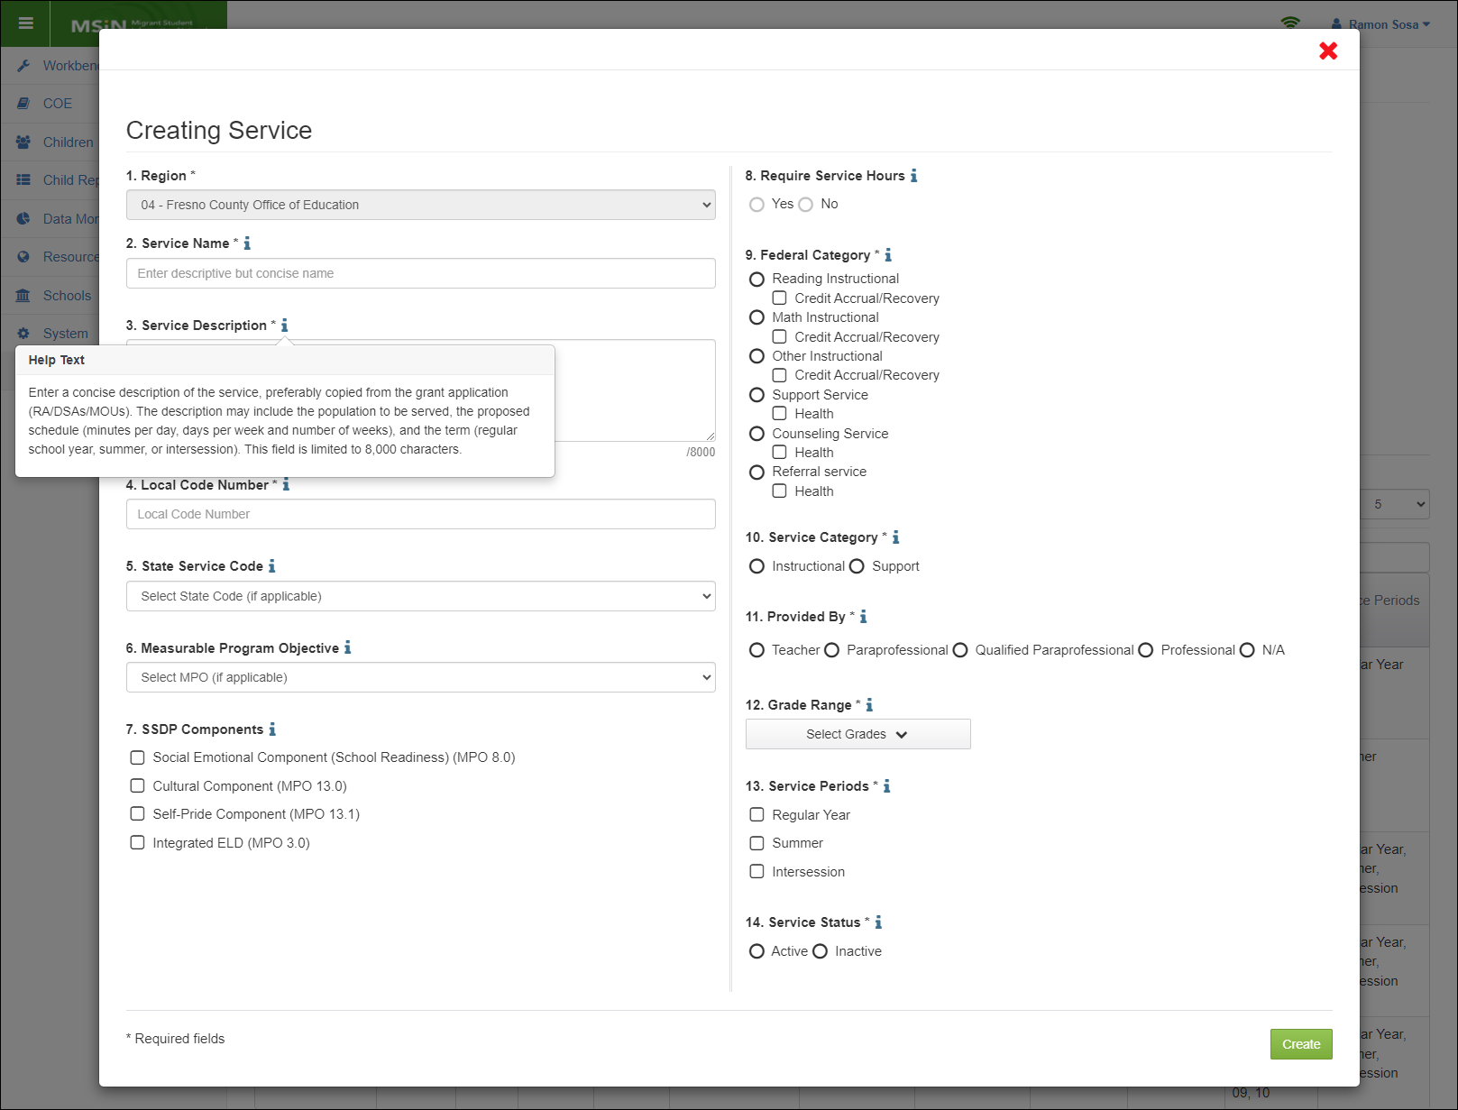

The Help Text contents for each field are summarized in the table below.

Field | Instructions
2. Service Name | Enter a brief, distinct, and descriptive name for the service. The CDE requires that local management teams enter the same service name in MSIN as they used in their applications (RA/DSAs/MOUs) to facilitate technical and programmatic assistance. Alternatively, subgrantees may set up service “buckets” to make service entry easier for reimbursable districts. For example, Saturday math services may be grouped together or after school math services may be grouped together. Services in a “bucket” must have the same SSDP Components (e.g., integrated ELD, cultural pride, and/or self-pride). In this case, please provide a general name that encompasses all services for that “bucket” (e.g., After School Math Service). This field is limited to 100 characters including spaces.
3. Service Description | Enter a concise description of the service, preferably copied from the grant application (RA/DSAs/MOUs). The description may include the population to be served, the proposed schedule (minutes per day, days per week and number of weeks), and the term (regular school year, summer, or intersession). For regions setting up service “buckets,” please provide a general description that covers all the services. Services in a “bucket” must have the same SSDP Components (e.g., integrated ELD, cultural pride, and/or self-pride). This field is limited to 8,000 characters.
4. Local Code Number | Enter a unique code number for the service for the region/direct-funded district. The number must be unique (i.e., not currently in use or used in the past) and between 1 and 9,999. The existing Health Code numbers (900 range), SSDP numbers (1000 range), Mini-Corps numbers (2000 range), Credit Accrual numbers (3000 range), and SSDP OSY numbers (4000 range) cannot be overwritten.
5. State Service Code | -Optional Field-  These are pre-set service codes that the State has developed. Subgrantees can use these pre-set codes if they have local services that align with the State Service Code definitions. The State Service Codes include the Health Code numbers (900 range), SSDP numbers (1000 range), Mini-Corps numbers (2000 range), Credit Accrual numbers (3000 range), and SSDP OSY numbers (4000 range).  After you select one of the State Service Codes listed above, most remaining options on this set-up screen will automatically populate, including Measurable Program Objective. Two options can be edited after your State Service Code selection are:  • SSDP Component (you may select applicable check boxes), and  • Service Status (Active/Inactive).
6. Measurable Program Objective | -Optional Field-  The SSDP has specific implementation goals for different program areas called Measurable Program Objectives (MPOs). Using MSIN, the State can collect service data to measure progress toward meeting some MPOs.  This drop-down menu is only editable when the previous field, State Service Code (#5), was skipped (i.e., no selection). You may select an MPO if your service aligns with the definition of that MPO. Most remaining options on this set-up screen will automatically populate. The exceptions are SSDP Component (which you may select, if applicable) and Service Status (Active/Inactive).  Note: If a State Service Code was selected in field 5, the applicable MPO will automatically populate and it will have a shaded appearance (i.e., not editable).
7. SSDP Components | -Optional Field-  If applicable to this service, select one or more State Service Delivery Plan Components. For example, all School Readiness services must include a Social Emotional Component. Other instructional services may include integrated ELD, a Cultural Component and/or a Self-Pride Component. Please refer to the SSDP to identify in which services these components should be added.
8. Require Service Hours | This field is not editable. Whether or not a service requires hours is based on the selected MPO. Certain MPOs (such as MPOs 1.0, 2.0, 7.0) require hours and will auto-select "Yes." All other MPOs will automatically make this field a "No."
9. Federal Category | Instructional Services  Reading Instruction:  Reading instruction provided by a teacher. If applicable, select the sub-category Credit Accrual/Recovery. If instruction is provided by a paraprofessional, then select Other Instruction instead.  Math Instruction:  Math instruction provided by a teacher. If applicable, select the sub-category Credit Accrual/Recovery. If instruction is provided by a paraprofessional, then select Other Instruction instead.  Other Instruction:  Any type of MEP-funded instructional service, either provided by a teacher or a paraprofessional. If applicable, select the sub-category Credit Accrual/Recovery.  Credit Accrual/Recovery (check box):  This is a sub-category under each of the Instructional Services. It is defined as instruction in courses that accrue credits needed for high school graduation provided by a teacher for students on a regular or systematic basis, usually for a predetermined period of time. High school credit accrual includes correspondence courses taken by a student under the supervision of a teacher. If the service is for credit accrual or recovery and provided by a teacher, then this box should be checked.  Support Services  Counseling Services:  Services to help a student to better identify and enhance his or her educational, personal, or occupational potential; relate his or her abilities, emotions, and aptitudes to educational and career opportunities; utilize his or her abilities in formulating realistic plans; and achieve satisfying personal and social development. These activities take place between one or more counselors and one or more students as counselees, between students and students, and between counselors and other staff members. The services can also help the child address life problems or personal crisis that result from the culture of migrancy. If applicable, select the sub-category Health.  Referred Services:  Educational or educationally related services provided from non-MEP programs or organizations that otherwise would not have been obtained by migrant children (but are obtained for migrant children through the efforts of MEP-funded personnel). Other non-MEP local, state, and/or federal funds support the delivery of the referred services. If applicable, select the sub-category Health.  Support Services:  These MEP-funded services include, but are not limited to, health, nutrition, counseling, and social services for migrant families; necessary educational supplies, and transportation. The one-time act of providing instructional or informational packets to a child or family does not constitute a support service. If applicable, select the sub-category Health.  Health (check box):  This is a sub-category under each of the Support Services. If the service is health-related, then this box should be checked.
10. Service Category | Select if this an Instructional Service or a Support Service.
11. Provided By | Select who provides the service. The definitions for service providers are:  • Teacher: An instructor who is licensed and meets any other teaching requirements in the State.  • Qualified Paraprofessional:  - High school diploma or the equivalent, and  - Two years of college (48 units), or  - A.A. degree (or higher), or  - Pass a local assessment of knowledge and skills in assisting in instruction.  • Paraprofessional: An individual who carries out activities described under qualified paraprofessional but does not meet the other requirements listed.  • Professional: For support services, a provider who is licensed by the State and meets all qualifications to work with school-age children and youth.  • N/A: Not applicable. This service may be provided by any MEP-funded staff.
12. Grade Range | Select the grade(s) that may receive the service. This causes the service name to appear only for the selected grade(s) when an MSIN user enters service participation data.
13. Service Periods | Check the service period(s) when this service is offered. Note that this causes the service name to appear only for the selected service period(s) when an MSIN user enters service participation data.
14. Service Status | Active: The service name will appear in the SERVICE NAME drop-down menu within the service entry screens (Service Participation tab in Child Record Modal and Group Services feature).  Inactive: The service name will not appear in any service entry screens.

When creating a new service, it is important to start at the beginning with the Service Name (item #2) and follow the numerical order.
In addition to the instructions and definitions in the table above, which are copies of the Help Text for each item in the Creating Service modal, please consider the following reminders and clarifications for the optional fields:

- Item #5, State Service Code, should only be selected if your service aligns with one of the pre-set State Service Codes (consult the definitions provided by CDE to clarify any doubts). If a pre-set State Service Code is selected, then most other options on the Creating Service window will automatically populate. The only remaining steps are to select any applicable SSDP Components (item #7) and to select Active or Inactive under Service Status (item #14).

- Item #6, Measurable Program Objective, is only editable when item #5 is skipped. This optional field should only be used if your service aligns with one of the MPOs in the drop-down menu. If an MPO is selected, most other options on the Creating Service window will automatically populate. The only remaining steps are to select any applicable SSDP Components (item #7) and to select Active or Inactive under Service Status (item #14).

- Item #7, SSDP Components, may be used in conjunction with any instructional service, regardless of whether it aligns with a State Service Code or a Measurable Program Objective listed in item # 6.

All other fields are required. If you forget to complete any of the required fields, the system will display red text indicating which field(s) need your attention. Furthermore, please consider the following clarifications for the required fields:
- Regarding #12 (Grade Range) and #13 (Service Period), note that these required fields influence how service participation data is entered in MSIN by users with the Data Specialist and Student Services roles. For example, if a service is set up with grades P3-P5, then the service will only appear in the service entry screens if the child is enrolled in those grades. Similarly, if a service is set up with only Summer selected under #13, then that service will only show up as an option when Summer is also selected in the service entry screens (under the Service Participation tab for an individual child or the Group Services page for groups of children). This “filtering” helps staff who are entering service participation data because they only see the relevant services, based on matching grade and service period.

Common Service Set-up Scenarios (Regional Administrators, Data Specialists)
MSIN can accommodate different approaches to aligning the services on your grant application(s) to the services used by data entry staff to record student participation. Four common service set-up scenarios are described below. You may use all four or any combination that best suits your local needs.

1. The subgrantee would like to use an existing State Service Code “as-is.” No set-up is needed.
If a service in your application(s) happens to match a pre-set State Service Code, then it is not necessary to create a new service. You can begin using the State Service Code “as-is” simply by ensuring that the service is Active. At the same time, we recommend that you disable the State Service Codes that you will not use (see “Enabling and Disabling Services” above for details).

2. The subgrantee considers their local service to be a variation of an existing State Service Code.
In this case, you can create your own Service Name (item #2), Description (item #3), Local Code Number (item #4), and then select the applicable State Service Code (item #5). The State Service Code selection will automatically populate most of the remaining options. The advantages of this approach are that you can use the same Service Name as your grant application (which your local staff may already recognize) and you can use the same Description as your grant application. This makes it easier to see the correspondence between the planning component (grant application) and the reporting component (service entry in MSIN).

3. The subgrantee thinks their local service is different from all State Service Codes but it still addresses a Measurable Program Objective.
When using this approach, you would create your own Service Name (item #2), Description (item #3), Local Code Number (item #4), and then select the applicable Measurable Program Objective (item #6). Note that this entails skipping the State Service Code drop-down menu and then selecting an applicable MPO instead. Most of the remaining options will automatically populate.

4. The subgrantee thinks their local service does not match a State Service Code or an MPO but it meets the definition of “service” provided in Guidance.
This is like approaches 2 and 3 above, but you would not select a State Service Code or a Measurable Program Objective. All other fields should be selected manually, unless they are not editable (such as item #8, Require Service Hours).
For more details and concrete examples of approaches 2-4, please view the “How-To Videos” found in the California Migrant Education Program Help Center (https://mephelpcenter.wested.org/hc/en-us/articles/7918499676692-How-To-Videos-Services-Service-Administration-and-the-SSDP).

Additional Resources
Before creating new services in the production MSIN site, we recommend practicing in the Training MSIN site (https://trainingmsin.wested.org/). Training MSIN is a safe place to try the different service set-up scenarios described above. In addition, we always recommend referencing the Help Text found next to each item in the Creating Service window.
If you have specific questions not covered in this guide, please consult with your local team of MSIN Power Users, Managers, and fellow Data Specialists. You are welcome to submit any remaining questions to the MSIN Service Desk by email (msinsupport@wested.org) or phone (1-800-342-2964, option 2).

These definitions are based on files specifications provided by the U.S. Department of Education (ED) for annual federal reporting purposes, particularly FS145 (https://www2.ed.gov/about/inits/ed/edfacts/file-specifications.html).
U.S. Department of Education, Office of Elementary and Secondary Education, Office of Migrant Education, Non-Regulatory Guidance for the Title I, Part C Education of Migratory Children, Washington, D.C., 2017.

