Service Report

Introduction
The purpose of the Service Report is to extract child participation data for Migrant Education Program (MEP) services that were accessed during the selected school year. This can help you evaluate how data entry for service participation is progressing, especially toward the end of each term and the school year. All MSIN user roles, except Viewer, may use this report to track child participation in MEP services, as needed.
This user guide covers the following topics:
- Search criteria
- Columns in the results table
- Exporting the results
- Additional resources

Search Criteria
The Service Report can be run on multiple levels: by region, county, district, or school. The first field defaults to your region or Direct Funded District (DFD) number. Next, you can select a county, district, and school (one or many). If a region or DFD serves a single county, then the second field will default to that county automatically. The final item to select in the Search Criteria panel is the school year. At this point, you can click on Search and the system will populate the results table, as shown below:
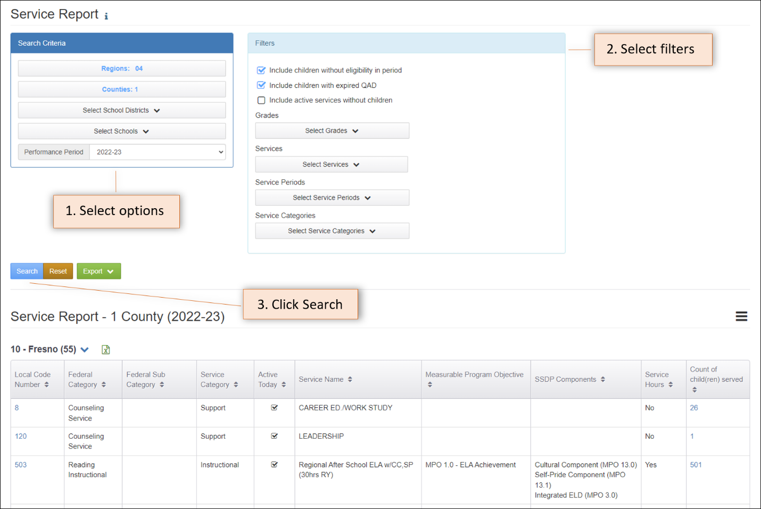
This search, for Region 4, was run at County level, meaning that all districts and schools in Fresno County were included. The results table shows 55 services, although the screenshot only captures the first three. Each row represents a service and the last column shows the number of children who participated in that service. For example, if we focus on the third row (Local Code Number 503), we notice that 501 children participated in an instructional service named “Regional After School ELA w/CC, SP (30hrs RY).”

Filter Options
The Service Report has seven filters that you can use individually, or in combination, to narrow your results, as needed. The filters are defined as follows:
Filter | Definition
Include children without eligibility in period | This filter allows you to include or exclude children based on their “Eligible in Period” (EiP) status. This is checked by default.
Include children with expired QAD | This filter allows you to include or exclude children based on whether the Qualifying Arrival Date (QAD) on their most recent Certificate of Eligibility (COE) has expired. This is checked by default.
Include active services without children | This filter allows you to include services that are active, in the Administer Services screen, but they do not have any participating children (at the time the report is run).
Select Grades | This filter allows you to include only the selected grade(s) and exclude the remainder.
Select Services | This filter allows you to include only the selected service(s) and exclude the remainder.
Select Service Periods | This filter allows you to include only the selected service period(s) (Regular Year, Summer, Intersession) and exclude the remainder.
Select Services Categories | This filter allows you to include only the selected categories (Instructional, Support) and exclude the remainder.

Columns in the Results Table
After you conduct a search, the results table populates ten columns, which are defined as follows:
Display Column | Definition
Local Code Number | The subgrantee’s local code number for the service. You can click on the number to bring up the details of the service (how it is set up under the Administer Services page).
Federal Category | The Federal category to which the service is mapped.
Federal Subcategory | The secondary category for the service (e.g., Counseling is a secondary category under Support Services).
Service Category | Indicates whether it is an Instructional or Support service.
Active Today | This is selected if the service is active (on the date when the report is run). Unchecked services are currently inactive.
Service Name | The name of the service, as set up on the Administer Services page.
Measurable Program Objective | This field lists any applicable Measurable Program Objectives (MPO), as set up on the Administer Services page.
SSDP Components | This field lists any applicable SSDP Components (e.g., Integrated ELD, Cultural Component, etc.), as set up on the Administer Services page.
Service Hours | Yes or No, depending on whether the service requires an hours entry.
Count of child(ren) served | The unduplicated number of children who participated in the service. You can click on the number to open a list of the children represented in the count. Within the list, children’s MSD Numbers are also links that open their Child Record Modals (so you can view their individual service histories, as needed).

Exporting the Results
The Service Report results can be exported in Excel format, for monitoring, analysis, and planning purposes.
After you run the report, you can use the green Export button to download the results in Excel format, either on a single sheet or with each service code on its own sheet. Referring to the screenshot above, clicking on the Export button would download service participation data for all districts and schools within Region 4, Fresno County Office of Education.
Alternatively, you can click on the Excel icon next to the table header to export the service participation records for the 55 services listed in the search results table. You can choose to download the service records in two different formats, as shown below.
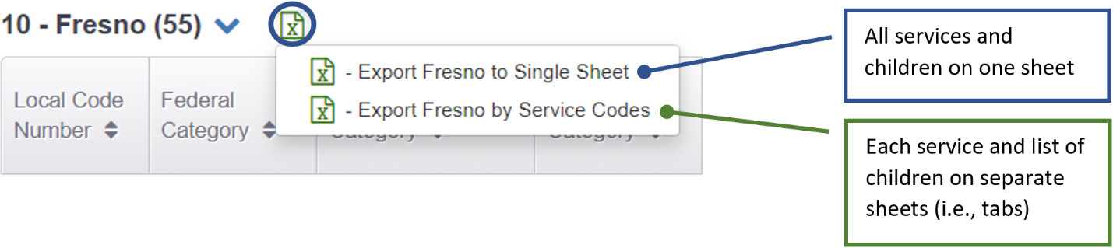

Single Sheet Format
Once you have downloaded the Excel file and opened it, notice that there are two tabs along the bottom. The first has a summary of the data. The second tab has detailed information about each child, the service they received and the service dates. The worksheet also includes columns related to the SSDP, such as selected MPOs, SSDP Components, and Service Hours (if applicable). You can filter specific columns to narrow your view, as shown below:
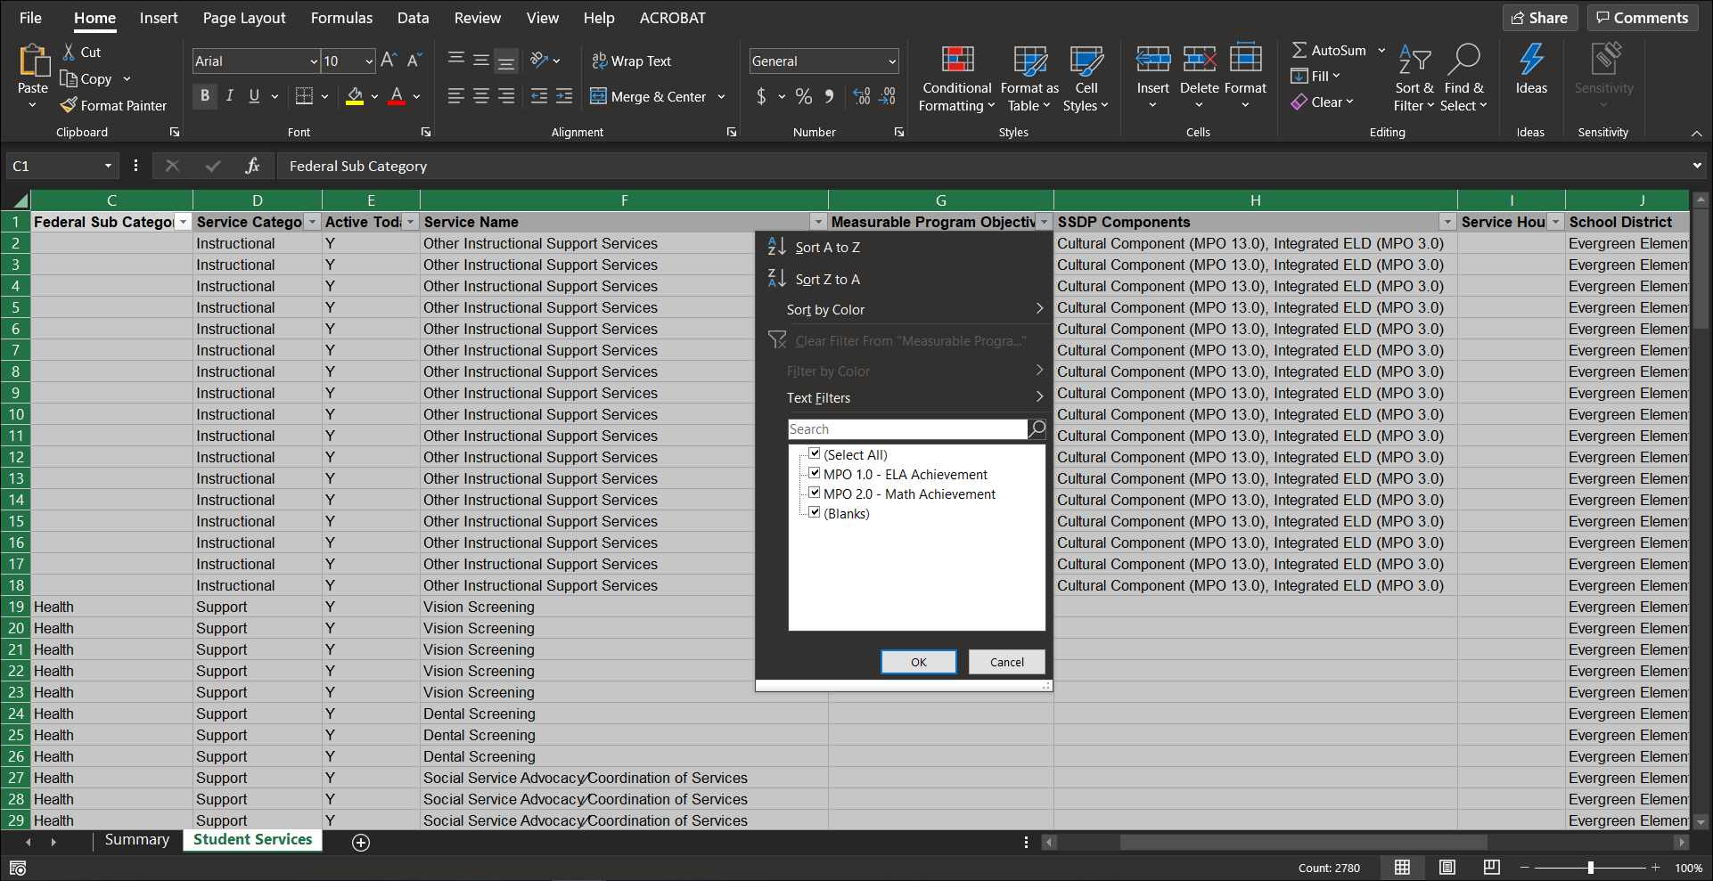

Service Codes Format
After opening the file in Excel, notice that there are several tabs along the bottom. The first tab has a summary of the data. The remaining tabs correspond to each service code in the search results table. Like the Single Sheet Format, this worksheet includes MPOs, SSDP Components, and Service Hours (if applicable), as shown below:
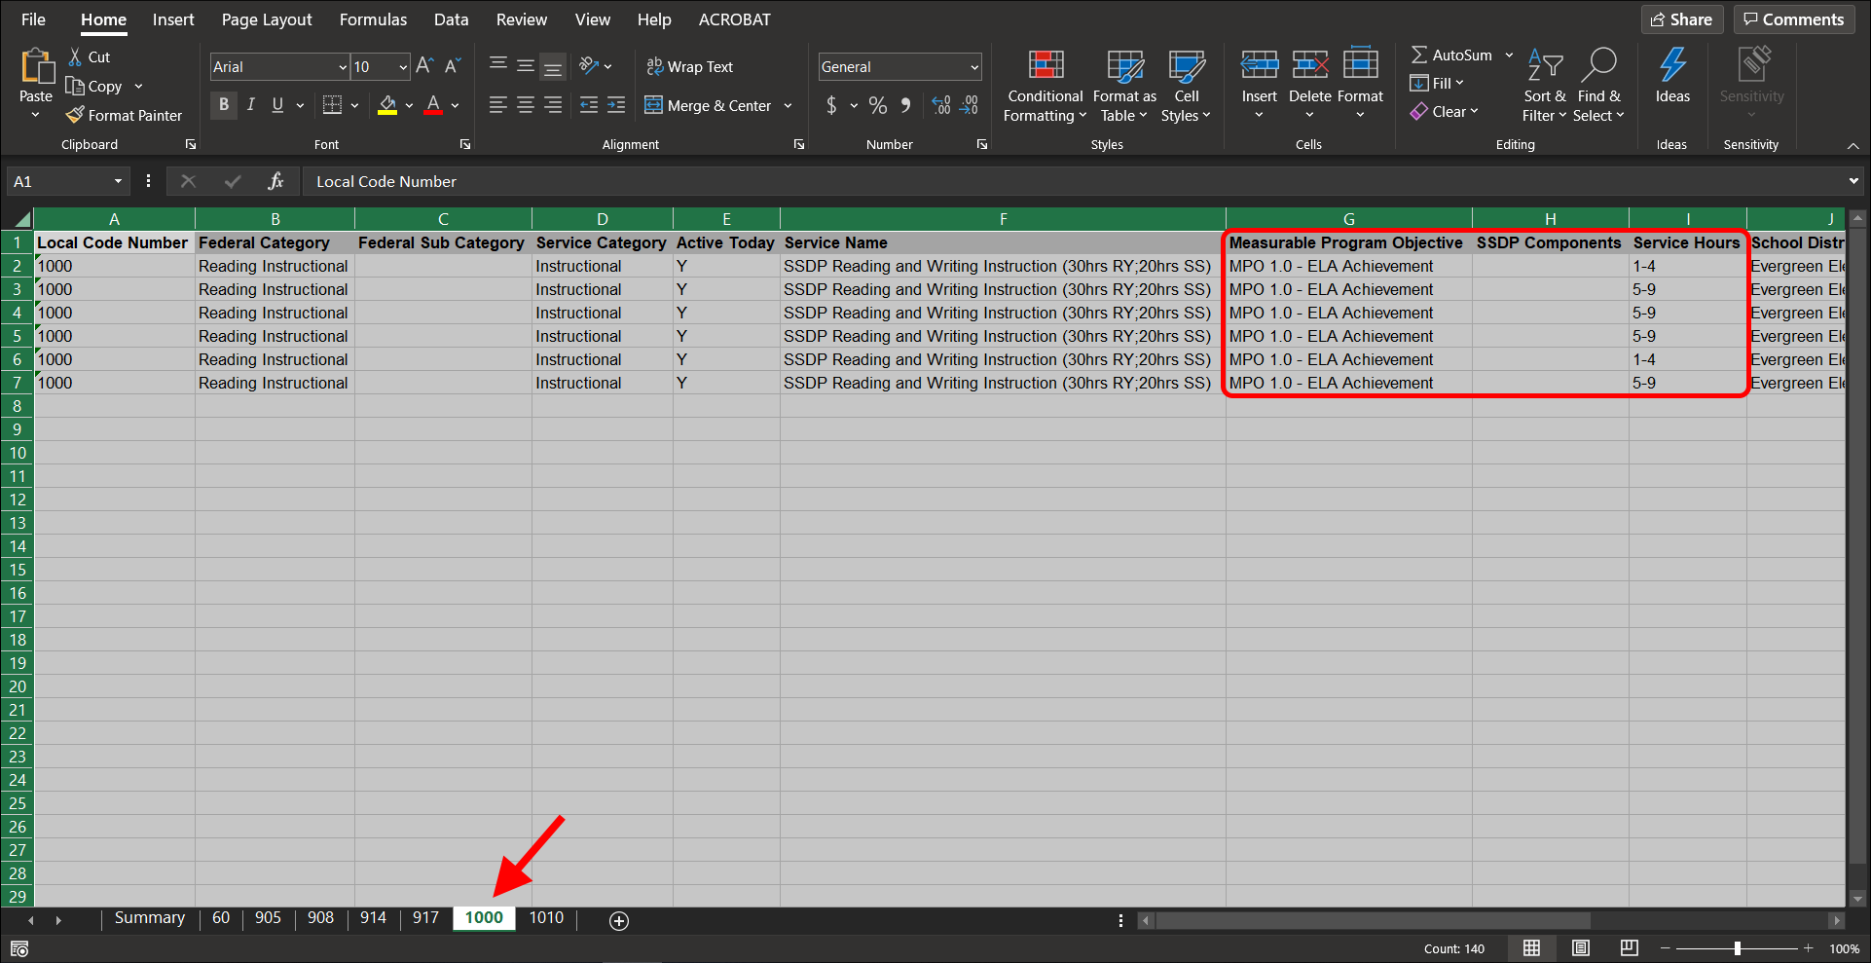

Exported File: Column Definitions
The following table details the contents of the Excel spreadsheet, regardless of format.
Export Column | Definition
Local Code Number | The subgrantee’s local code number for the service.
Federal Category | The Federal category to which the service is mapped.
Federal Subcategory | The secondary category for the service (e.g., Counseling is a secondary category to Support Services).
Service Category | Indicates whether it is an Instructional or Support service.
Active Today | This is selected if the service is active (on the date when the report is run).
Service Name | The name of the service, as set up on the Administer Services page.
Measurable Program Objective | This field lists any applicable MPOs, as set up on the Administer Services page.
SSDP Components | This field lists any applicable SSDP Components (e.g., Integrated ELD, Cultural Component, etc.), as set up on the Administer Services page.
Service Hours | Yes or No, depending on whether the service requires an hours entry.
School District | The district where the children were served.
School Name | The school where the children were served.
CDS Code | The code representing the County, District, and School (CDS).
MSD Number | The child’s Migrant Student Directory (MSD) number.
SSID | The child’s Statewide Student Identifier (SSID) issued by California.
Name | The child’s name.
Grade | The child’s grade when they were served.
Service Period | The service period when the child was served (R, S, I).
Start Date | The date when the service began.
End Date | The date when the service ended.
COS | The Continuation of Services type (COS1, COS2, COS3) for a child who participated in a service after their eligibility expired. Blank, if not applicable.

Additional Resources
If you have specific questions not covered in this guide, please consult with your local team of MSIN Power Users, Managers, and Data Specialists. You are welcome to submit any remaining questions to the MSIN Service Desk by email (msinsupport@wested.org) or phone (1-800-342-2964, option 2).

EiP status is conferred to a migratory child when they have remaining eligibility, based on a valid and unexpired Certificate of Eligibility (COE), and a date was added in the MSIN system (such as a Communication Event, service date, etc.) to prove that the child is/was present in California during the applicable performance period.
The Federal Category options are based on files specifications provided by the U.S. Department of Education (ED) for annual federal reporting purposes, particularly FS145 (https://www2.ed.gov/about/inits/ed/edfacts/file-specifications.html).

