Entering Service Participation Data

Introduction
There are two ways to enter service participation data for migratory children in MSIN: by individual child and as a group of children who participated in the same service(s). Both methods incorporate embedded rules that help users enter accurate, non-conflicting service participation dates.
The target audiences for this guide are MSIN users with the Data Specialist or Student Services role(s). Readers should have experience working with MSIN child records and be familiar with the terminology used for Migrant Education Program (MEP) student services, as detailed in the current State Service Delivery Plan (SSDP).
This guide covers the following topics:
- Entering services for an individual child
- Entering services for a group of children
- Updating services for a group of children
- Tips for using the Group Services feature
- Additional resources

Entering Services for an Individual Child
To enter services for an individual child, we must access their statewide child record. One way to do this is by conducting a search using the Search Children page, as shown below.
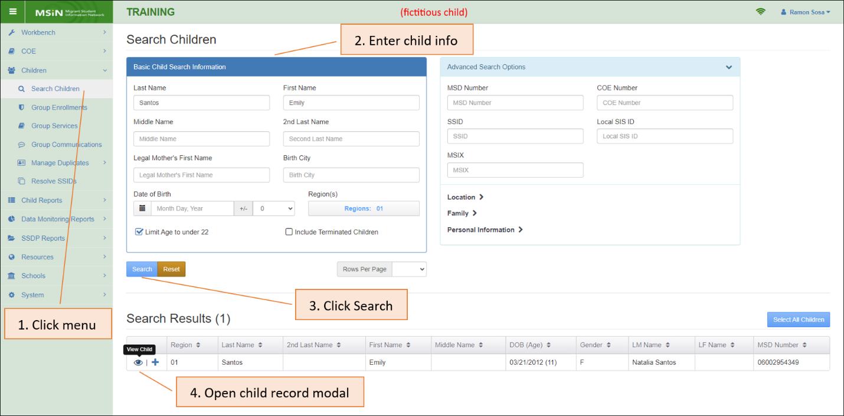
Enter a child’s basic information, such as their name and Date of Birth (DOB), and then click Search. Find the child in the results table and bring up their child record modal by clicking the view icon.
We have created a fictitious child named Emily Santos to serve as an example. The following screenshot shows the Service Participation tab within Emily’s child record modal.
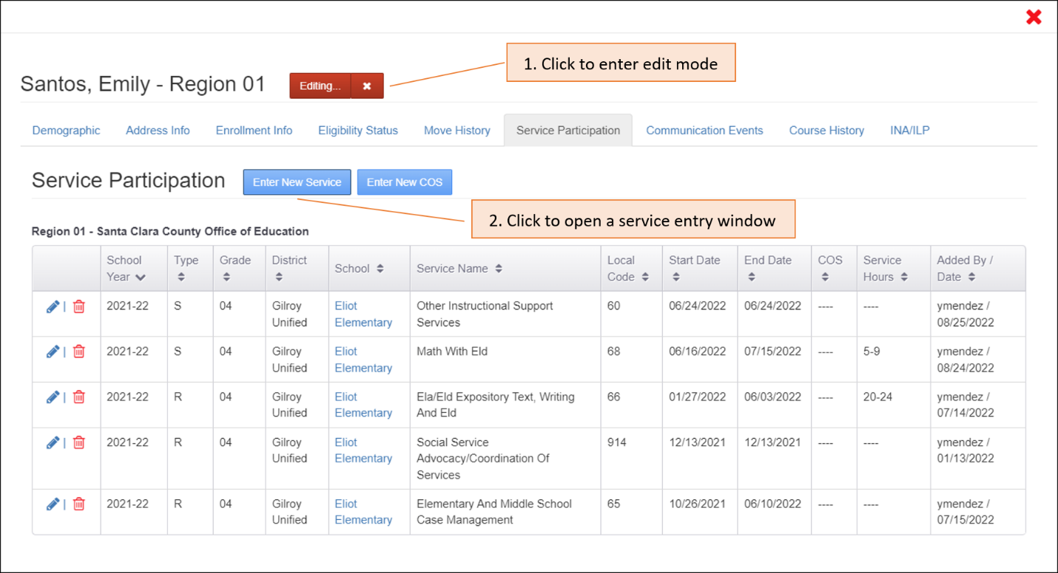
Click the “Edit” button to enter edit mode and then click the blue button labeled “Enter New Service.” This will open a new service entry window with multiple input fields.

School Year
In the service entry window, select the School Year when the child received the service(s).
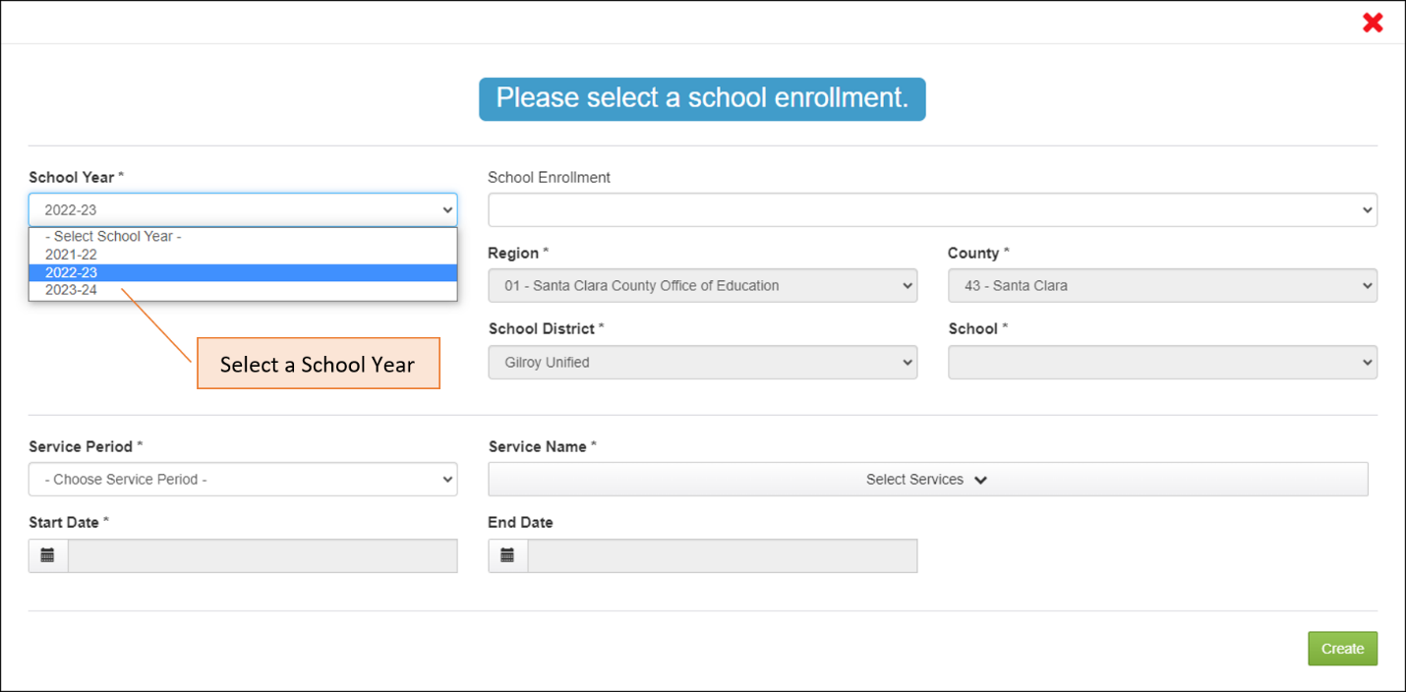
Use local district calendars to determine the correct School Year (the dates when the instructional year begins and ends, including school breaks). If your region covers multiple districts, then you will probably have many different school calendars.

School Enrollment
Once you have selected a School Year, the School Enrollment drop-down menu will automatically populate with the enrollment line(s) in the child’s record that match the School Year, as shown below.
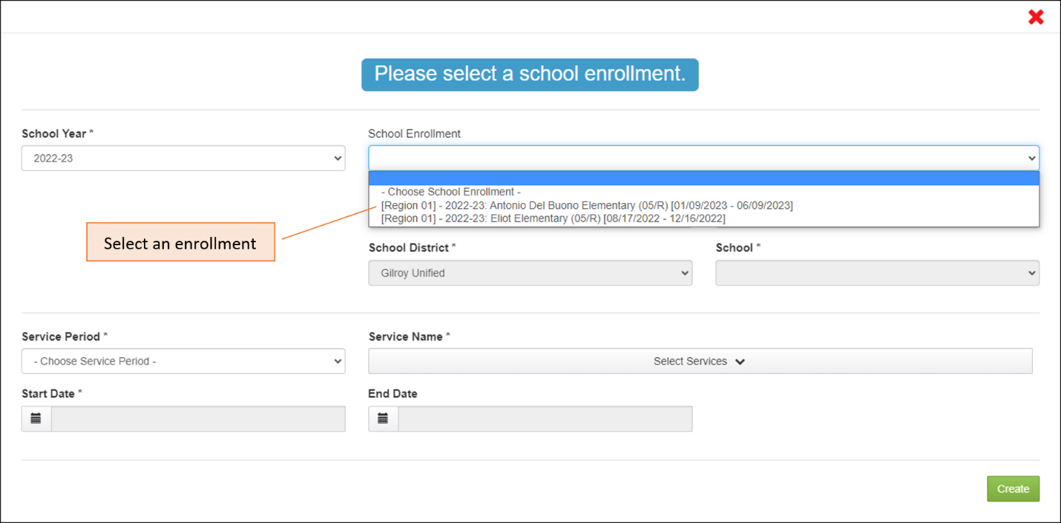
Notice that the options in the School Enrollment drop-down menu show enough information so you can quickly select where (school) and when (Enrollment - Withdrawal Dates) the service took place. In this example, there are two enrollment lines for the 2022-23 School Year.
After you choose an enrollment line, the Region, County, School District and School fields populate automatically. In the screenshot below, we selected the most recent enrollment at Antonio Del Buono Elementary.
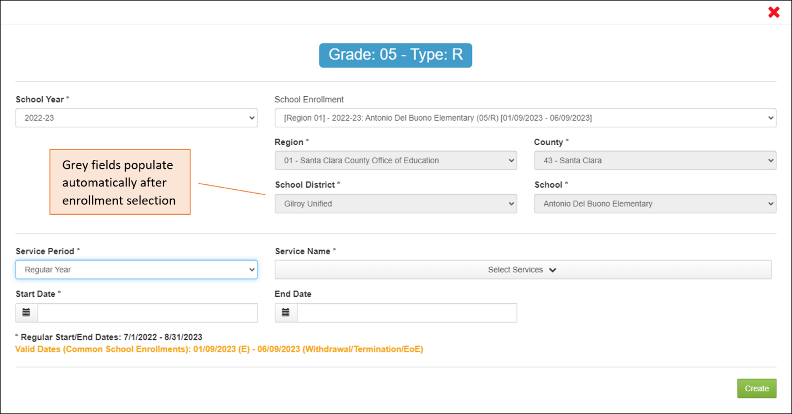
The next step is to select the Service Period when the service was provided.

Service Period
Based on the categories defined in the Consolidated State Performance Report (CSPR), we have three distinct periods for reporting services. MSIN incorporates date rules for each one, as described in the following subheadings.

Regular Year Service Period (RY)
The Regular Year Service Period is used to enter services that were given during the Regular Year (not during breaks). As shown in the screenshot above, your selection will cause guiding messages to appear beneath the Start Date and End Dates fields. These dates are constrained on two levels:
- By the date ranges allowed in the selected Service Period (bold black text).
- By the Enrollment and Withdrawal Dates in the child’s selected enrollment line, if available (bold yellow/gold text).
When we focus on the bold black message, we see a broad date range, between 7/1/2022 and 8/31/2023. Think of these dates as “bookends” which prevent us from accidentally entering service dates that fall outside of the selected School Year. In addition, the message in bold yellow text will often show a narrower range of acceptable service dates because it considers the child’s Enrollment and Withdrawal Dates, if available. This rule prevents us from accidentally entering service dates that fall outside the window when the child was enrolled in school.
To summarize how the date limits work, consider the enrollment lines in Emily’s child record.
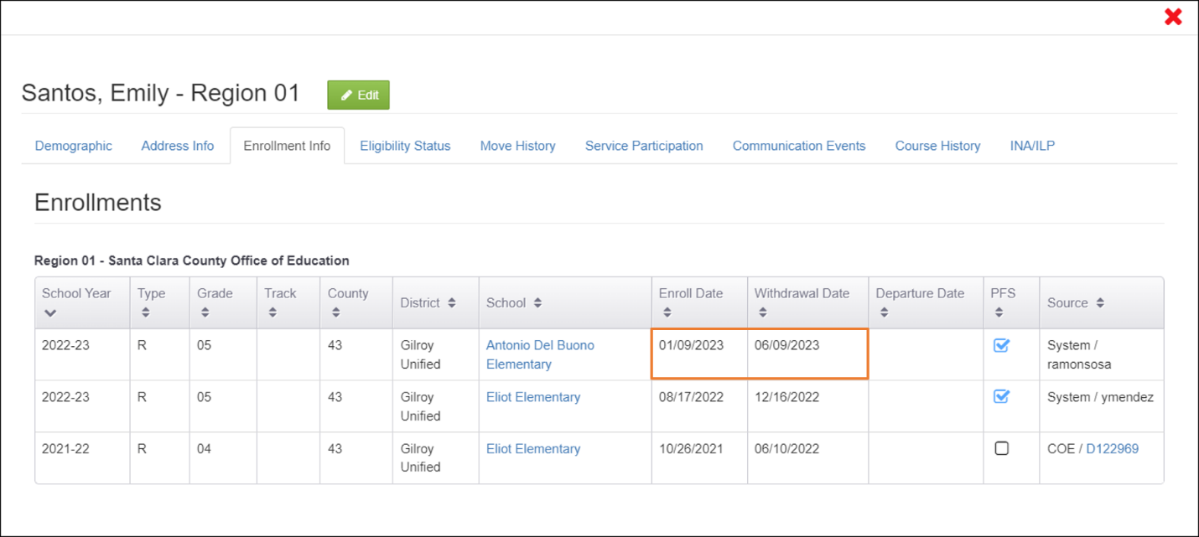
If a Regular Year service is associated with the most recent 2022-23 enrollment line, the Start Date will need to be on or after 1/9/2023. In addition, the service End Date must be before (or up to) the Withdrawal Date, 6/9/2023. This makes sense because a child must be present and enrolled in the local MEP to receive a service from them. The service dates must “fit inside” the enrollment line dates.
Note: Do not enter future Start or End Dates, as the Migrant Student Information Exchange (MSIX) system will reject them and California’s data will be flagged as inaccurate.

Summer Service Period (S)
The Summer Service Period is used to enter Summer services for school districts with traditional calendars that include extended summer breaks. Entering a Summer service is similar to Regular Year, except that the Summer service Start Date must be after the Regular Year Withdrawal Date. An example is shown in the screenshot below.
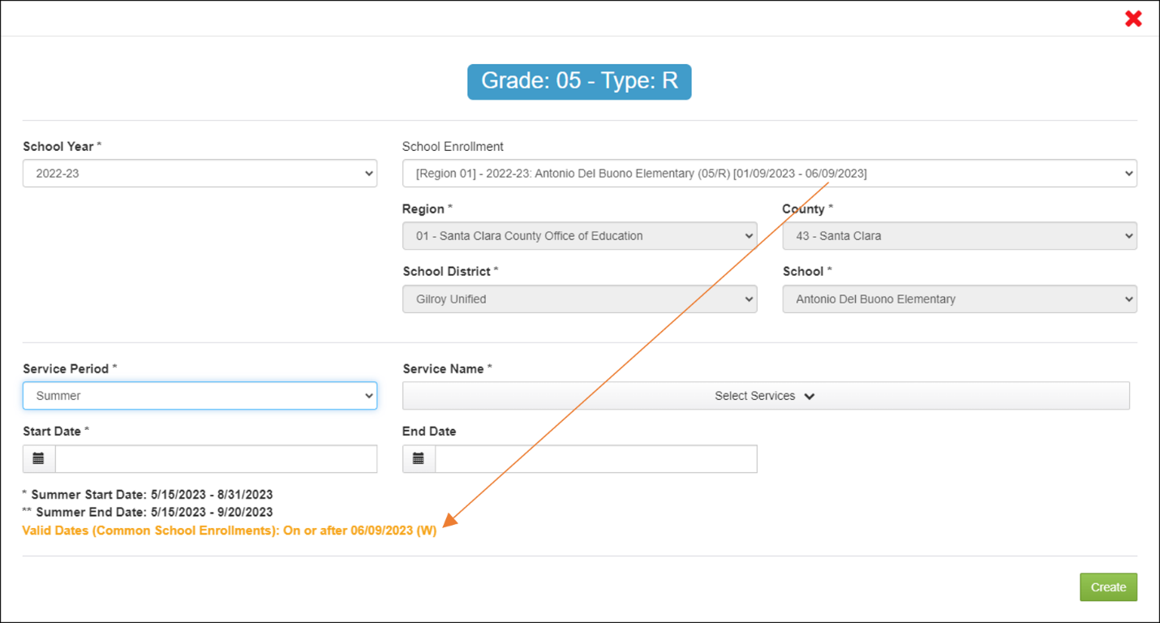
Notice the bold yellow/gold message, which says that the dates must be on or after the Withdrawal Date, 06/09/2023. This rule ensures that dates follow a logical order, with Regular Year services coming first and Summer services following after the Regular Year ends.
To recap, the service Start Date for the Summer service must be after the child’s Withdrawal Date for Regular Year. If no Withdrawal Date exists, then the Start Date must be between 5/15 and 8/31 of the selected School Year (see bold black text). For example, if 2022-23 is selected, then the Summer service Start Date must be between 5/15/2023 and 8/31/2023. The Summer service End Date must be between 5/15 and 9/20 of the selected year (for example, between 5/15/2023 and 9/20/2023). In addition, when both dates are entered at the same time, the End Date must be after the Start Date. These date rules prevent inconsistent or illogical data, as it gets forwarded to the national system, MSIX, and other states may rely on it to better support migratory children who recently arrived in their local area.
Note that there are no Summer School enrollment lines in MSIN. Instead, Summer services are attached to any Type=R (regular attending) or Type=N (non-attending) enrollment line in the selected School Year.
It is especially important to make sure your Summer service information is accurate because it is a funding factor in California’s allocation and your subgrantee allocations. As a result, Summer services are audited regularly by staff at the State level and by the Office of Migrant Education (OME) via the MSIX system. As stated earlier, do not enter future Start or End Dates, as the MSIX system will reject them and California’s data will be flagged as inaccurate.

Intersession Service Period (I)
The Intersession Service Period should only be used when a child is enrolled in a year-round school and the service(s) occurred during a break, or Intersession. This means that a child at a year-round school will only have Regular Year and Intersession services (not Summer services).
The following example is from a different child record (not Emily Santos), and it shows an enrollment at a year-round school in Region 9, Otay Elementary.
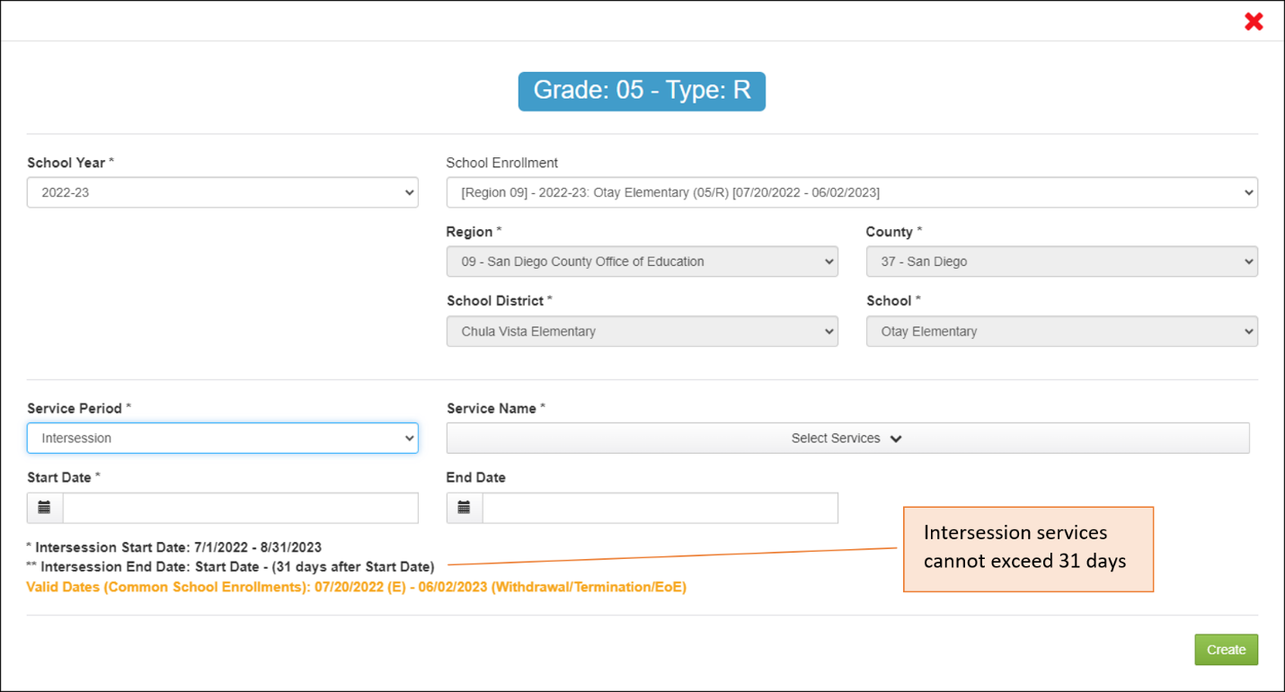
After selecting “Intersession,” review the date limits described in the black text message under the Start Date and End Date fields. Let us zoom in a little more:
*Intersession State Date: 7/1/2022 – 8/31/2023
**Intersession End Date: Start Date – (31 days after Start Date)
Valid Date (Common School Enrollments): 07/20/2022 (E) – 06/02/2023 (Withdrawal/Termination/EoE)
The earliest Intersession service you can have will be during the first school break in the year-round calendar, which will logically be after the child’s enrollment date. Furthermore, the Intersession service End Date must be within 31 days of the Start Date. These rules ensure that Intersession services follow a logical format, given that year-round calendars do not have extended summer breaks like traditional school calendars.
In addition, notice that the message in yellow/gold text will reference the Enrollment and Withdrawal Dates from the child’s enrollment line. These limits ensure that the Intersession service “fits inside” the dates when the child was enrolled in the year-round school.
Like Summer services, Intersession services are a funding factor. Please make sure you only use this option for year-round schools and that all service data is accurate. This is very important because the MSIN system continuously exchanges data with the MSIX system. Again, do not enter future Start or End Dates, as the MSIX system will reject them and California’s data will be flagged as inaccurate.

Service Name
The next step is to add the Service Name(s) from the drop-down menu. Returning to our example with fictitious student Emily Santos, we can select one or more services, if they have the same Start Date and End Date.
Suppose that Emily received a case management service while she was enrolled at Antonio Del Buono Elementary School. Notice that the local code number is always shown first and then the Service Name: 65—Elementary and Middle School Case Management.
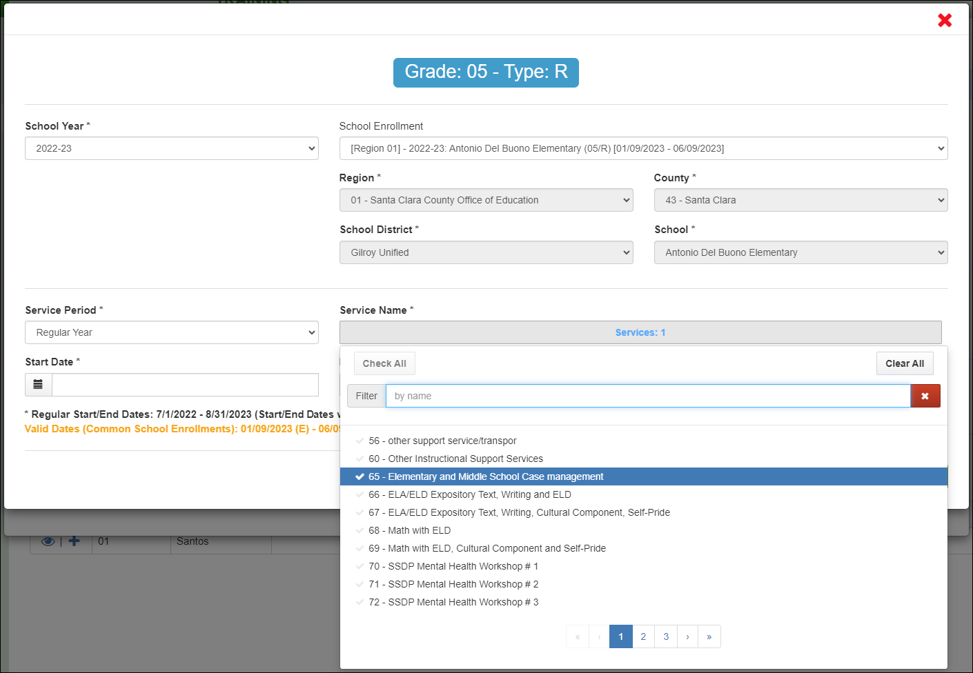
It is also important to know that the list of service options under the Service Name drop-down menu is constrained in two ways:
- By the child’s grade level (grade 5 in the example above).
- By the service period (Regular Year above).
These two properties, grade level(s) and service period(s), were configured when each service was created by your management team, under the Administer Services page. The result is that only the appropriate services will appear in the drop-down menu. For example, services that were created for preschoolers (grades P3-P5) will not appear for our fifth-grade student, Emily. In addition, when you select the Regular Year Service Period, this will exclude any services created specifically for Summer or Intersession. The net effect is that the Service Name list is shorter, directly applicable, and easier to use.

Start and End Dates
As described earlier in the Service Period sections above, the combination of Service Period date limits and School Enrollment date limits, together, constrain the service entry calendars. This happens when you click on the date fields, as the calendars will only enable the date ranges shown in the messages. For instance, the calendars in our example will only allow us to select dates on or after Emily’s Enrollment Date and before (or up to) her Withdrawal Date, as shown in the screenshot below:
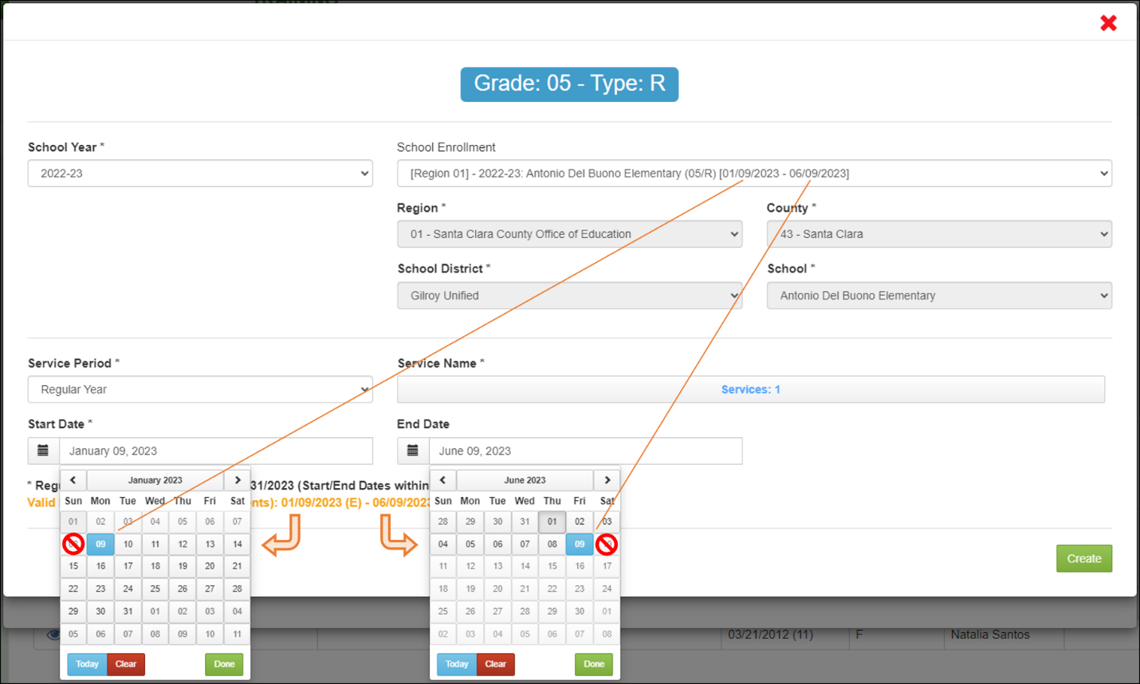
Notice that dates before 1/9—before Emily enrolled—are grey and disabled. In addition, the dates after 6/9—after Emily withdrew—are also grey and disabled. If we try to click on a date outside these limits, the cursor will turn into a no symbol (circle-backslash). This prevents us from accidentally selecting dates that would logically conflict with either date in the enrollment line.

Confirmation
The penultimate step is to click on the “Create” button, found on the lower right corner. This will trigger a confirmation window, as shown below:
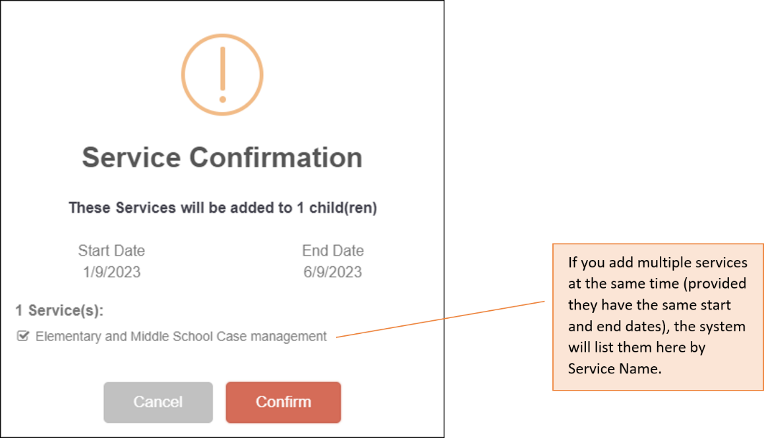
Review the information to make sure it is correct. If you find an error, return to the previous screen by clicking “Cancel.” If everything looks perfect in the Service Confirmation window, then click “Confirm” to save. The service entry process is now complete.
We can double check that our service was truly saved by reviewing Emily’s child record, under the Service Participation tab. The service table displays the most recent services at the top, which is where we find the case management service we just entered.
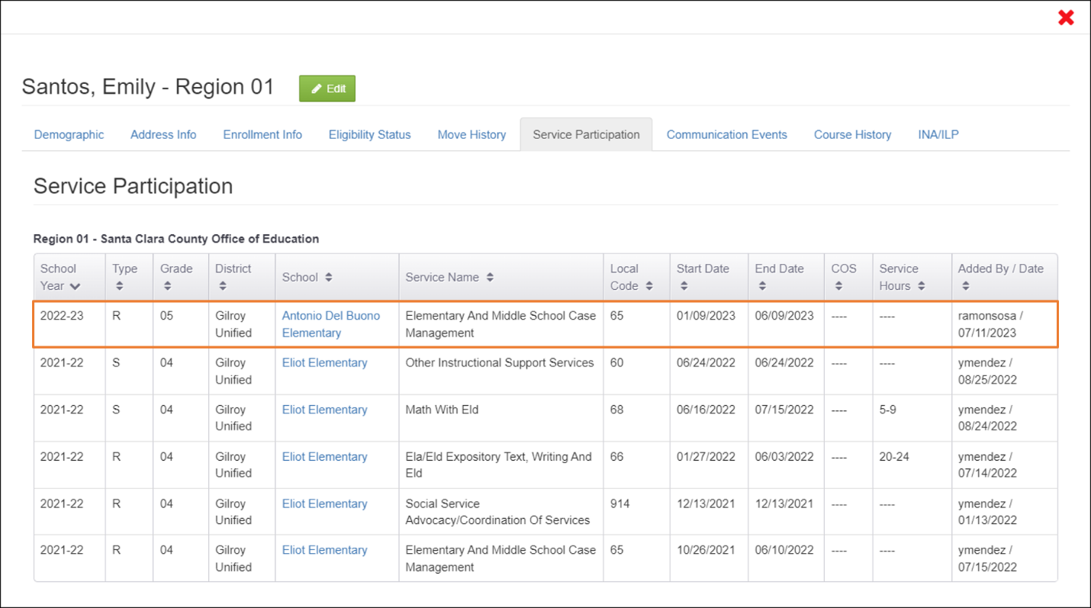
Notice that the final column on the right shows who added the service (Ramon Sosa) and when they added it (07/11/2023).
Emily’s service participation data can also be confirmed using the Service Report, which is designed to extract data for many children at once (such as by school, district, and many other filters).
This concludes our example with fictitious student, Emily Santos. The next two sections cover variations that may apply to some children, depending on their enrollment type and whether the services they received should also include hours of participation.

Children with Type=N Enrollments
Children who are not attending school, such as very young children (grades P0-P5) and Out-of-School Youth (OSY, grade NA) will have Type=N (non-attending) enrollment lines. Type=N enrollment lines do not have enrollment and withdrawal dates, so they cannot serve as date limits. Instead, the limits shown in yellow/gold text for a Type=N enrollment are the first possible date in the selected service period and the child’s End of Eligibility (EOE) date. For example, here is a service entry window for an OSY who received services from Sequoia District Adult Education:
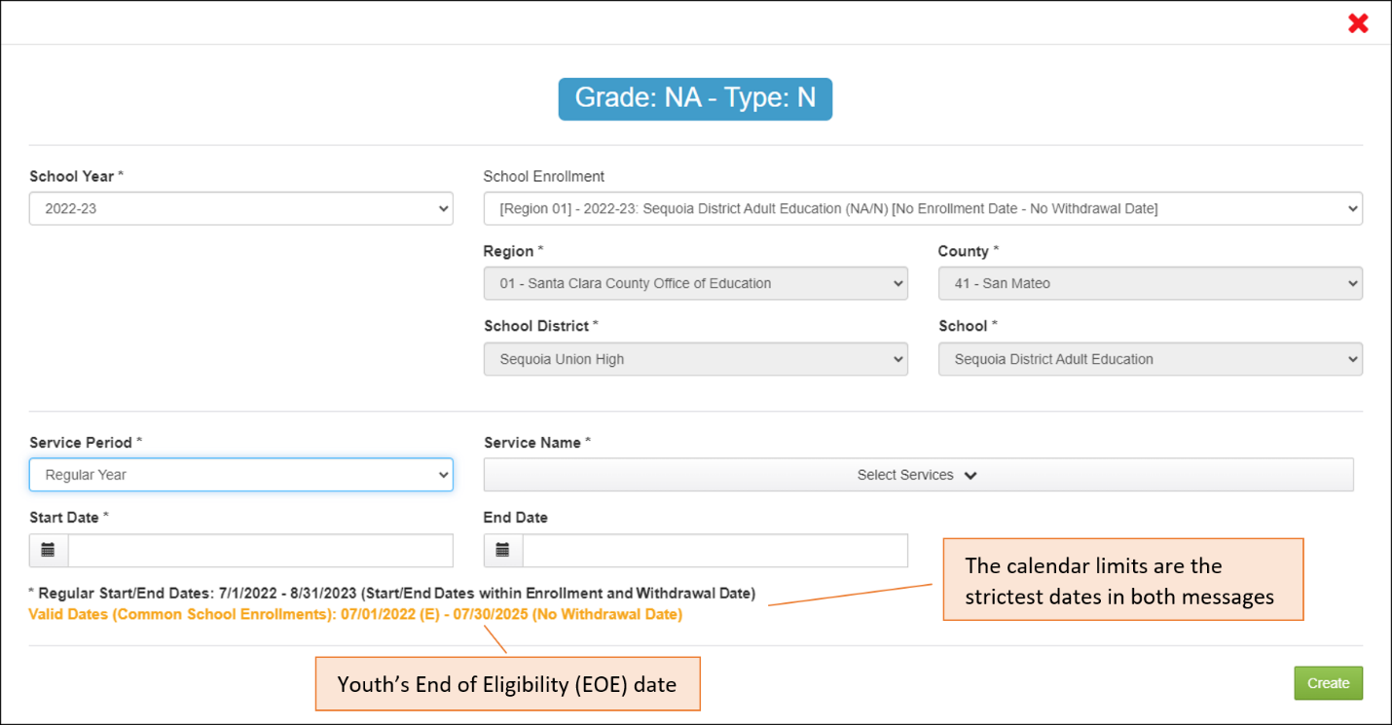
Based on the two date limit messages, the Start Date for a Regular Year service must be on or after 7/1/2022 and the End Date must be on or before 8/31/2023. In this case, the yellow message is not relevant because the youth does not lose eligibility until the 2025-2026 School Year.
To further illustrate how the date limits work for Type=N enrollments, imagine that a different youth has the same enrollment information, except they will turn 22 years old on 2/1/2023. If this were true, then their service End Date must be on or before 2/1/2023 and the yellow/gold message would show this date. The system will limit the date fields based on the strictest, or narrowest, window of time shown in the two messages.

Services with Hours of Participation
Some services related to the State Service Delivery Plan (SSDP) require you to enter hours of participation. If this is the case, the system will prompt you to select a range of hours from a drop-down menu, as shown below.
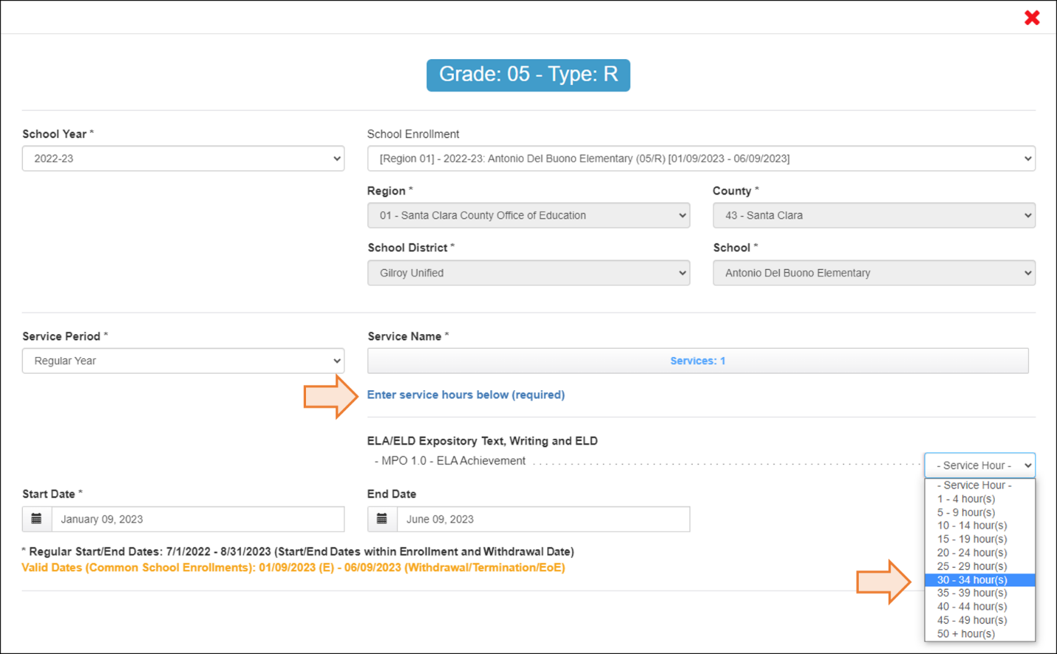
Services hours are a required field for some SSDP-related services, which means that you cannot save the service without selecting an hour range.
Teachers, paraprofessionals, and other service providers have attendance logs where total hours are typically calculated before they provide a copy to Data Specialists, or staff with the Student Services role, to enter in MSIN.
For a real-world example of an SSDP-related service, including a demonstration of entering service hours, see the following video: https://vimeo.com/675611198

Entering Services for a Group of Children: Step-by-Step Instructions
The Group Services page is used to add services for a group of children who are enrolled at the same school. This page is found under the Children menu option, as shown in the screenshot below.
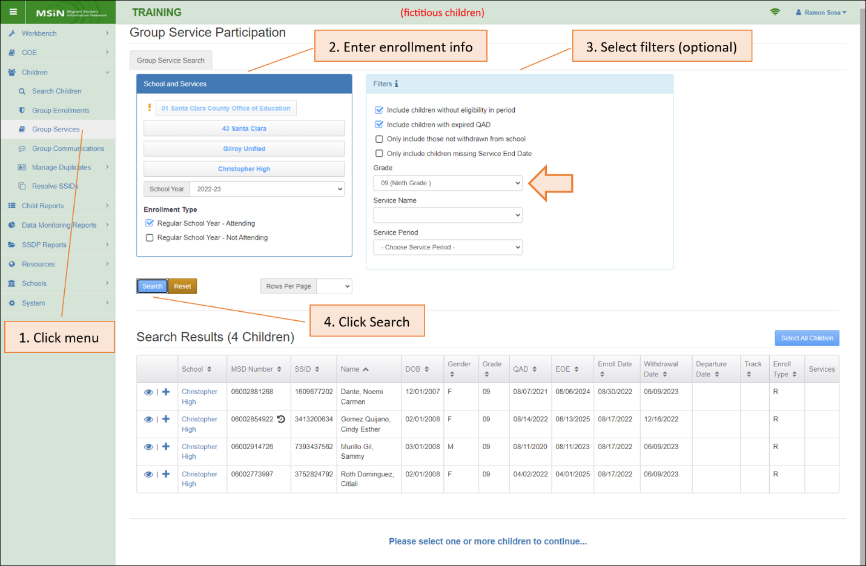
Notice that you must enter enrollment information (number 2 above) to create the list and filter options are available (number 3) to narrow down the results. For example, this search includes a filter for ninth grade (see arrow above) and the results table only shows ninth-graders in the MEP who attended Christopher High School in Gilroy, Region 1.
Let us take a moment to define all the filter options.
Filter | Description
Include children without eligibility in period | Selected by default. Returns children who do not have a date within the performance period that confirms their presence (such as a Communication Event, enrollment date, service date, etc.).
Include children with expired QAD | Returns children who are no longer eligible for the MEP, as of the search date.
Only include those not withdrawn from school | Returns children who do not have a Withdrawal Date in the selected School Year.
Only include children missing Service End Date | Returns children who have service records that are missing service End Dates. Used in conjunction with the Service Name drop-down menu.
Grade | Returns children who are enrolled in the selected grade level.
Service Name | Returns children who have the selected service. Used to update the same service for a group of children, such as adding or changing a service End Date for a group.
Service Period | Returns children who have a service(s) in the selected service period. Used to update services for groups of children.
In the following step-by-step example, the fictitious children in the screenshot above will help us demonstrate the recommended process to enter services for groups. The larger the group of children, the more important it is to follow these recommended steps because they minimize mouse clicks and help you avoid confusion about the service Start Date and End Date limits.
For our Group Services example, we want to enter Case Management services for ninth-graders that were provided during the Regular Year, from 8/22/2022 to 6/9/2023.

Step 1: Use the Group Service Participation screen to bring up a group of children and create the target list.
Returning to the previous screenshot, we conducted a search for children with a Regular School Year enrollment at Christopher High School and we used the Grade filter to get only the ninth-graders. From the results table, we can create the target list of children who will receive the Case Management service information.
One option is to select all the children in the results table by clicking on the blue button labeled “Select All Children,” as shown below.
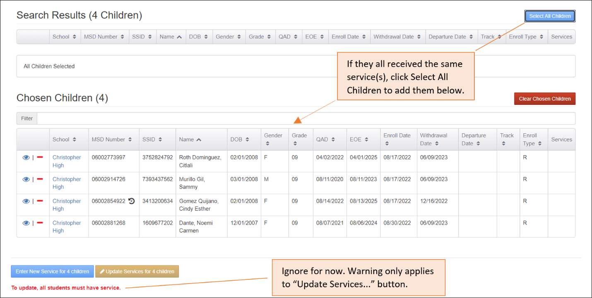
Notice that this moves the children from the “Search Results” table to the “Chosen Children” table below it.
Another way to create the target list is to add or remove children from the “Chosen Children” table by clicking on the plus and minus icons in each child’s row. For example, Citlali and Sammy were added individually using their plus icons in the following screenshot:
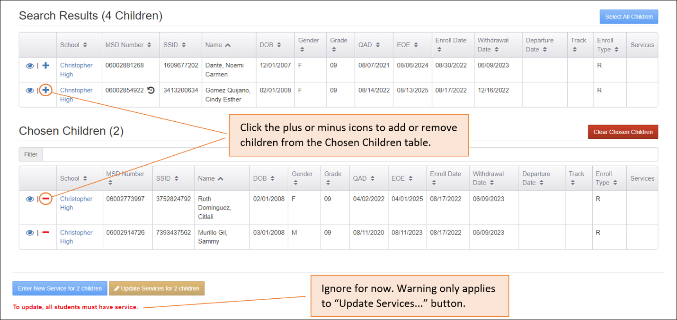
In this case, the target list only has two children. In a real-world scenario, you would keep adding or removing children, using the plus and minus icons, to get the desired list.
For our example, let us suppose that all four children are chosen, as shown earlier, and then we click on the blue button labeled “Enter New Service for 4 children.” This will trigger a pop-up window where we will enter service information for our target list.

Step 2: Display the list of children who will receive the service information.
Let us examine the service entry window in detail. As with the prior example, only fictitious children are shown in the following screenshots.
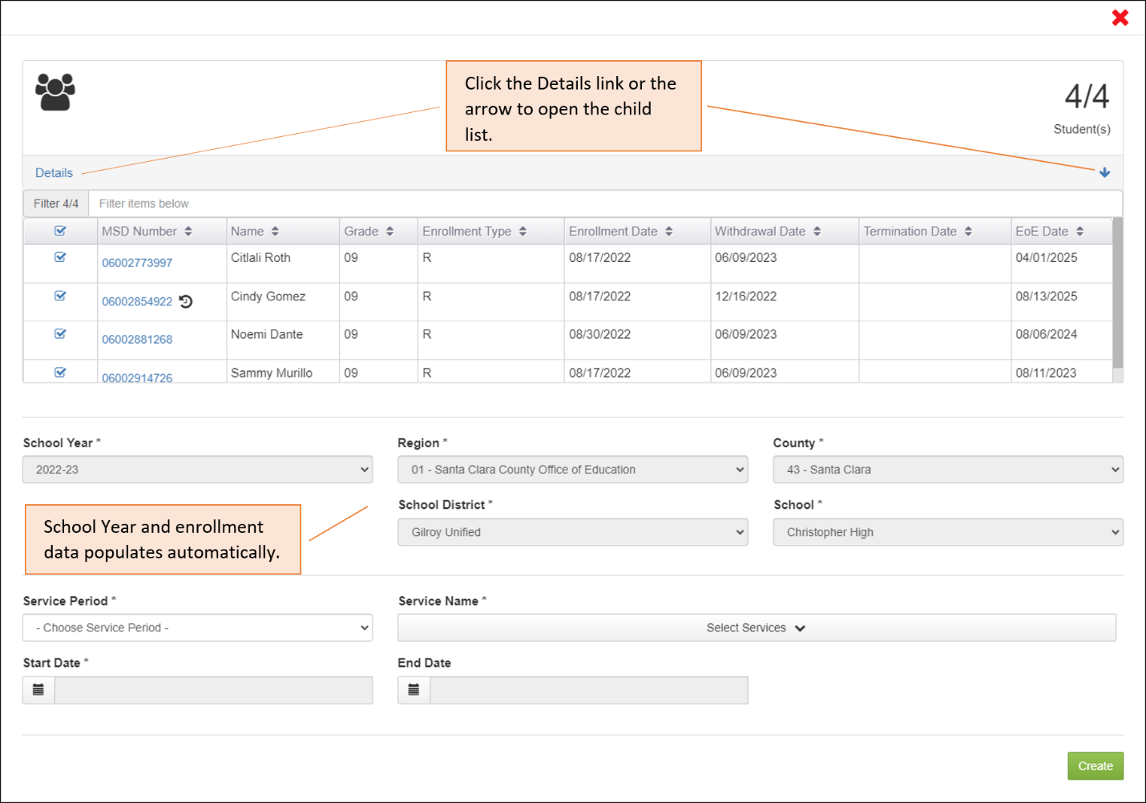
The upper panel shows the number of children in the group. Click on the “Details” link, or the blue arrow on the right, to expand the panel and display a table listing the children and their relevant information.
Notice the grey fields, where the MSIN system automatically populated the School Year and enrollment information by copying the enrollment parameters that we entered in our initial search. This reduces the number of clicks needed to enter services and ensures that the services are clearly associated with the intended enrollment line.

Step 3: Sort the list of children by their Enrollment Date and uncheck the children with date conflicts (those with Enrollment Dates after the service Start Date).
Our goal is to enter a Case Management service that started on 8/22/2022, so we need to consider if any of the children’s enrollment information will conflict with this Start Date. The easiest way to check for conflicts is by following this process:
- Click on the “Enrollment Date” column header to sort.
- Uncheck all children who were enrolled after the service started (after 8/22/2022). A child cannot be served before they are present (enrolled).
After sorting the Enrollment Date column, our screenshot shows that one student has a conflict with our intended Start Date. Noemi enrolled on 8/30/2022, so we will uncheck her row to remove her from this group.
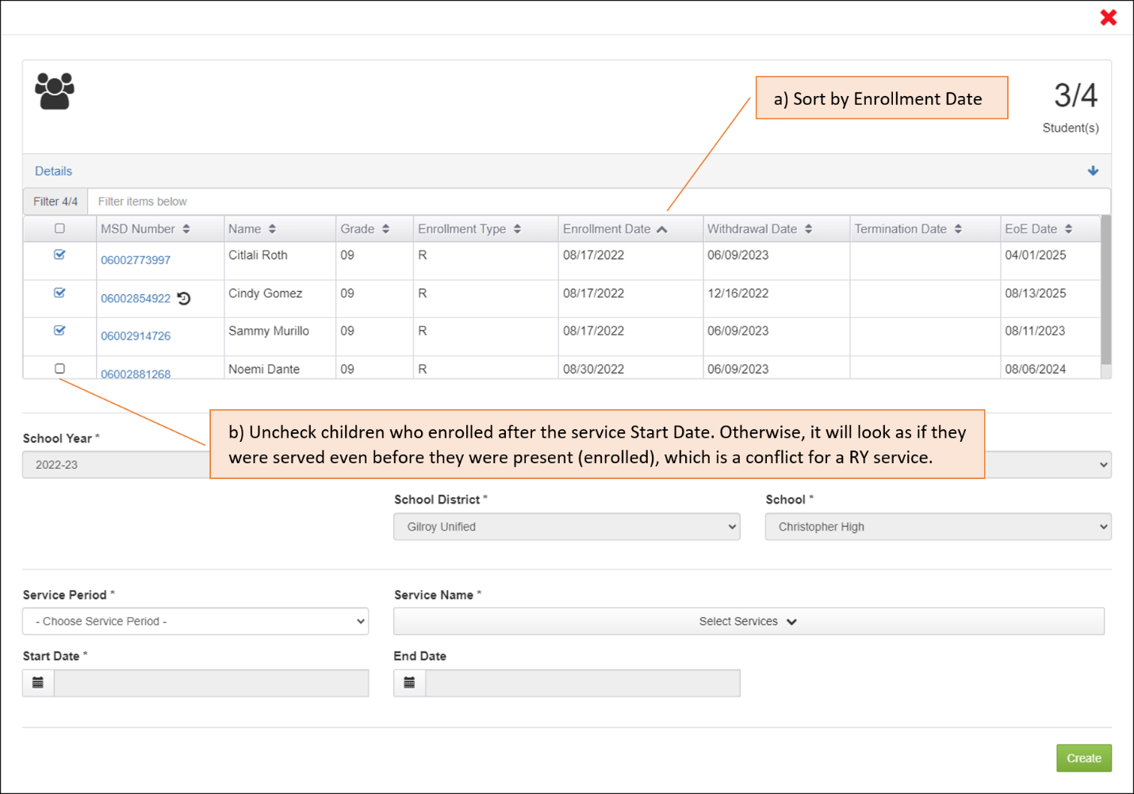
Because Noemi enrolled later (was not present yet on 8/22), she would need a different Start Date. This means her service participation information will need to be entered separately (not part of this group). The remaining children do not have a conflict with our service Start Date, so we can leave them checked.
Notice the upper right corner of the window, where it now says that three children (of the original four) will receive the service participation record.

Step 4: Sort the list of children by their Withdrawal Date and uncheck the children with date conflicts (those with Withdrawal Dates before the service End Date).
The Case Management service we want to enter ended on 6/9/2023, so we need to remove any children who left before our service End Date. We can check for date conflicts by following this process:
- Click on the “Withdrawal Date” column header to sort.
- Uncheck all the children who withdrew before the service ended (6/9/2023). They could not have been served if they were no longer present.
After sorting the Withdrawal Date column, our next screenshot shows that one student has a conflict with our intended End Date. Cindy withdrew from school on 12/16/2022, so we will uncheck her row to remove her from this group.
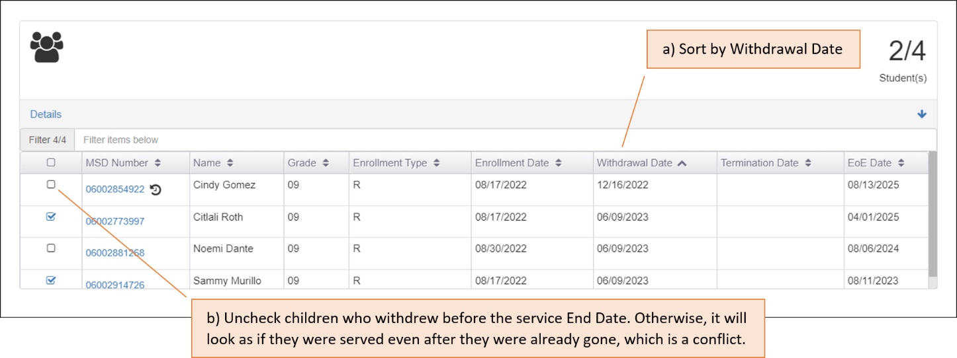
Given that Cindy withdrew earlier (was not present up to 6/9/2023), she would need a different End Date. This means her service participation information will need to be entered separately (not part of this group). The remaining children do not have a conflict with our service End Date, so we can leave them checked.
Notice the upper right corner of the window, where it now says that two children (of the original four) will receive the service participation record.

Step 5: Select the Service Period and check the warning messages under the Start Date and End Date fields to be sure the intended service dates will not conflict with any child’s Enrollment and Withdrawal Dates.
As soon as you select the Service Period, the system will display a warning message regarding the Service Period date limits (in black text), and it will detect the Enrollment and Withdrawal Dates that are common to the selected children in the group (in yellow/gold text).
After selecting Regular Year for our example group, the system displayed the following messages:
*Regular Start/End Dates: 07/01/2022 – 08/31/2023
Valid Dates (Common School Enrollments): 08/17/2022 (E) – 06/09/2023 (Withdrawal/Termination/EoE)
The Start Date field will accept a date on or after 8/17/2022 because it is the latest enrollment date for the remaining two children (see the first date in the yellow/gold text).
The End Date field will accept a date before (or up to) 6/9/2023 because this is the earliest withdrawal date for the group (again, see the second date in the yellow/gold text).
The combination of Service Period limits and School Enrollment limits, together, define the acceptable date window. In addition, when you click on the date fields, the calendars will only enable the strictest, or narrowest, date range shown in the two messages.

Step 6: Select one or more services.
The next step is to add the Service Name(s) from the drop-down menu. As with individual children, it is also possible to add multiple services at once, if they have the same Start Date and End Date.
In this example, we want to add one service: 120—SSDP HS Case Management—Increase Grad Rate. The following screenshot shows this selection in blue, and it lists other services which could apply to the selected group.
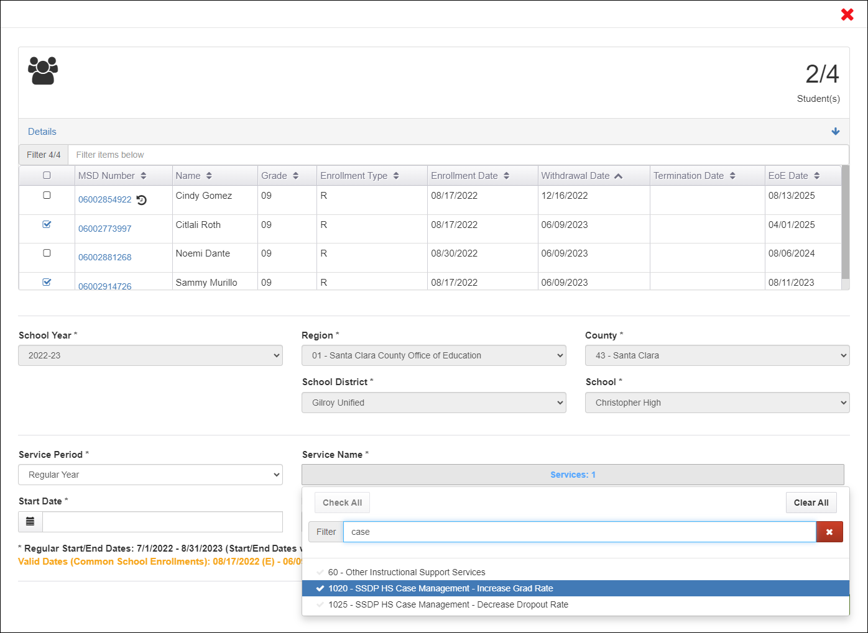
It is important to know that the list of service options under the Service Name drop-down menu is constrained in two ways:
- By the group’s grade levels (only grade 9 in the example above).
- By the service period (Regular Year above).
These two properties, grade level(s) and service period(s), were configured when each service was created by your management team, under the Administer Services page. The result is that only the services which could apply to the selected children in the group will appear in the drop-down menu.
If you are working with a group of children in different grade levels, then the drop-down menu will only show services that are common to those grade levels. For example, if we add students in grade 12 to the target list above, the drop-down menu will no longer show codes 1020 and 1025 because these were set up for grade 9 only and they would not apply to 12th-graders. But code 60 (Other Instructional Support Services) would still appear because it was set up as applicable to all grades. To recap, the Service Name drop down menu will only show services that can apply to all the grade levels in the selected group of children.
In addition, when you select a service period, this will automatically exclude services that were set up exclusively of other service periods. In our example, selecting the Regular Year Service Period automatically excludes all services created specifically for Summer or Intersession.
The net effect of these Service Name filters—which consider both grade levels and service periods—is that the Service Name list is shorter, directly applicable to the group, and it prevents conflicting data.

Step 7: Enter service Start and End Dates.
As stated earlier, when you click on the Start Date and End Date fields, the calendars will only enable the strictest, or narrowest, date range shown in the two date limit messages. These messages are based on the children we selected from the group. For instance, based on selecting Citlali and Sammy, the calendars in our example will only allow you to select dates on or after the latest enrollment date in the group (8/17/2022) and before (and up to) the earliest withdrawal date in the group (6/9/2023), as shown in the screenshot below:
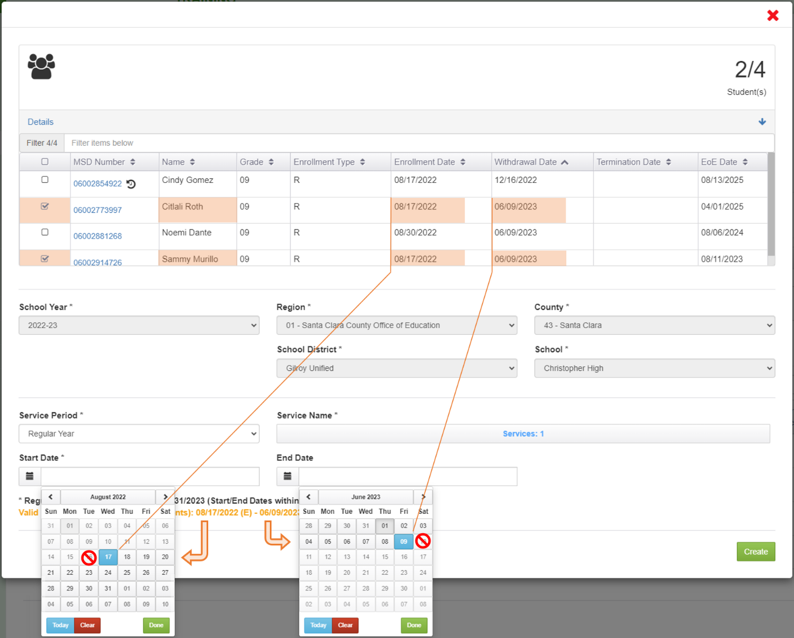
Remember, we want to enter Case Management services for ninth-graders and these services were provided during the Regular Year, from 8/22/2022 to 6/9/2023. As a result, we had to de-select Cindy and Noemi because one of their dates conflicted with the desired service date range. Their enrollment information is unique, so their service participation should be entered individually rather than using the Group Services feature.
Focusing on the Start Date calendar, notice that dates before 8/17/2022 are grey and disabled. In the End Date calendar, dates after 6/9/2023 are also grey and disabled. These restrictions prevent us from accidentally selecting dates outside of the limits described in the messages.
To summarize, the service Start Date and End Date calendars will only allow selections between the dates shown in the messages. Unchecking (or checking) any child in the target list will cause the yellow/gold message to update with new dates and the calendars will update accordingly.

Step 8: Confirm the service information before saving it to the selected group of children.
When you are ready to submit, the Group Service Participation window should only include the children without any conflicts, where the service dates “fit inside” the Service Period dates and the group’s enrollment dates. This is summarized in the following screenshot with notes.
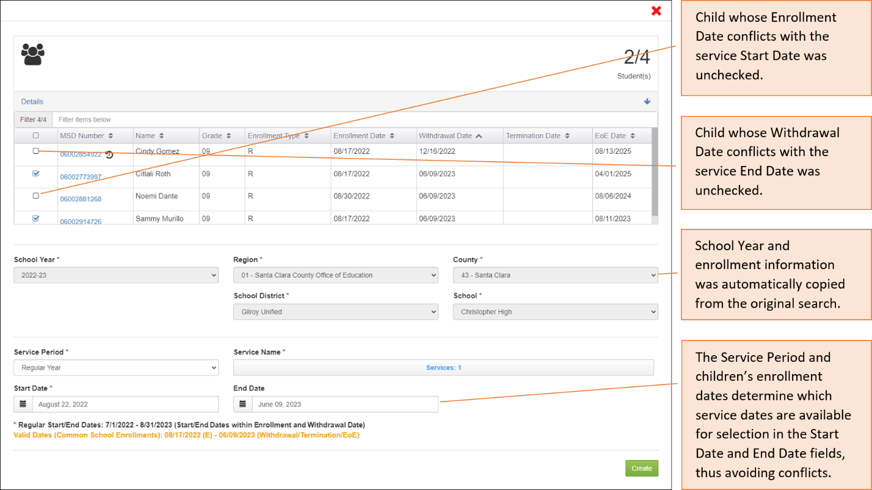
At this point, we review every field, make any needed adjustments, and then we click the “Create” button on the bottom right.
Creating the participation record(s) will trigger a final confirmation window that shows the number of children, the service dates, and the service(s) by name.
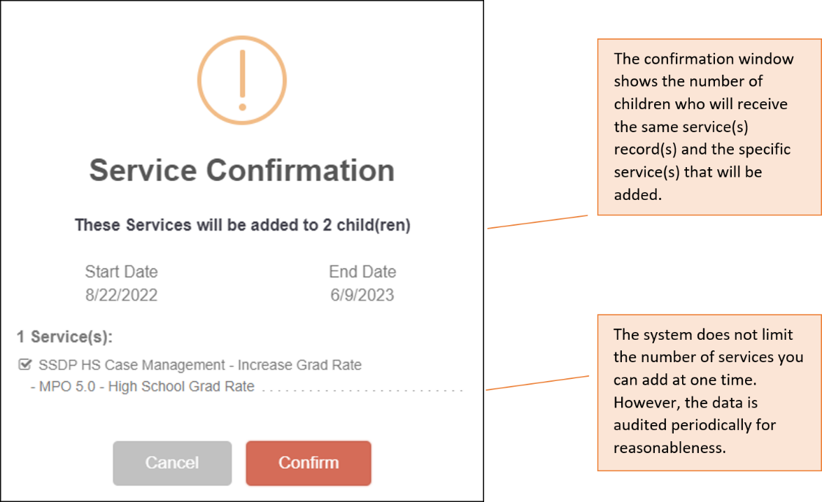
If everything looks as expected, click “Confirm” to apply the information to the selected children in the group. Conversely, you can click “Cancel” to return to the prior screen and make changes, as needed.
This concludes our Group Services example. We recommend practicing the steps shown above in the Training MSIN site (https://trainingmsin.wested.org/) until you feel confident using this feature for large and diverse groups.

Updating Services for a Group of Children
When you create a target list of children with the Group Services page, you will see an additional button labeled “Update Services for (#) children.” This button is visible but disabled by default, unless one or more children in the target list already have a service record. This feature is commonly used for two purposes:
- To fix incorrect Start Dates or End Dates for a group.
- To add missing End Dates for a group of children who have incomplete service participation records.

Correcting Start Date or End Date information for a group
Returning to the group of children we used in the Group Services example, imagine that we made a mistake on the service End Date. Instead of being 6/9/2023, suppose the service actually ended two days earlier, on 6/7/2023. We can correct this mistake by calling up the same group of children, based on the service information we entered earlier. We can do this by using the filters on the Group Services search screen, as shown below.
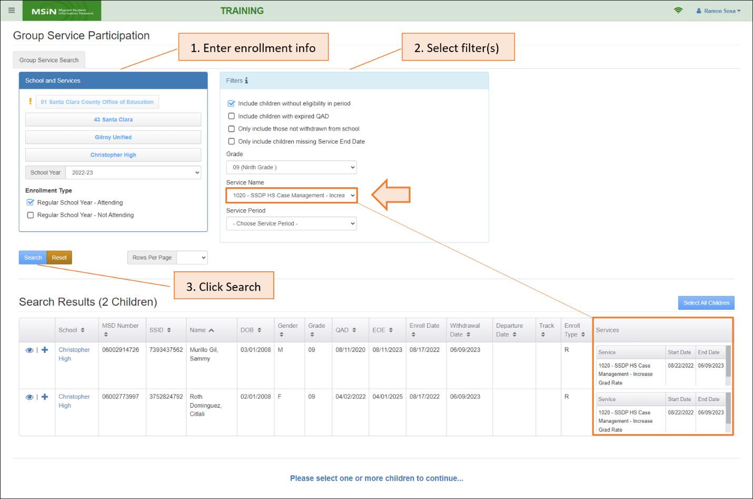
Notice that the search process is the same as our previous Group Services example, except that we used the Service Name drop-down to return children who already have code 1020 (SSDP HS Case Management). The last column in the results table helps us confirm the service and dates.
Next, we create the target list by selecting the children who need the date correction, as shown below:
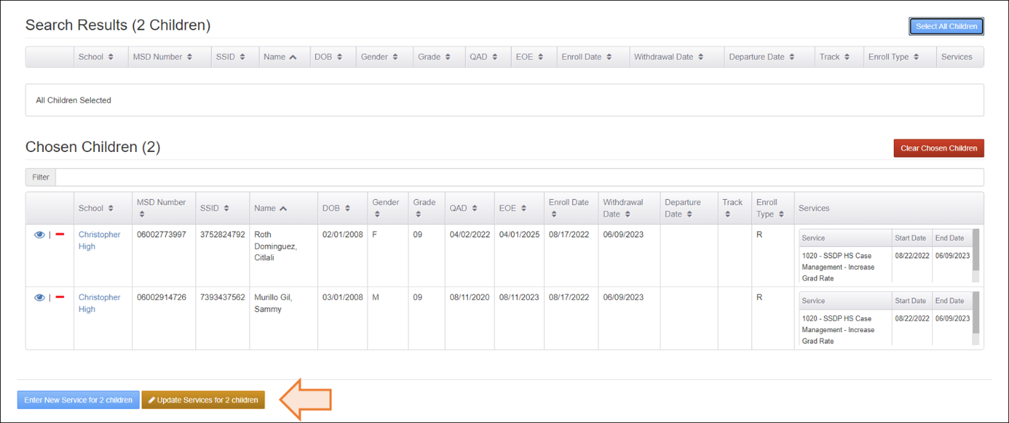
All the “Chosen Children” have service information, so the system enables the “Update Services...” button. We can click on this button to bring up the following Update window:
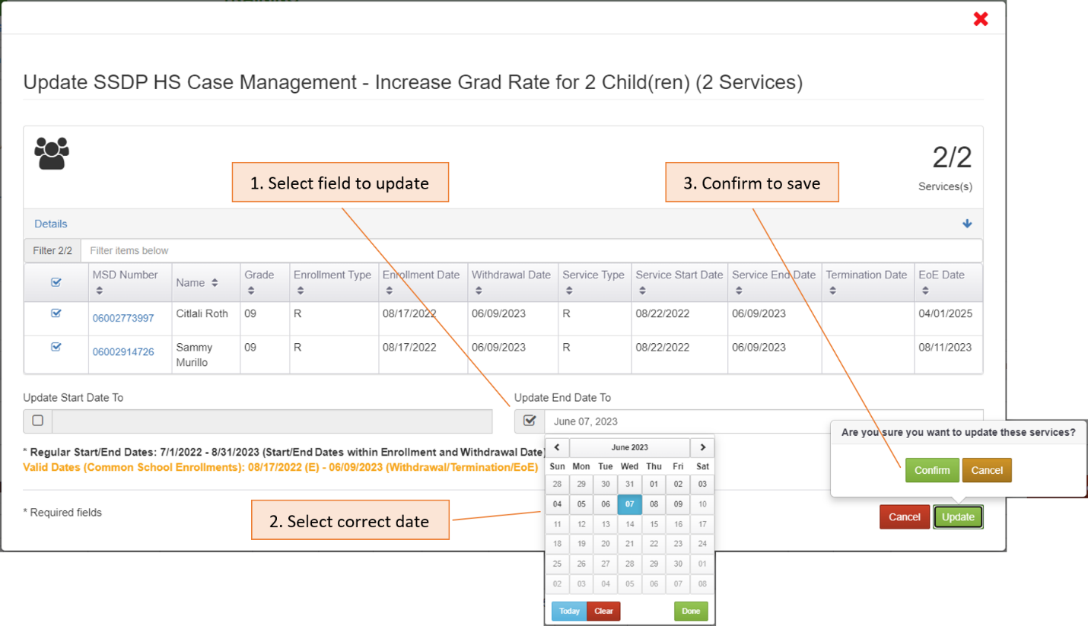
The Update window is like the original service entry window used to enter these services, except that it only has fields to change the Start Date and/or End Date. In this example, we check the field labeled “Update End Date To” and then select the new date, 6/7/2023. Next, we click on the green “Update” button and we confirm this choice to save the corrected information.
Immediately after saving, the system will display the updated service date(s), as follows:
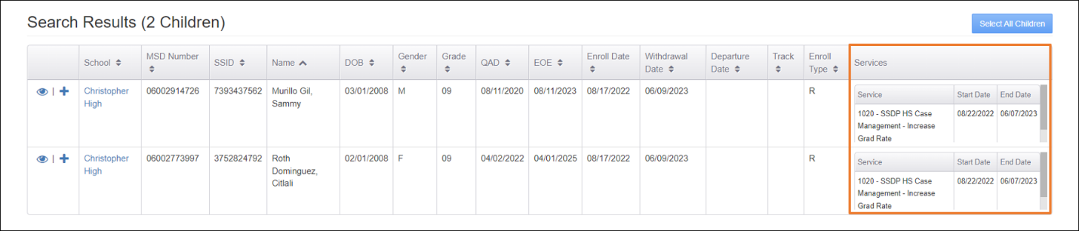
Focusing on the End Date information, we can see that it changed to 6/7/2023. We can also double check the updates on the children’s records, under their Service Participation tab, or by using the Service Report.

Adding missing End Date information for a group
Instead of waiting to enter service data until after each service concludes, some subgrantees choose to enter their Start Dates early and intentionally leave the corresponding End Dates blank. This practice is permissible and might make sense for services that are offered for an extended period, such as the entire Regular Year. Subgrantees who use this two-step method to enter service participation data will need to call up the same children later to add the missing End Dates.
We can use the “Update Services...” window to enter the missing information for a group of children who already have partially entered service records, assuming their End Date will be the same.
First, we must bring up the children who have partially entered service records. We can focus the search on those with missing End Dates by selecting the applicable filters, as shown in the example below:
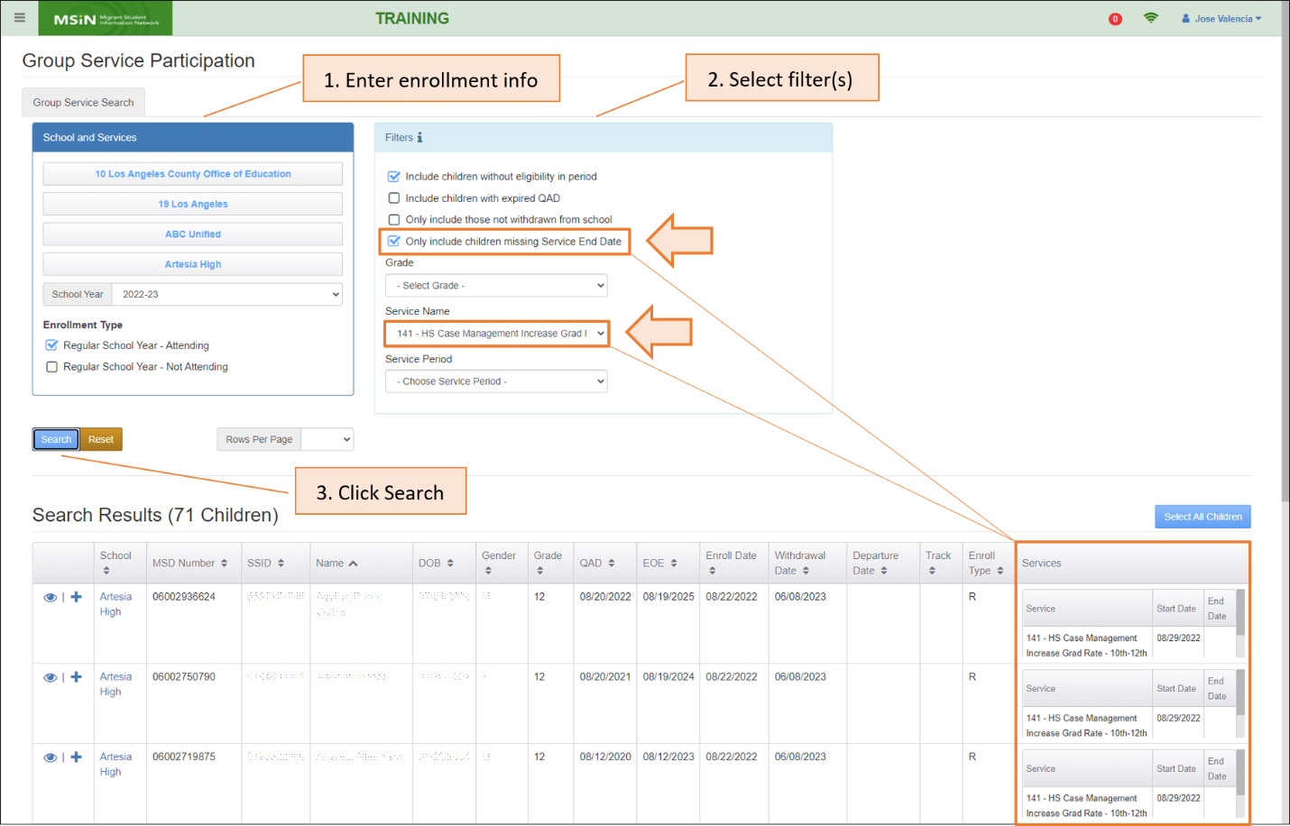
Notice that in the second step, we checked the filter labeled “Only include children with missing Service End Date” and we selected service code 141 (Case Management for grades 10-12). After clicking “Search” (third step), the results table displays a list of 71 children who match the criteria for a partial service record and therefore need End Dates to make them complete.
Next, we select the children who need the update and this moves them into our target list. In this case, we want to select all 71 children, as shown below:
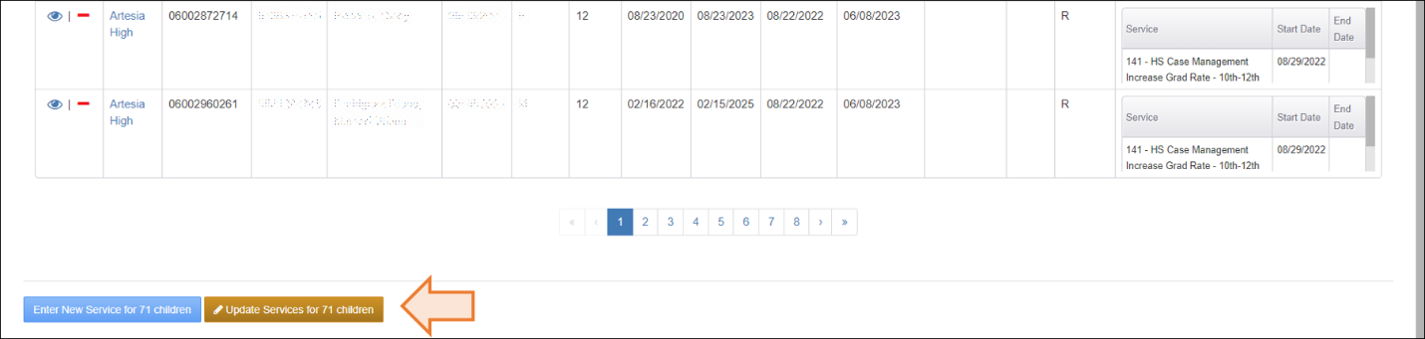
The presence of service records in the target list enables the “Update Services...” button.
We can click this button to bring up the Update modal, which is used to modify existing service records. In this example, we want to update the End Date field, from blank to 6/2/2023, as shown in the following sequence:
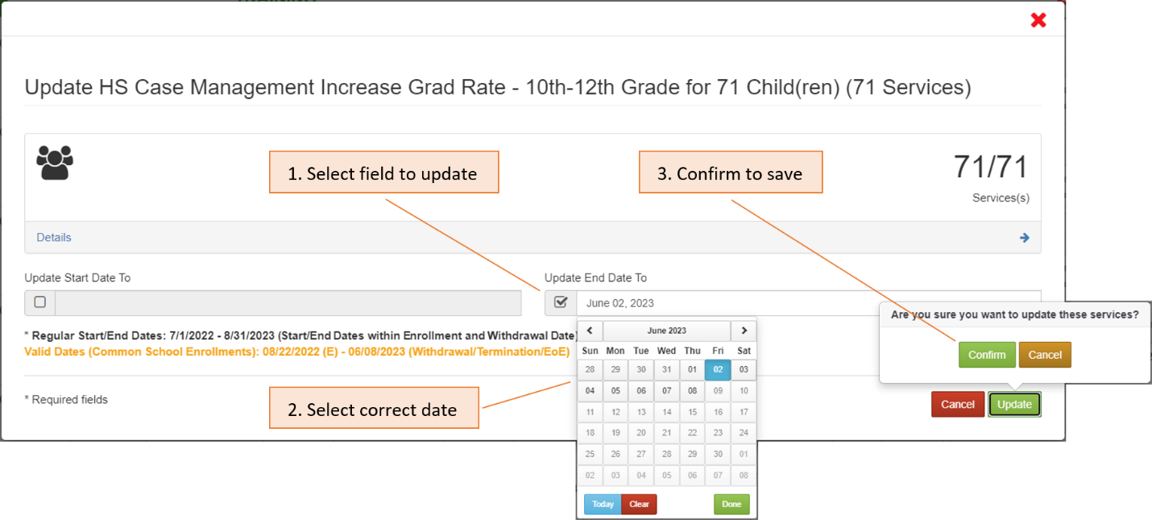
As demonstrated in the previous Group Services examples, you can modify the target list by expanding the child list and unchecking children with conflicting enrollment information. In this case, our intended End Date, 6/2/2023, is before the date limits in both warning messages (black and yellow/gold text), so we can enter the date and confirm the information to save.
Immediately after saving, you can perform a second search—without the filter for missing End Date—to verify that the service records were updated for the selected group of children.
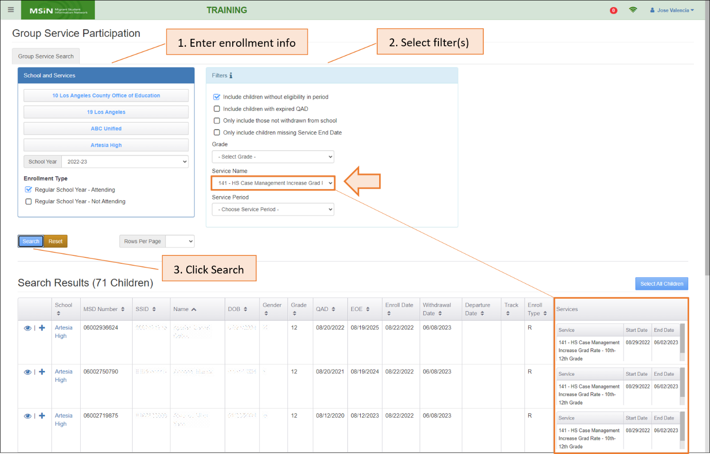
Notice that in the second step we are using the Service Name filter to bring up only children with this specific service (141) so that we can check it for completeness (no missing dates). Given that this is a large group, you can also double check the updates by using the Service Report.
Note: This service entry approach is not recommended for services that require hours because the system will force you to enter an initial hour range before saving the service information. But this initial hour range will only be preliminary. Instead, for services that require hours, we recommend entering them immediately after the services have ended so that you can enter the total hours. This recommended approach ensures that your Measurable Program Objective (MPO) reports will calculate accurate percentages based on each participating child’s total service hours.
This concludes our examples for the Group Services feature.

Tips for Using Group Services
- The Group Services feature works best for groups of children who have the same or similar enrollment and withdrawal dates. Note that even one child with a very different enrollment or withdrawal date will affect the Start Date and End Date limits. We recommend experimenting in the Training MSIN site (https://trainingmsin.wested.org/) to gain an understanding of the nuances.

- It may be more efficient to enter services for children with complex or unique enrollment histories through the Service Participation tab in their Child Record Modal. A child with multiple enrollment lines in the same School Year, or enrollments in multiple schools, will probably get removed from most groups because of date conflicts.

- Rules-of-thumb:
- Regular Year service dates must “fit inside” the enrollment dates.
- Summer services must be after the Regular Year Withdrawal Date.
- Intersession service dates must “fit inside” the enrollment dates.
  - Intersession services are only for year-round schools.
  - A child should not have both Intersession and Summer services in the same School Year (unless they moved from a year-round school to another school with a traditional calendar).

Additional Resources
As emphasized throughout this guide, we strongly recommend practicing in the Training MSIN site (https://trainingmsin.wested.org/) before entering service participation data in the production MSIN site. Training MSIN is a safe place to try the different service entry scenarios described above.
We also recommend double checking your service entry work using the Service Report. A user guide for this report, as well as other MSIN features and reports, is always available on the California MEP Help Center (https://mephelpcenter.wested.org).
The California MEP Help Center also includes video demonstrations of setting up services and entering service participation data for both individual children and groups. In addition, you can find past webinar presentations, Q&A documents on service-related topics, and information meant to help you implement the SSDP and monitor your MPO reports.

If you have specific questions not covered in this guide, please consult with your local team of MSIN Power Users, Managers, and fellow Data Specialists. You are welcome to submit any remaining questions to the MSIN Service Desk by email (msinsupport@wested.org) or phone (1-800-342-2964, option 2).

A modal is a “pop up” window that allows you to perform tasks or view additional information.
The CSPR is an annual report collected by the federal Office of Elementary & Secondary Education, within the U.S. Department of Education. The report collects participation and performance data on several programs, including the Migrant Education Program.
Summer and Intersession services contribute to your Category 2 Count.
If you have any doubts about this, look up the school in the California School Directory (https://www.cde.ca.gov/schooldirectory/) and confirm that the “Year Round” field shows “Yes.”
Having accurate service data is also critical because MEP services are reported to the U.S. Department of Education via EDFacts files 054 and 145, which automatically populate sections of the CSPR.
For more details about setting up services, and the properties in each service, see the user guide on administering services found in the California MEP Help Center (https://mephelpcenter.wested.org). For specific questions about the services in your drop-down menu, please consult with a local Data Specialist or your management team.
See the user guide on the Service Report for more details: https://mephelpcenter.wested.org/hc/en-us/articles/6210292915860-Reports-Service-Report
For more details about setting up services, and the properties in each service, see the user guide on administering services found in the California MEP Help Center (https://mephelpcenter.wested.org). For specific questions about the services in your drop-down menu, please consult with a local Data Specialist or your management team.

